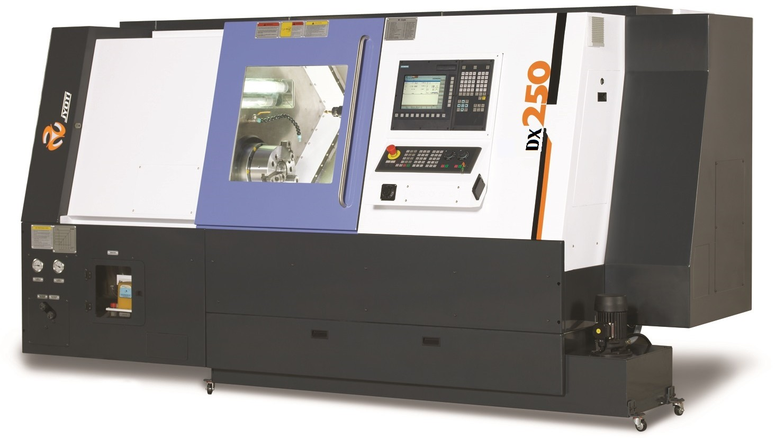

###### Copyright:

This documentation is intended for the operating, maintenance and installation personnel. Passing on as well as copying of this document in full or part is not permitted, nor its use and notification of its contents. Exceptions must be expressively agreed to 'Jyoti Cnc Automation Ltd.' reserves all rights in the event of a patent granted or rights for utility model. Infringement will be liable to damages and can have legal repercussions.

Contents V5CH0000201A Page 0.2.1 of 4

Contents V5CH0000201A Page 0.2.3 of 4





Machine Serial No.: …………………………..

Date of Dispatch : ……………………………

Customer : …………………………….

The publisher reserves all rights, including reprinting and copying of parts of this handbook and its translation.

Reproduction or copying with an electronic copying system of any part of this manual is forbidden unless approved in writing, this also includes learning and training purposes.

Contents V5CH0000201A Page 0.2.4 of 4

Safety Regulations V5CH0100100A Page-1.1.1 of 12

## Safety regulations and Precautionary measures

2:09:17 PMCreated on 11/30/2005 6:59:00 PMConfidential Page 1 8/28/2020V5CH0100100A SAFETY REGULATION AND PRECAUTIONARY MEASURESLast printed

8/28/2020 2:09:00 PM

1

### List of contents

1. **Safety regulations and precautionary measures**

1 Intended use ……………………………………………. 1.1.4

* 1. Symbol and information explanation …………………. 1.1.6
  2. General safety instructions ……………………………. 1.1.7

4 Safety window ………………………………………….. 1.2.1

5 Operation ……………………………………………….. 1.3.1

1. Safety instruction for the installation of the machine 1.3.2
2. Safety instruction for the operation of the machine … 1.3.3
3. Electrical safety rules ………………………………….. 1.3.5
4. Maintenance and repair ……………………………….. 1.3.6

10 Warranty ………………………………………………… 1.3.8

11 Warning labels on the machine ………………………. 1.4.1

12 Noise emission …………………………………………. 1.4.2

Safety Regulations V5CH0100100A Page-1.1.3 of 12

#### Safety regulations and precautionary measures

2:09:17 PMCreated on 11/30/2005 6:59:00 PMConfidential Page 3 8/28/2020V5CH0100100A SAFETY REGULATION AND PRECAUTIONARY MEASURESLast printed

8/28/2020 2:09:00 PM

JYOTI make Machining centers/turning centers (Vertical or Horizontal) are constructed with latest state of the art technology and are operationally safe. Prerequisite for the perfect and safe operation of this machine, however being the correct transport, installation and commissioning as well as careful operation and maintenance.

**Ensure that the information contained in:**

Planning documentation covering preparatory measures

* Transport instructions
* Installation instructions
* Operating instructions
* Programming manual

**Is strictly adhered too.**

### Intended use

2:09:17 PMCreated on 11/30/2005 6:59:00 PMConfidential Page 4 8/28/2020V5CH0100100A SAFETY REGULATION AND PRECAUTIONARY MEASURESLast printed

8/28/2020 2:09:00 PM

Prior to switching on / starting up the machine ensure that no person is endangered by the start up of the machine.

Observe the setting, maintenance, inspection activities and dates, including the data for the exchange of parts/items of equipment outlined in the operating instructions.

Only authorized persons are permitted to undertake this work.

These machining centers/turning centers (Vertical or Horizontal) including its options are intended for:

* Machining of work pieces of iron, die casting, aluminum, copper, stainless steel, alloy steel etc., metal material, except easily flammable and/or explosive materials (e.g. Magnesium, silicon) and/or radioactive material.
* Machining contains milling (surface milling, circular milling, helical, milling, hobbing, profile milling, form milling) & drilling (spot facing, drilling and boring, tapping and threading, profile drilling)

Handling of work pieces, Lin machined parts and tools as applicable according to the machine design and its peripheral equipment.

Only specially trained, authorized and reliable personnel may operate the machine. Persons without the necessary training are not allowed to work on the machine, not even for short periods of time.

There must be clear rules to define the responsibilities of the persons entrusted with the tasks of transporting, installing, tooling, setting up, operating, servicing and maintaining the machine, and compliance with these rules must be ensured by regular spot checks.

Take the proper precautions concerning the materials to be machined, take into account temperature rise during machining, the fire and explosion hazards that may result, possible gas leaks and chemical reactions with the fluids used.

Safety Regulations V5CH0100100A Page-1.1.4 of 12

Safety Regulations V5CH0100100A Page-1.1.5 of 12

###### Standards:

2:09:17 PMCreated on 11/30/2005 6:59:00 PMConfidential Page 5 8/28/2020V5CH0100100A SAFETY REGULATION AND PRECAUTIONARY MEASURESLast printed

8/28/2020 2:09:00 PM

The health and safety measures applied to the machine are in conformance with the following

European standards:

EN ISO 12100-1

EN ISO 12100-2

The electrical equipment, installation, safety are in conformance with the EN 60204 standard.

###### Not Permissible are:

* + Reaching into the machine with the hands or tool or job while machine is running.
  + Programming rotational speed and speed of axes exceeding maximum defined into machine parameter.
  + Modifying or putting out of action (additions or conversions) safety devices such as safety position switches, interlocking, covers etc.
  + Painting over or removing plates, information signs, etc.
  + Operating the machine by unauthorized persons and those not trained.
  + Machining of ceramic, magnesium, inflammable, explosive, radioactive and artificial resin impregnated laminated wood.
  + The wearing of long hair and jewellery, including rings. Making program changes (software) to programmable control systems.
  + The use of equipment which generates electro-magnetic radiation (e.g. handy electrical welding units), within a range of 8/10 m from the machine.
  + Operating the machine with a damaged safety window.
  + Operating the machine with open door.

Safety Regulations V5CH0100100A Page-1.1.6 of 12

**Symbol and information explanation**

2:09:17 PMCreated on 11/30/2005 6:59:00 PMConfidential Page 6 8/28/2020V5CH0100100A SAFETY REGULATION AND PRECAUTIONARY MEASURESLast printed

8/28/2020 2:09:00 PM

###### Warning, Caution!

This symbol is used when warning of possible danger of injury or t to health independent of the degree of danger.

This symbol is used when referring to particular information or instructions and prohibitions intended to avoid damage.

This symbol indicates advantageous and economical applications and uses.

This symbol indicates situations requiring the notification of the authorized service.

Safety Regulations V5CH0100100A Page-1.1.7 of 12

#### General safety instructions

2:09:17 PMCreated on 11/30/2005 6:59:00 PMConfidential Page 7 8/28/2020V5CH0100100A SAFETY REGULATION AND PRECAUTIONARY MEASURESLast printed

8/28/2020 2:09:00 PM

Incorrect use of the machine or operation which does not correspond to the intended use or undertaken by untrained persons can result in the danger of injury, to the health or in damage to property The operator must ensure that only correspondingly qualified and authorised personnel work on the machine.

Check at certain intervals that the personnel operating the machine are aware of safety and dangers whilst taking the operating instructions into consideration.

###### Fixed or moving safety devices

Ensure that all movable protection hoods and doors are closed prior to starting up the machine. Do not open during operation. Do not put fitted safety devices out of operation.

###### Oil, lubricant and coolant

Due to the additives, these products imply a possible danger to health and environment.

Selection and application are exclusively in the hands of the owner. Operating instructions to be prepared by the owner covering the handling of these materials should contain:

* + - Designation of the material
    - Designation of danger to persons and the environment
    - Protective measures and behavior directives, e.g.

Wear protective gloves made of resistant plastic material Avoid contact with eyes and skin

Do not inhale vapours and fumes

* + - Behavior in the event of danger, first aid
    - Correct disposal

###### Rotational speed limitation

2:09:17 PMCreated on 11/30/2005 6:59:00 PMConfidential Page 8 8/28/2020V5CH0100100A SAFETY REGULATION AND PRECAUTIONARY MEASURESLast printed

8/28/2020 2:09:00 PM

Enter the value as a parameter when the max. Rotational speed is less than the max. Speed of the machine. Access to these settings is only possible via the key switch or a password.

* Machine should be operated by one person only..
* At the time of operation machine should be off.
* Use cutting oil as recommended by cutting fluid supplier for work piece material
* The owner must ensure that the operators, maintenance and service personnel are fully familiar with all safety and warning instructions and that is adhered to.
* Keep all safety and danger warning information on the machine in a legible condition.
* All working methods are forbidden which influence the safety of the machine.
* The operator must notify his superior of any changes to the machine encountered which may impair safety.
* Stop and secure the machine immediately, overcome malfunction at once.
* Where necessary, the owner is obliged to ensure that the operating personnel wear personal protective equipment as well as tight fitting clothing. **Work boots** must be worn.
* Take every **health precaution concerning fluids** that may come into contact with the skin (lubricants, cutting oil, and cleaning products) and use suitable protective clothing and gloves. Do not inhale the fumes.
* Apart from machine noise. Machining may produce **strident sounds** in certain cases. The operator must thus use suitable earmuffs. If necessary. People in the vicinity must do likewise.

Safety Regulations V5CH0100100A Page-1.1.8 of 12

Safety Regulations V5CH0100100A Page-1.1.9 of 12

#### The machine safety can be impaired by:

2:09:17 PMCreated on 11/30/2005 6:59:00 PMConfidential Page 9 8/28/2020V5CH0100100A SAFETY REGULATION AND PRECAUTIONARY MEASURESLast printed

8/28/2020 2:09:00 PM

* Conversions or changes made to the machine.
* The use of additional equipment (options) on the machine other than proposed or approved by the manufacturer.
* The use of spare and wear parts other than those intended by the manufacturer.
* Non observance of the stated schedules prescribed or in the operating instructions for repetitive checks/inspections
* When the hydraulic hose lines are not exchanged at suitable intervals, even if no safety relevant faults are detected (guide value: replace in every 2 years.)

Safety Regulations V5CH0100100A Page-1.1.10 of 12

#### General

2:09:17 PMCreated on 11/30/2005 6:59:00 PMConfidential Page 10 8/28/2020V5CH0100100A SAFETY REGULATION AND PRECAUTIONARY MEASURESLast printed

8/28/2020 2:09:00 PM

* Check the machine filling levels if necessary, prior to switching on the machine.
* Check the machine for leaks and overcome cause.
* Ensure a clean and well arranged workplace on the machine.
* Take care when removing swarf, only use swarf hooks and hand broom. Swarf projection is hazardous. The temperature of Swarf may be very high and cause serious burns. Protect your eyes!
* Do not throw any waste into the coolant or chip removal.
* It is advisable to use wooden platform all around the m/c to avoid any slips & shocks.
* Set an additional lubrication impulse following an extended stoppage (from 2 days).

Safety Regulations V5CH0100100A Page-1.1.11 of 12

#### Vision Panel

2:09:17 PMCreated on 11/30/2005 6:59:00 PMConfidential Page 11 8/28/2020V5CH0100100A SAFETY REGULATION AND PRECAUTIONARY MEASURESLast printed

8/28/2020 2:09:00 PM

###### Maintenance and care

* Clean the vision panel only using a mild household detergent and a soft cleaning cloth. Don’t use strong alkaline cleaning agents or soiled cleaning cloths under any circumstances.
* Replace damaged vision panel immediately. Damage has occurred if the internal safety glass is cracked or punctured.

Do not operate the machine with a damaged vision panel

###### The vision panel is to be replaced for the following reasons.

* Any accident takes place or indentation or crack is evident.
* Vision is not clear or any kind of deformation is evident.
* Change of vision panel is advisable after one year. (It is subjected to environmental conditions.)

###### Glazing on machine tools is a very important safety component. Its role is to protect the user if particles are projected during machining.

* **All glazing must be replaced within a period of one year or if the following damage being noted: heavy scratching making the screens opaque, yellowing or swelling.**

###### If this rule of safety is not observed, JYOTI will not accept any liability in the event of an accident.



Contents C2CH0100200B Page 1.2.1 of 1



**Vision panel**

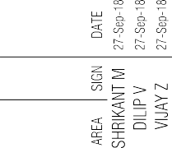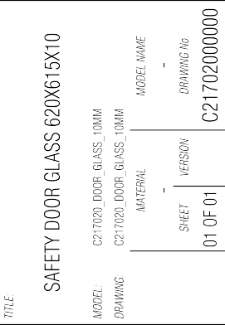

#### Operation

12:23:56 PMCreated on 4/22/2008 5:07:00 PMConfidential Page 1 8/13/2017V5CH0100300A SAFETY REGULATION AND PRECAUTIONARY MEASURESLast printed

8/13/2017 12:23:00 PM

Observe the switching off procedures stated in the operating instructions for all work concerning operation, installation, maintenance and service of the machine.

In other words for **switching off the machine**

* + Stopping at cycle end
  + Open protection hood
  + Button: machine DRIVE OFF
  + Main switch: OFF
  + Secure the main switch against switching on again

**!**

###### Main switch

Main switch is at the right hand side of the machine and put on this switch to start the machine function.

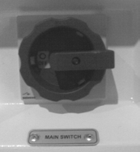

Do not switch off the main switch during the manufacturing program, as this will result in machine and/or tool damage.

###### EMERGENCY STOP

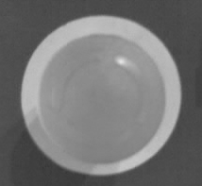

**!**

Actuate the emergency stop button in the case of danger. Emergency stop button is a red mushroom type button which is kept on the operating panel.

###### CHIP CONVEYOR (OPTION)

Do not reach into the running chip conveyor or undertake any manipulations.

Operation of the chip conveyor is only admissible when the chip bath is correctly positioned below. Do not remove chips manually. Switch off the machine prior to cleaning the chip ejector.

Safety Regulations V5CH0100300A Page-1.3.1 of 9

Safety Regulations V5CH0100300A Page-1.3.2 of 9

#### Safety instruction for the installation of the machine :

12:23:56 PMCreated on 4/22/2008 5:07:00 PMConfidential Page 2 8/13/2017V5CH0100300A SAFETY REGULATION AND PRECAUTIONARY MEASURESLast printed

8/13/2017 12:23:00 PM

* + - The equipment must be handled by qualified and authorized personnel.
    - For lifting and handling, be sure to **sling the equipment correctly,** in order to prevent accidents and damage.

###### Use lifting and handling equipment that is adequate and in good condition.

* + - **Make sure that personnel are properly attired: hard** hat, work boots, gloves, goggles, etc.
    - Installation of the machine in an explosive atmosphere is not authorized.
    - The connection of electrical equipment to earthling conforming to standards is obligatory.
    - Provide an exhaust system for cutting oil fumes in conformance with labour regulations.
    - Make sure that the machine is sufficiently illuminated for it to be used properly.

#### Safety instruction for the operation of the machine

12:23:56 PMCreated on 4/22/2008 5:07:00 PMConfidential Page 3 8/13/2017V5CH0100300A SAFETY REGULATION AND PRECAUTIONARY MEASURESLast printed

8/13/2017 12:23:00 PM

* + - Ensure that no one is in a dangerous position when the machine is turned on.
    - Please execute safety check and maintenance according to the rule of the operation manual.
    - Before the axis stops, do not pull the safety door and all viewing windows open.
    - **Devices for clamping** parts on the table must be suited to the machine and intended machining; they must be in good condition. Take all precautions when handling the part to be machined or machined (sharp edges, stability, heat) when transporting, loading/ unloading.
    - Use only **cutting tools adapted** to the machine and the machining to be performed; they must be in good condition. Take every precaution when unloading tools, they may be very hot.
    - The cutting at the tool tip shall not get rid of by hand, instead of use brush
    - Whenever the tool is loosening, make sure to fix it.
    - For the adjustment of the coolant nozzle, wait until the machine stop running.
    - Do not use low flash point cutting solution.
    - Before processing the working pieces, make sure to fix tight.
    - Make sure the position and cutting speed between the cutter and the working pieces is correct.
    - Do not operate the switch with glove on, as it often lead to wrong operation and cause other fault actions.
    - Take all necessary precautions during use in manual control.
    - Make sure that no one can give commands when setting the machine,
    - **Never put your hanks, arms, or head between parts in motion** or part that may be set in motion,

Safety Regulations V5CH0100300A Page-1.3.3 of 9

Safety Regulations V5CH0100300A Page-1.3.4 of 9

* + - According to the program a **Cycle may come to an end after a machine shutdown command has been sent.** Take this into account before doing work on the machine. Take into account as well the inertia of certain moving elements.

12:23:56 PMCreated on 4/22/2008 5:07:00 PMConfidential Page 4 8/13/2017V5CH0100300A SAFETY REGULATION AND PRECAUTIONARY MEASURESLast printed

8/13/2017 12:23:00 PM

* + - For safety's sake, the working site must have sufficient` lighting.
    - It is prohibited for two persons (include more than two) to operate the control panel and other button switches.
    - Please follow the safety rules of other chapters at the same time.
    - After making or editing program, see simulation (at that time put axes in safe position).
    - Take all precautions before doing work on pressurised elements.

###### Loosening unions or hydraulic hoses under pressure is forbidden.

* + - Do not open the pressurised reservoir.

Safety Regulations V5CH0100300A Page-1.3.5 of 9

#### Electric safety rules

12:23:56 PMCreated on 4/22/2008 5:07:00 PMConfidential Page 5 8/13/2017V5CH0100300A SAFETY REGULATION AND PRECAUTIONARY MEASURESLast printed

8/13/2017 12:23:00 PM

* + - **Prevent all electrical hazards.** it is strictly prohibited to do any maintenance or repair work on a live installation.
    - At the rear side of the machine shall leave enough room for opening control box door when doing maintenance or making adjustment, there is a PE connecting point inside the control box, please connect it with the outside protective conductor (ground wire) to establish complete protective grounding.

###### Make sure that no one is place in a dangerous position during maintenance.

* + - Making off the work area is recommended.

###### Make sure that no one can run any commands or programs during maintenance work.

* + - Any maintenance or adjustment regarding electric or electronic must be executed by trained and capable technician.
    - Customer should ensure that the operator, maintenance and service personnel are fully familiar with all safety and warning instructions.

###### In order to prevent the danger for being sent in electric by mistake, it is best after turning off the power source to lock the switch at "OFF” or to hang a "prohibit to send electricity' label or to ask another person to take care.

* + - After completion of operation, windows and covers shall be filled and closed to restore the original condition.
    - Before supply of the electricity, be sure there is no one doing other work on the machine.
    - It is prohibited to put any thing above the control box or operation box.
    - The pins inside the control box, transformer, motor, relay box etc., Have high voltage, and don’t touch. Don’t touch the switches or electric parts with a wet hand.

**!**

###### Do not touch any wire or control devices in power ON condition. Do not fix or remove any plug or connection in power ON

**condition.**

In order to ensure your safety and the normal operation of the machine, please proceed with safety check of the machine based on following check and inspection sequence,

12:23:56 PMCreated on 4/22/2008 5:07:00 PMConfidential Page 6 8/13/2017V5CH0100300A SAFETY REGULATION AND PRECAUTIONARY MEASURESLast printed

8/13/2017 12:23:00 PM

* Check the power source up to machine is as per requirements.
* Check the machine body and earthing point in the panel is properly connected with earth.
* Check all the hoods, doors, pipes must not loose.
* Check all external cables and conduits are placed in proper placed.

#### Maintenance and repair

**!**

Set the main switch to OFF prior to undertaking maintenance of repair work and secure against unauthorized switching. This also applies to work on the chip conveyor and switch cabinet as well as peripheral equipment.

* + Only trained personnel are permitted to undertake maintenance and care in accordance with the information laid down in the operating instructions.
  + Only use lint free cleaning cloths for cleaning the machine.
  + Under no circumstances clean the machine with compressed air or high pressure cleaner as chips could enter the guide ways, spindle bearings or as tool holders.
  + Cover/apply adhesive tape to all openings for safety or/and function reasons to prevent the ingress of liquids prior to cleaning the machine with water or other cleaning agents. Particularly endangered are electric motors and switch cabinets.
  + Completely remove covers/adhesive tape once cleaning is finished.
  + Ensure that no persons are in the danger zone.
  + Protect the danger zone over a wide area using additional barriers or fences.

Safety Regulations V5CH0100300A Page-1.3.6 of 9

* + When exchanging parts carefully fix the individual parts and larger modules onto lifting means and secure, so that no danger can exist. Only use suitable and technically perfect lifting means, as well as load bearing devices with a suitable bearing capacity.

12:23:56 PMCreated on 4/22/2008 5:07:00 PMConfidential Page 7 8/13/2017V5CH0100300A SAFETY REGULATION AND PRECAUTIONARY MEASURESLast printed

8/13/2017 12:23:00 PM

* + Do not stand or work below suspended loads.
  + Ensure that a second person is present when working on live parts that can actuate the main switch in an emergency. Close off the working area with a red and white safety chain and a warning plate. Only use insulated tools.
  + For the repairing work use proper tools and fixtures.
  + Only trained and qualified staffs with special knowledge and experience are permitted to work on electrical and technical liquid systems.
  + Only use original spare parts.
  + Check the function of the safety devices in the case of damage, exchange damaged parts.
  + Clean off oil or lubricants from the machine and in particular connections and screw fittings prior to starting repair work! Do not use aggressive cleaning agents! Only use lint free cleaning cloths!
  + Tighten screw fittings released during repair work with a torque corresponding to the screw quality (deviations can be found in the corresponding chapter).

###### Do not open or repair any module without prior permission for manufacturer, which can be void the warranty of that particular part and related parts.

**Replace any part of control panel with same make and same technical specifications only.**

* + Before opening any screw of drive or power module of the drive check the instructions for discharging or any other.
  + Only trained and/or skilled people are permitted to undertake maintenance and repairing work with proper tools and documentation.

Safety Regulations V5CH0100300A Page-1.3.7 of 9

Safety Regulations V5CH0100300A Page-1.3.8 of 9

* + Recheck and tighten screws releasing during repairing work with proper tool and torque.

12:23:56 PMCreated on 4/22/2008 5:07:00 PMConfidential Page 8 8/13/2017V5CH0100300A SAFETY REGULATION AND PRECAUTIONARY MEASURESLast printed

8/13/2017 12:23:00 PM

* + Replace any part of electrical/electronics with same specifications only and preferably same make or brand.

Safety Regulations V5CH0100300A Page-1.3.9 of 9

#### Warranty

12:23:56 PMCreated on 4/22/2008 5:07:00 PMConfidential Page 9 8/13/2017V5CH0100300A SAFETY REGULATION AND PRECAUTIONARY MEASURESLast printed

8/13/2017 12:23:00 PM

* + The manufacturer accepts neither liability nor guarantee, if the instructions contained in the operating and programming instructions, planning, transport and installation instructions are not observed,
  + If the machine, including additional equipment is incorrectly used,
  + If the machine, including additional equipment is not correctly maintained and repaired.
  + If safety devices are not used or put out of operation.
  + If any technical or functional modifications are undertaken which are not approved by the manufacture

Safety Regulations C2CH0100401A Page 1.4.1 of 14

### Warning labels on the machine

Safety-related information, which must be strictly observed by all machine operators, is given on caution labels. These caution labels are attached to the machine

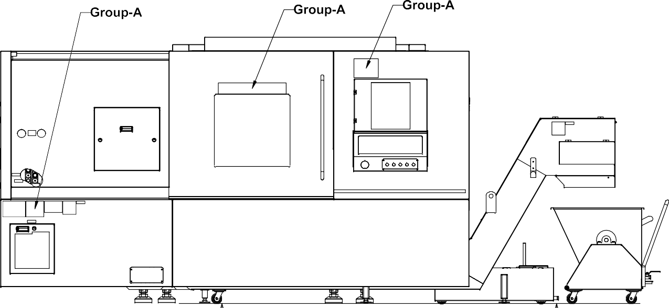

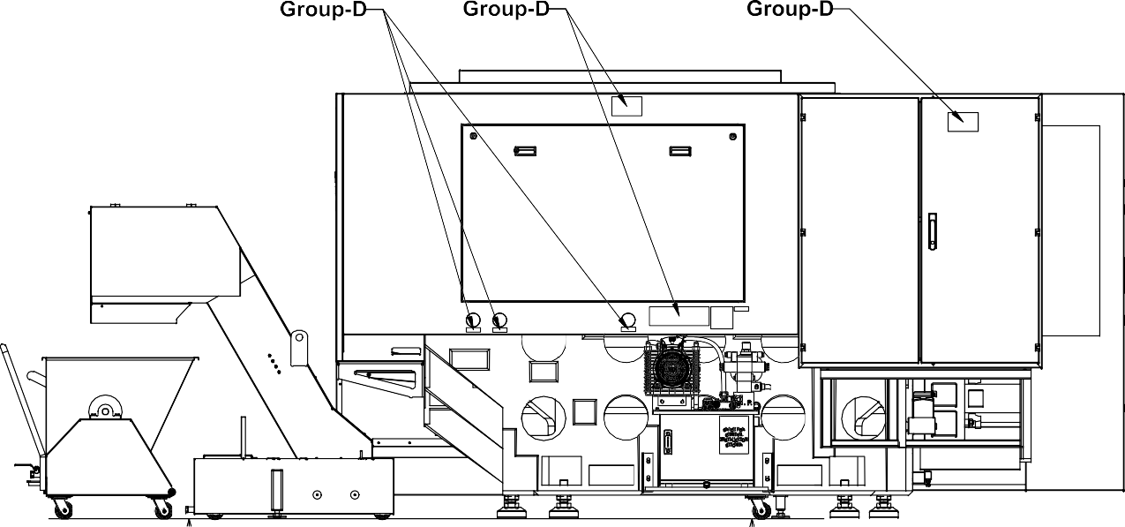



Safety Regulations C2CH0100401A Page 1.4.2 of 14

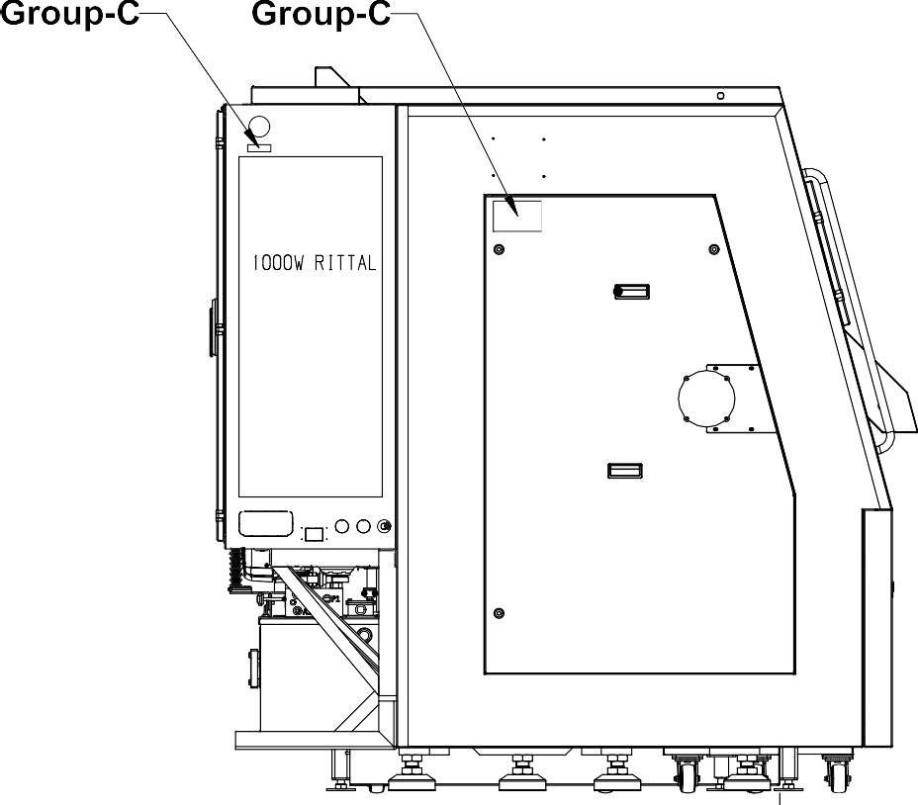

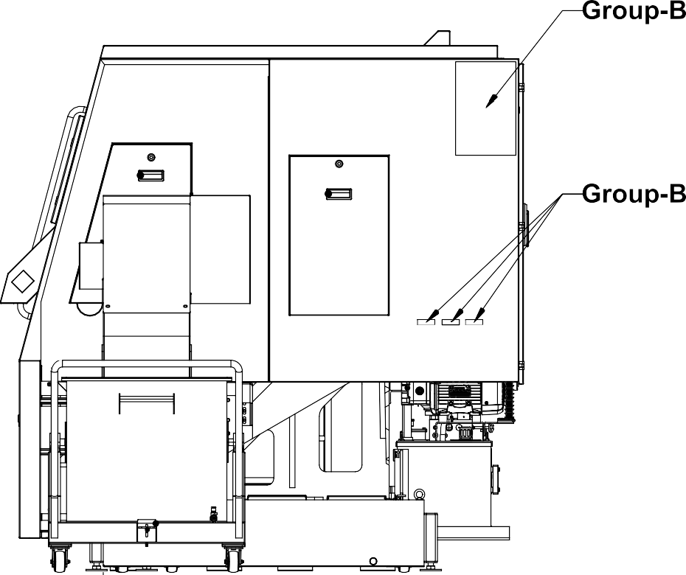



Safety Regulations C2CH0100401A Page 1.4.3 of 14

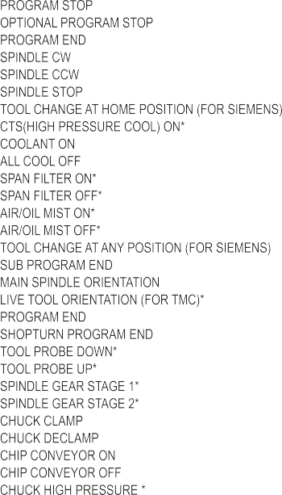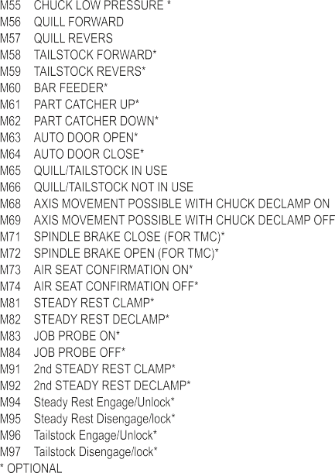

### Group-A

Safety Regulations C2CH0100401A Page 1.4.4 of 14

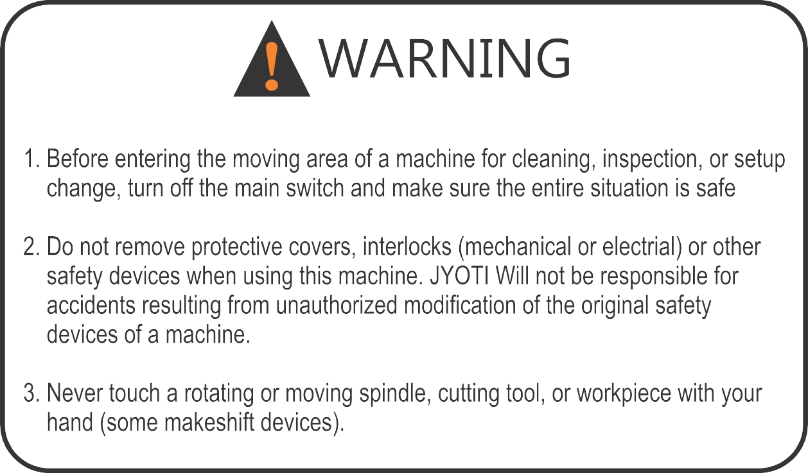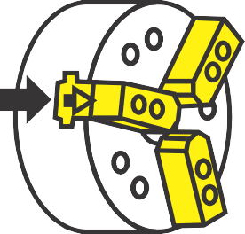

Safety Regulations C2CH0100401A Page 1.4.5 of 14

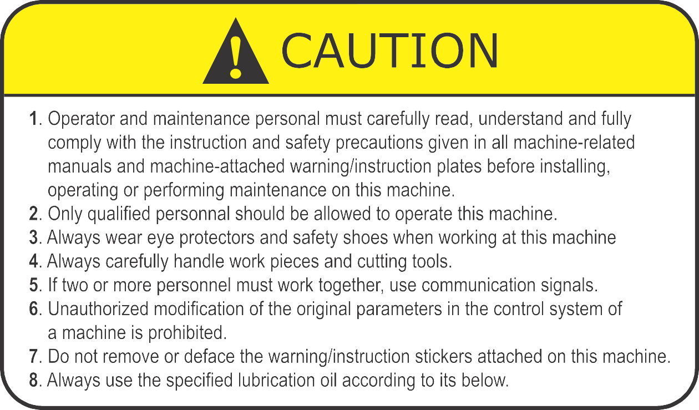



Safety Regulations C2CH0100401A Page 1.4.6 of 14

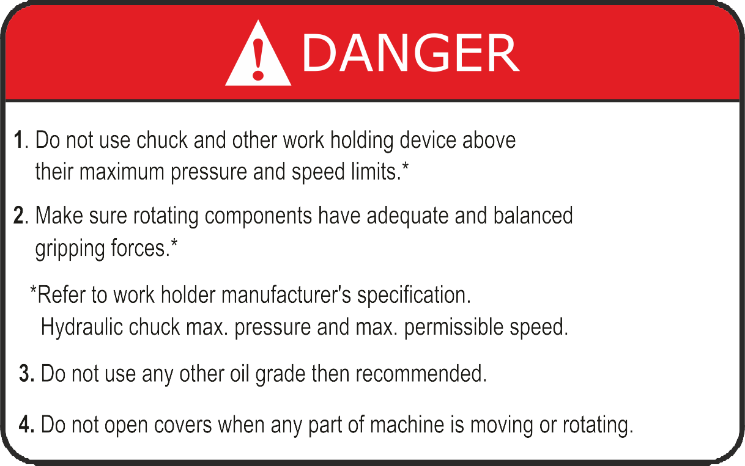

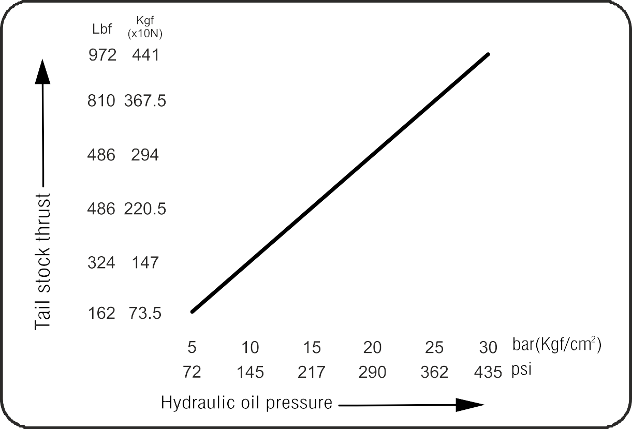

Safety Regulations C2CH0100401A Page 1.4.7 of 14









Safety Regulations C2CH0100401A Page 1.4.8 of 14

### Group-B

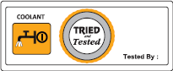



Safety Regulations C2CH0100401A Page 1.4.9 of 14

  

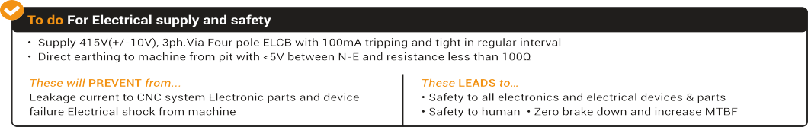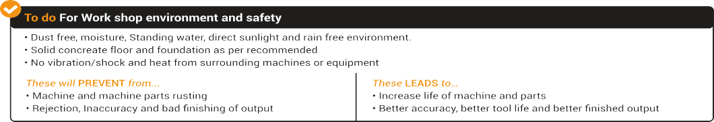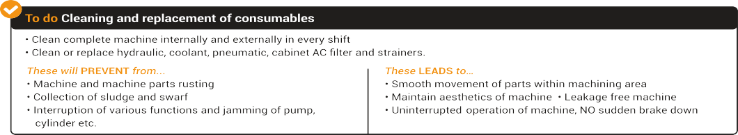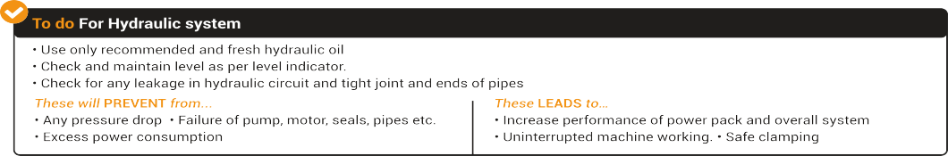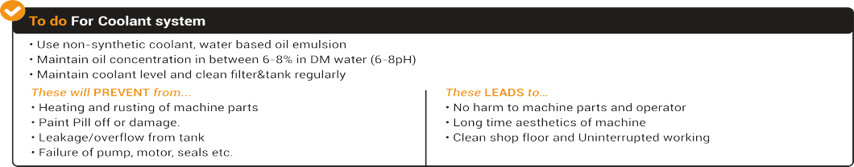



Safety Regulations C2CH0100401A Page 1.4.10 of 14

### Group-C



Safety Regulations C2CH0100401A Page 1.4.11 of 14

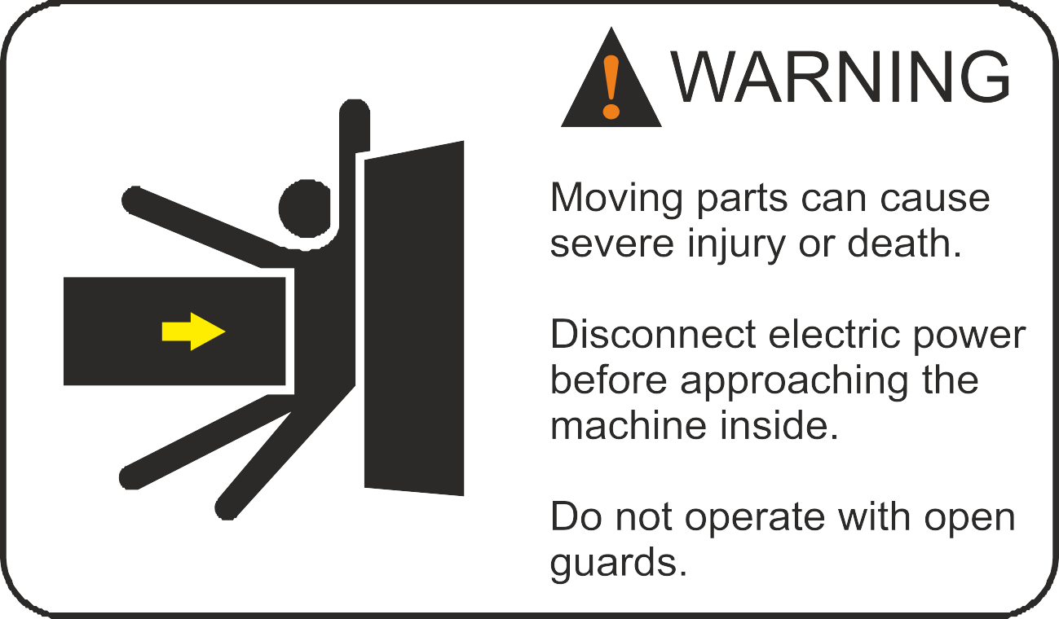

Safety Regulations C2CH0100401A Page 1.4.12 of 14

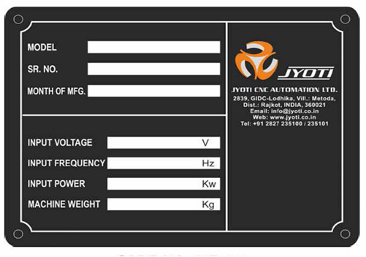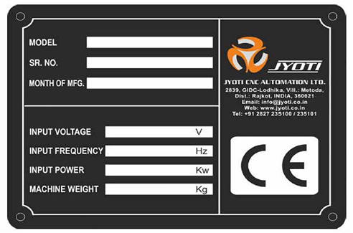



Safety Regulations C2CH0100401A Page 1.4.13 of 14

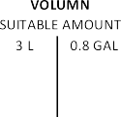

**Group-D**

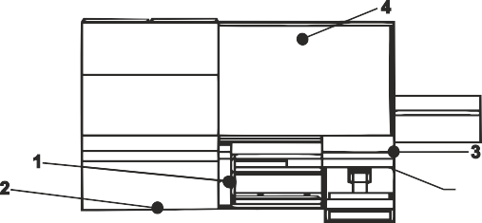

|  |  |  |  |  |
| --- | --- | --- | --- | --- |
|  |  |  |  |  |
|  |  |  |  |  |
|  |  |  |  |  |
|  |  |  |  |  |
|  |  |  |  |  |

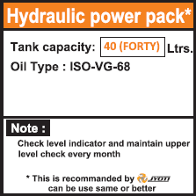





Safety Regulations C2CH0100401A Page 1.4.14 of 14

### Noise emission

Value of aerial noise produced by the machine, according to section 1.7.4.2

(U) of ANNEX 1 of 2006/42 MD DIRECTIVE:

A Weighted sound power level emitted by the machinery does not exceeds 80d B(A)

### Data collecting system:

The measuring position is as shown on drawing and is taken at 1600 mm from the floor and at 1000 mm from the machine.

### Measuring conditions:

Spindle rotation at maximum speed. (Not cutting)

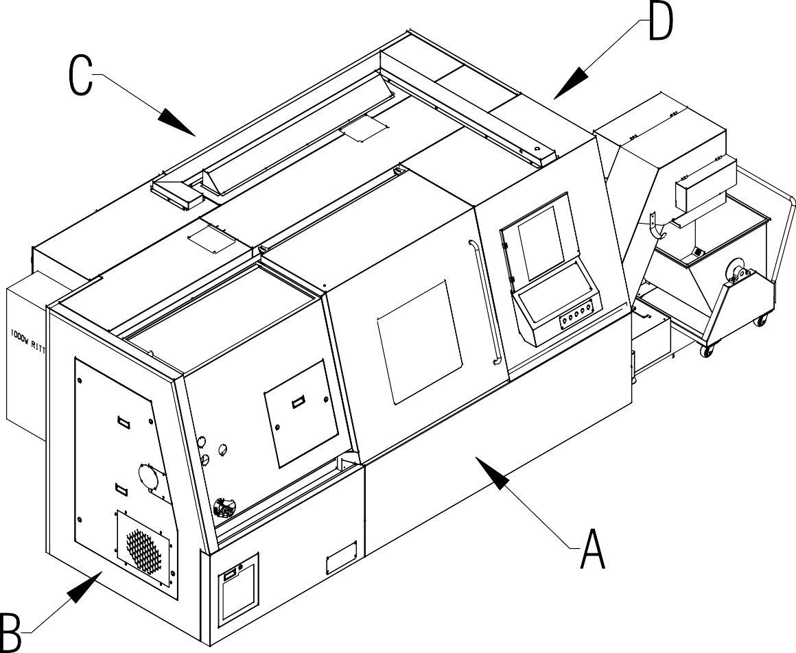

## Procedure for installation 2

### List of contents

1. **Procedure for installation**

1 Installation procedure ………………………………………………. 2.1.3

2 Storage instruction ………………………………………………….. 2.1.4

3 Unpacking …………………………………………………………… 2.1.5

4 List of Instruments / Equipments …………………….................... 2.1.6

5 Lifting …………………………………………………………………. 2.1.6

6 Initial Inspection …………………………………………………….. 2.1.8

7 Cleaning of machine ………………………………………………... 2.1.8

8 Guide to select an installation site (Environmental Requirements) ……………………………………………………….

2.1.9

9 Foundation requirements…………………………………………… 2.1.11

Procedure for Installation G2CH0200101A Page- 2.1.1 of 13

10 Preparation of the machine & other equipments for installation... 2.1.13

11 Electrical Equipments ….…………………………………………… 2.2.1

12 Commissioning…………………………………………………......... 2.2.5

Procedure for Installation G2CH0200101A Page- 2.1.3 of 13

### Installation Procedure:

The installation procedure for installing the machine and its auxiliary equipment is given below,

#### Handling instruction:

###### Handling operation must be performed by quilted, authorized Staff.

* Comply with labor legislation and the company’s own safety rules.
* Check the delivery against the packing list provided to ensure that it is complete.
* Take note of the indicated mass.
* **Observe the indications on slinging diagrams** and information regarding the centre of gravity.
* Use the suitable lifting and handling equipment in good condition.
* Use appropriate protective equipments: ear muffs, safety foot ware, gloves, etc.
* Sling the equipment correctly to avoid any accidents or risk of damage.
* Make sure that there is no danger to people.

Procedure for Installation G2CH0200101A Page- 2.1.4 of 13

### Storage Instruction:

* The equipment must be kept sheltered from the weather in closed room.
* The equipment shipped in a case must be kept sheltered from it’s original packaging.
* Take note of position indication: “HAUT” (Top) and “BAS” (bottom).
* The equipment is packed in cases containing one or more dehydrating cartridges.
* An inspection and replacement of the dehydrating cartridges must be carried out every six months.
* In case of prolonged storage, all equipment should initially be checked before it is put into storage.
* Do not remove the protective grease from metallic parts.

Storage conditions:

Temperature: -30 to +60 °C Humidity :- <80% condensation free

The electrical cabinet contains electronic equipment with a magnetic memory. The equipment must therefore be kept away from magnetic fields.

#### Unpacking:

* It is advisable to delimit and mark out the area where the parts and components are stored during installation.
* Remove all items used for packaging and chocking during transport.
* The protective covers on the electrical cabinets and box will only be removed on assembly.
* The protective films will only be removed from the control panels on commissioning.
* The wooden box/crate containing the machine and other equipment should be handled very carefully to avoid costly damage during movement and uncrating.
* Extreme care should be taken while moving the operator station, which contains precision electronic equipment.
* Careless handling or manipulation of these units may upset the calibration of the components, thus introducing error into the control system.
* Boxes containing the standard accessories, tools, manuals, etc., should be opened preferably in the presence of JYOTI Commissioning engineer.

Avoid all impacts.

The protective grease will only be removed from the machined surfaces on assembly.

Beware not to damage electrical cables and the various hoses. Do not disconnect them. Do not remove their identification. Do not pull on these components. Do not remove the caps from the various couplings.

Procedure for Installation G2CH0200101A Page- 2.1.5 of 13

#### List of Instruments/Equipments:

The following is the list of the required instruments /equipments required for installing and commissioning of the machine and which should be kept available before installation.

* + Wire rope
  + Overhead crane or any suitable lifting equipment having 30 to 40 percent more capacity than the total machine weight.
  + Wooden blocks and felt pads to prevent damage to machine elements while slinging;
  + Leveling bridge, leveling plates and leveling screws.
  + Precision spirit levels graduated in 0.02/100 mm /meter.
  + Foundation bolts (not supplied with the machine)
  + Set of hand tools for mechanical assembly (a kit of essential service tools are supplied with the machine)
  + Set of electrical tools.
  + Digital multi meter.

#### Lifting:

**Care in handling a machine:**

This model is built in one unit and it can be easily moved without separating it into consisting unit. (Not that coolant tank is installed separately.)

Lifting and moving machine:

There are two different methods for moving the entire machine to any desired location; by an overhead crane, (lifting hooks supplied together with the machine) and by rolling over where the machine is pushed by manual labor.

Procedure for Installation G2CH0200101A Page- 2.1.6 of 13

#### Machine Lifting:

The following are the points to be taken into consideration before lifting the machine:

1. Use good quality of wire ropes; the strings should be free of kinks, knots, broken strands or loose connections.
2. At positions where the wire ropes contact the machine body, make sure to insert protective materials such as pads, bags, or wooden blocks suitably, in order to prevent damage.
3. Whatever your lifting equipment or conditions may be, you must practice good safety procedures. Know your equipment well and anticipate safety hazards.
4. Coolant tank or Chip conveyor should be removed out of the machine before lifting.

Follow the steps given below for lifting the machine using an over head crane or any other similar equipment.

1. Move X-axes to its lowermost position (hard stops) & Saddle should be locked from behind (through axes locks). Move Tailstock or sub-spindle (if mounted) to the right end and clamp it.
2. Remove any work pieces, tools, etc. out of the machine.
3. Turnoff the power supplies of the machine and disconnect power cables and other hoses from the machine.
4. Place the leveling blocks at the planned position.
5. Fix the lifting hook at the predetermined position.
6. When lifting, wind up slowly and stop lifting, once the wire ropes get tightened, and ensure that the ropes are attached properly.
7. Try to balance the machine in a horizontal position as good as possible before moving.

Procedure for Installation G2CH0200101A Page- 2.1.7 of 13

1. Extra care should be taken while lowering the machine on to the foundation; lower slowly to avoid abrupt hits on the floor and align the leveling plates and foundation bolts suitably to avoid dragging the machine.

###### Rolling:

When machine is handled by rolling, be careful that the machine does not tip over on any side so that the machine base may not strike the ground. Use proper roller and plate that can endure machine weight.

### Initial Inspection:

Inspect all packing materials supplied for completeness as per the enclosed packing list and identification tags, and check for any shortage or transport damages. Particularly, while unpacking these boxes with tools and accessories, ensure that no equipment is lost. In case you have any complaints, convey them to the Engineer, Servicing CNC Group, JYOTI, INDIA.

### Cleaning of Machine:

* All bright parts, which are coated with rust preventives, should be removed carefully before moving any of the sliding/rotating parts of the machine. While cleaning the machine, ensure that no organic solvents such as carbon tetra-chloride, alcohol, ketones concentrated acids benzyl, phenol etc are applied.
* Cleaning with a cloth lightly soaked in cleaner will keep the bright metal parts and painted surfaces in good condition.
* Do not use wet cleaning substances on the control panel or on any electrical/electronic components.
* Remove packing materials completely away from the machine, especially from the operating range of moving parts.

Procedure for Installation G2CH0200101A Page- 2.1.8 of 13

* Also make sure that the hydraulic tank and coolant tank are free from any large dust particles or water. If necessary thoroughly clean them before any attempt is made to fill them.
* Do not raise the machine more than whatever is necessary.
* Protect yourself by wearing approved protective shoes and gloves.
* Never allow a person to work under the suspended load from the crane hook.

### Guide to Select an Installation Site (Environmental Requirements):

In order to ensure high machine accuracy and performance, the following points should be considered with regard to the installation site.

Avoid the following places when choosing the installation site for the machine:

* Places subject to direct sunlight, near heat sources, or
* Subjected to excessive temperature change
* Humid places
* Dusty places
* Places near vibration generating equipment
* Weak soil

1. Foundation work is advised for sites where the subsoil is soft to prevent the machine from tilting or sinking after installation. For details regarding foundations, refer Fig.
2. Determine the location for machine installation, taking account of :
   * Its space requirement
   * A working and maintenance area all around the machine (see Plan).
3. Take all measures to collect the sprinkler fluid and other fluids liable to be spilled accidentally from the machine.

Procedure for Installation G2CH0200101A Page- 2.1.9 of 13

1. The workshop atmosphere must not be contaminated by aggressive vapors. No nuisances are caused by machine operation.
2. The installation site should be as far as possible from vibration sources such as roads, stamping/press equipment, or planer machine tools. If nearby sources of vibration are unavoidable, prepare dampening pits around the foundation to reduce the vibration effects.
3. NC malfunctions could result from the proximity of high frequency power generators, electric discharge machines, and electric welding machines, or when power is supplied from the same distributor panel as these machines, for wiring details, consult our service engineer dispatched to assist with installation.
4. Keeping the ambient temperature at a constant level is an essential factor for accurate machining.
5. In order to maintain static machine accuracy within guaranteed values, the machine installation site should be so located that it is unaffected by air currents within the factory. Although air- conditioning is not required,

Optimal ambient temperature: **+17 to 25 °C.**

Allowable temperature during machine operation: **+0 to 40°C**

Relative humidity: **40 to 75 %**

1. To maintain static machine accuracy at levels even higher than the standard guaranteed values:
2. Keep the ambient temperature variance within **+/- 2 °C** per day (24 hours)
3. Ambient temperature variances from floor level to a height of about 5 meters (16.4ft) should be held within **1°C**.

Installation of the machine in an explosive atmosphere is not allowed.

Emergency stop devices must remain visible and accessible in all circumstances.

Procedure for Installation G2CH0200101A Page- 2.1.10 of 13

Procedure for Installation G2CH0200101A Page- 2.1.11 of 13

#### Caution!

Electronic parts with magnetic memory to be kept away from magnetic fields.

### Foundation Requirements:

If the following conditions are satisfied, no foundation work is required for general machining activities and foundation bolts are not necessary:-

* The subsoil must be solid.
* The concrete floor thickness must be approximately 200mm.
* There must be no gap between the floor and the subsoil.

For long-maintained accuracy and where sub-soil or ground under the floor is not strong enough, a new concrete foundation should be set up in accordance with the Foundation Plan attached to this Manual.

The floor shall be a workshop slab. It must be flat and level: tolerance

0.5 cm/m, max. 1 cm over the entire length. The laying of easily cleaned, oil-resistant flooring (epoxy flooring for example) is recommended.

1. Foundation requirements vary depending on the characteristics of the subsoil. Under any soil conditions, it is important that sub- soil should be well compacted to keep the foundation from unsettling once the machine has been installed.
2. Where sub-soil is too soft, it is necessary to drive concrete piles into the subsoil.
3. The Foundation Plan attached to this Manual is prepared for laying a typical concrete foundation specifically for the machine. The concrete thickness or depth should be determined in terms of the ground condition in each case.

###### Leveling with concrete base

After placing the machine on its foundation, level the machine. Check the level and re-level as per schedule for good results. It is recommended to use a precision

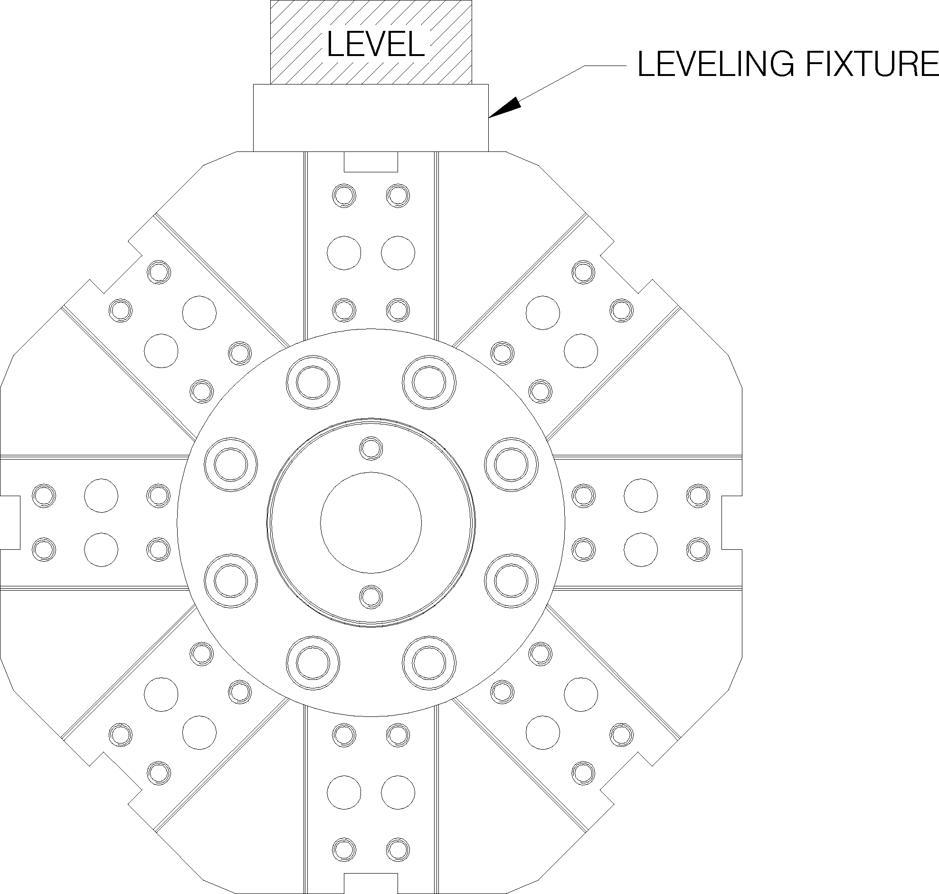spirit level graduated in 0.02/100mm per meter. Mount the Leveling fixture on the Turret by bolting the fixture on the Turret. Place the precision level on the Leveling fixture (as shown in fig.).

Make sure that the foundation bolts and leveling plates are set hard in the concrete, place the machine on to leveling plates, such that the leveling screws sit on the counter bores of the plates. There for outer leveling

screws are adjusted for obtaining acceptable longitudinal level. The inner screws are adjusted for transverse level of convexity Refer to the test chart for acceptable values of leveling, which is 0.04mm/meter. Tighten all the foundation bolts and lock the leveling screw check nuts without disturbing the level.

It is advisable to recheck and adjust the level, if necessary after running the main spindle at medium speeds for about 2 hours during commissioning. Fill the gap between the base and ground with cement grout. the leveling bolts in the motor support base, power pack and electrical cabinet should firmly press against the floor to reduce the vibration if any and to support the weight evenly Leave for about 24 to 30 hours after the final grouting. Recheck the level before operating. Also, check the level periodically.

###### IMPORTANT

INCORRECT LEVELING WILL STRAIN THE MAIN SPINDLE AND CAUSE UNEVEN WEAR ON THE BED GUIDE WAYS. IT WILL ALSO RESULT IN VIBRATION AT HIGHER FEEDS AND SPEEDS, WHICH MIGHT IMPAIR THE ACCURACY OF THE MACHINE.

Procedure for Installation G2CH0200101A Page- 2.1.12 of 13

**Preparation of the Machine and other Equipments**:

###### Mechanical:

After positioning and leveling the machine, as per the above instructions, prepare the machine for commissioning. Mount the CNC system in the operator control station if it was sent in dismantled condition. Place the chip conveyor, bar feeding mechanism or any other auxiliary equipment in their respective position as per the equipment requirement. Ensure that the chip conveyor is in level such that there is a free flow of coolant to the integral coolant tank by means of the height adjustment screws.

###### Hydraulic:

Hydraulic oil tank with an integrated power unit is mounted at rear of the machine on a suitable frame. Controls are kept near elements.

Check all the hydraulic lines for tightness and if some hydraulic hoses to accessories are disconnected, reconnect them as per circuit.

A list of approved oils is given in the hydraulic system manual and all necessary information on installation and commission are also given. Read the safety precautions, functional description and operation before attempting to undertake any adjustment.

Connect power plug of the hydraulic motor pump.

###### Coolant:

The coolant system consists either of a coolant tank and pump units with the coolant returned from the chip tray or an integrated system built in to the chip conveyor.

Read the coolant system manual for correct installation and commissioning. Keep the coolant filled and ready for operation. Connect coolant pump motor power plug and flow sensor connector.

Procedure for Installation G2CH0200101A Page- 2.1.13 of 13

Procedure for Installation G2CH0200200A Page-2.2.1 of 10

#### Electrical Equipments.

12:03:47 PMCreated on 5/15/2008 12:40:00 PMConfidential Page 1 4/3/2018G2CH0200200A PROCEDURE FOR INSTALLATION.docLast printed 4/3/2018 12:03:00 PM

* Take the power supply line and earthling connection from main distribution of shop and earth pit respectively which should be 60KVA max.The rating of the switch at the distribution board should be 50Amps. For this refer the drawings.
* Power supply should be with neutral of same three phase supply or isolation transformer not from single phase lightning supply.
* Power supply up to machine will rout through Main switch fuse unit (SFU) and servo voltage stabilizer and isolation transformer.
* Before putting SFU check the rating of Fuse links as per power supply drawing and mechanical working of the same for smooth ON/OFF operations.
* Connect all three phases and natural from distribution to SFU and check make and break of Power
* In power OFF condition take out put of SFU to voltage stabilizer and connect all four connections with proper wire terminals and tools and other required accessories.
* Switch on the SFU and check the input supply of stabilizer and confirm with input range of the same.
* Connect earthing also to stabilizer at proper place.
* Check the all meters, main s/w, selector switches, Indicators and push buttons etc of stabilizer.
* Set the out put of stabilizer in between 400V to 420V by following up the procedure of output voltage setting given in its manual. *(If the stabilizer is to be used for 220V, set an output range 200V~230V)*
* In power OFF condition take the output of voltage stabilizer to main panel and connect all four connections with earthing with proper wire terminals and tools and other required accessories.
* Use 25mmsq. 4 core flexible copper cable for main supply.

Procedure for Installation G2CH0200200A Page-2.2.2 of 10

**Specifications and Essential characteristics of Electrical Power equipment for trouble free operation of the machine & the control System**

12:03:47 PMCreated on 5/15/2008 12:40:00 PMConfidential Page 2 4/3/2018G2CH0200200A PROCEDURE FOR INSTALLATION.docLast printed 4/3/2018 12:03:00 PM

* + The voltage should be 415V (+10%,-5%) from a balanced 3-phase Power supply. (*Pl. consider voltage 200V for US & CANADA)*
  + The frequency should be 50Hz *(60Hz for US & CANADA)*
  + The Voltage regulation should be +/-1% from no load to full load(While maintaining condition 1)
  + The spikes, surges and noise distortion should be minimum. These are the main source for erratic behavior of electric equipment and there by of CNC machines. The switching of electrical utilities should be away from the machine.
  + Separate earth should be connected for the machine.
  + No fluctuating loads like induction hardening, welding equipment or power press should be connected to the power line supplying power to the CNC machines.
  + Power supply change over is not permitted when machine is running.
  + In case of generator power supplies, all the above conditions should be satisfied for trouble free operation.
  + Machine should not be connected to power lines with voltage boosters.

**Check - List Table A; Prior to switching ON the machine:**

12:03:47 PMCreated on 5/15/2008 12:40:00 PMConfidential Page 3 4/3/2018G2CH0200200A PROCEDURE FOR INSTALLATION.docLast printed 4/3/2018 12:03:00 PM

* + Is the machine received with all the accessories and entire set of manuals?
  + Are all the circuit diagrams relevant to the machine supplied?
  + Is logbook maintained for the day-to-day work and the progress of the machine?
  + Have the serial Numbers of the drive system and other units been noted down?
  + Are the values of the fuses same as those indicated in the drawing?
  + Are all the ferrules fitted as per the drawing?
  + Are all the wires used are of the correct gauge size, as per the drawing?
  + Are all the wires used of the correct color coding?
  + Are all the wires in the electrical cabinet, junction boxes, motors, earthing strip and other units tightened properly?
  + Do all wires of the electrical motors have the cable lugs?
  + Do all the wires on the earthing strip have the cable lugs?
  + Are all the wires connected to the terminals as required in the drawing?
  + Do all the terminals have the terminal markers?
  + Do all the terminals on the terminal rails in the proper sequence?
  + Are all the screws inside and outside of the solenoid plug tightened?
  + Are all overload relays set for the proper values as required?
  + Are all blowers and tube lamps in the machine working properly?
  + Is there any oil leakage, and, is oil falling in any terminal box?
  + Is the battery backup ok?
  + Are the values of the backlash and lead-screw compensation entered properly in the log book?
  + Are all the machine parameters noted down in the log book?

Procedure for Installation G2CH0200200A Page-2.2.3 of 10

Procedure for Installation G2CH0200200A Page-2.2.4 of 10

* + Does the temperature go beyond 35°C inside the electrical cabinet during 48 hours running of the machine?

12:03:47 PMCreated on 5/15/2008 12:40:00 PMConfidential Page 4 4/3/2018G2CH0200200A PROCEDURE FOR INSTALLATION.docLast printed 4/3/2018 12:03:00 PM

* + Are all conduits tight at joints?
  + Are the screens displays confirm to standard formats and are the display without any flickering?
  + Are all the acceleration/deceleration times, and axis motors proper?

#### COMMISSIONING

12:03:47 PMCreated on 5/15/2008 12:40:00 PMConfidential Page 5 4/3/2018G2CH0200200A PROCEDURE FOR INSTALLATION.docLast printed 4/3/2018 12:03:00 PM

###### First time Machine ON procedure

* Switch on main switch ON main panel and wait for complete booting of the CNC system. Don’t operate or push and PB of OP or MCP in between, which may lose the data of system.
* At the first time power ON of the machine and starting of machine functions check following the points before pushing of MACHINE ON PB.
  1. Connect external feedback switches and other devices.
  2. Check and fill hydraulic, lubrication oil and coolant and pneumatic supply etc.
  3. Release emergency actuator & push the MACHINE ON PB
  4. For Pneumatic System, check the pressure at pressure dials at pneumatic panel of machine at different pressure settings.
  5. For Coolant Systems, check flow and pressure of coolant at every outlets. Reveres movement of coolant motor can deliver low pressure or flow of coolant in that case change the phase sequence at main input that may correct all motor’s phase sequence.
  6. For Lubrication System, check the lubrication pressure at dial. Initially press the LUB ON PB frequently to reach the lubrication at every outlet and clear the air from each pipe.
  7. Set the pressure for proper lubrication at every outlet. Check the PLC alarm “LUBRICATION PRESSURE FAILED OR LEVEL LOW” and clear the alarm by filling the Oil or setting the pressure switch.
  8. For Chip removal (conveyor) System, check the direction of screw through CHIP FWD PB, CHIP RVS PB and CHIP OFF PB.
  9. Check the functioning of overload limit switch by manual pressing and at press condition conveyor should be stop and PLC alarm “CHIP CONVEYOR MOTOTR OVER LOADED”.

The commissioning procedure for the machine requires the receipt of the complete machine and accessories intact at the customer's site and after installation as described in section.

The procedure mainly is to power on the devices one at a time and ensure the correct working before operating the machine as a system.

Procedure for Installation G2CH0200200A Page-2.2.5 of 10

Procedure for Installation G2CH0200200A Page-2.2.6 of 10

Checklist Table - A to be followed to ensure that the machine is ready for commissioning. It should be verified before switching on off power to the machine.

12:03:47 PMCreated on 5/15/2008 12:40:00 PMConfidential Page 6 4/3/2018G2CH0200200A PROCEDURE FOR INSTALLATION.docLast printed 4/3/2018 12:03:00 PM

After completing the above checklist a further checklist for the activities during the commissioning is given in the table B

When all these activities are over, the machine can be handed over to the manufacturing department for the work pieces.

**Table B: Check List during commissioning of the Machine.**

12:03:47 PMCreated on 5/15/2008 12:40:00 PMConfidential Page 7 4/3/2018G2CH0200200A PROCEDURE FOR INSTALLATION.docLast printed 4/3/2018 12:03:00 PM

* + Are the voltages at the secondary of the control transformer as per drawing?
  + Are the supply voltages of the spindle drive, axis drive, CNO system and solenoids of proper value?
  + Is the direction of the rotation of the hydraulic pump motor correct?
  + Is AC motor running in correct direction?
  + Is the emergency push button functioning ok?
  + Are all other emergency condition and the limits functioning effectively?
  + Are all lubrication system functioning ok?
  + Do all the spindles and axis motor remain in close loop without running away?
  + Are all motors and drives controlled by the CNC system properly?
  + Is the homing of each axis performed correctly?
  + Are all software limits active as required?
  + Are all the proximity switches properly set?
  + Are all interlocks functioning as required in the list of interlocks?
  + Is the clamp unclamp function in-effective during spindle running?
  + Are x, y & z axes working correctly in either direction in both manual and automatic modes?
  + Have all faults and warning massages been checked for occurring at the proper time as given in the manual?
  + Are all the fuses, contactors, overload relays, transformers, motors, proximity switches, solenoids, limit switches, suppression networks, etc. marked as per the drawing?
  + Are all the PCBs in the proper slots?
  + Have all the fixing screws of the PCBs been tightened properly?
  + Are all the motors properly earthed?
  + Is a list of I/Os tagged inside the electrical cabinet?
  + Is a set of electrical circuit drawings available inside the cabinet?

Procedure for Installation G2CH0200200A Page-2.2.7 of 10

Procedure for Installation G2CH0200200A Page-2.2.8 of 10

* + Is the shield of the multi-core cables/STP wires grounded only at one point?

12:03:47 PMCreated on 5/15/2008 12:40:00 PMConfidential Page 8 4/3/2018G2CH0200200A PROCEDURE FOR INSTALLATION.docLast printed 4/3/2018 12:03:00 PM

* + Are all the cabinets lockable, and are they dust-proof with the proper ventilation?
  + Is the 3-phase input supply as per the requirement of the machine?
  + Are all the wire routed through the PVC raceways arrange in proper manner?
  + Are the proper filters fitted on air inlet side of the electrical cabinets?
  + Check oil levels of lubrication pump.

Procedure for Installation G2CH0200200A Page-2.2.9 of 10

###### Checking the all three axis, spindle & ATC movement and hardware limit in both directions.

12:03:47 PMCreated on 5/15/2008 12:40:00 PMConfidential Page 9 4/3/2018G2CH0200200A PROCEDURE FOR INSTALLATION.docLast printed 4/3/2018 12:03:00 PM

* + At the time of axes movement checking be ensure that all axis is in middle position and quill should be at IN position.
  + Check the X-axis movement in both direction with slow speed (With 10% over ride) and move up to hardware limit hits.
  + Check the Y-axis movement in both direction with slow speed
  + With 10% over ride) and move up to hardware limit hits. Check the Z-axis movement in both direction with slow speed (With 10% over ride) and move up to hardware limit hits.
  + Check the jerk and sound in movement. If any of these are there then, pl. check and clear for jamming any movable guards and/or chains or call to machine supplier or manufacturer.
  + Check the spindle movement in both direction with slow speed (With 10% over ride) and check the feed back and direction rotation on spindle screen.
  + Check the ATC indexing by ATC Jog.

###### Checking the referencing of the machine and software limit check.

* + Switch over the machine in Reference Mode from Jog mode and check the referenced symbol in front of all three axes and ATC.
  + After checking of reference move all three axes in both direction and check the software limits activation.
  + Software limit should come before (7 to 10mm) hardware limit in both directions of both axis and it activate after referencing only, machine is equipped with EnDAT type liner scale so referencing is not req. after every power ON.

Foundation details C2CH0300102A Page 3.1.1 of 3

# Foundation details 3

List of contents

1. **Foundation details**

1 Lifting diagram …………………...……………………. 3.1.3

2 Layout …………… …………….. …………………….. 3.2.1

3 Foundation plan ……………………….………………. 3.3.1

1. Foundation pocket detail ………………..…………….. 3.4.1
2. Preparation of Electrical for Machine…………………. 3.5.1

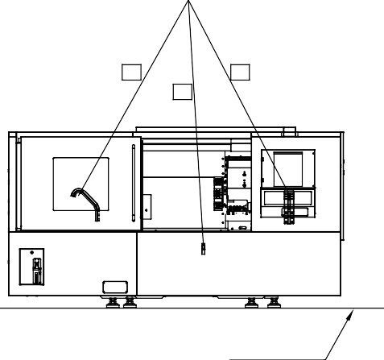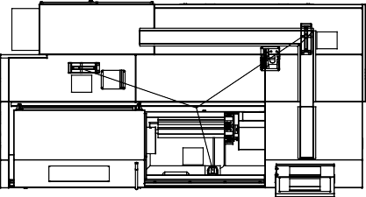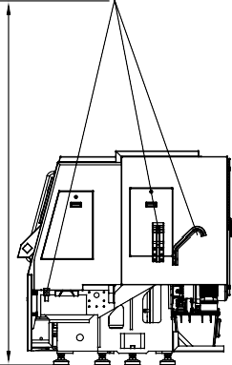

F

ound

at

i o

n

d et

ai

l s

C 2C

H 0300

1

0

2

A

P

a ge

3.

1.

3

of

3

**Lifting diagram**

LIFTING POINT

|  |  |  |  |  |  |  |  |  |  |  |  |  |  |  |  |  |  |  |  |
| --- | --- | --- | --- | --- | --- | --- | --- | --- | --- | --- | --- | --- | --- | --- | --- | --- | --- | --- | --- |
| A | | B | C | D | E | | F | | | | G | | | | H | | | | |
| 6 | NOTE-:  AT THE TIME OF LIFTING  -REMOVE CHIPTRAY/CHIPCONVEYOR.  -SURFACE SHOULD BE IN LOWER MOST POSITION (X-AXIS).  -SADDLE(Z-AXIS) SHOULD BE LOCKED FROM BEHIND AT GIVEN LOCATION  -DOOR SHOULD BE LOCKED IN OPEN POSITION.  3 -TAILSTOCK SHOULD BE AT THE END POSITION (RIGHT HAND SIDE).  -REMOVE TOOL HOLDERS NEAR ROPE. (250-700,350-700)  1  ROPE LENGTH (APPROX.) FOR DX250-700/1000 LIFTING POINT HIGHT 3200 MM FORM FLOOR LEVEL  2 1). 2300 MM  2). 2640 MM  3). 2360 MM  WEIGHT (Approx.)=5750 KG  ROPE LENGTH (APPROX.) FOR DX350-700/1000 LIFTING POINT HIGHT 3420 MM FORM FLOOR LEVEL  1 3 1). 2450 MM  2 2). 2860 MM  3). 2600 MM  WEIGHT (Approx.)=6500 KG  FLOOR LEVEL | | | | | | | | | | | | | | | | | | 6 |
| 5 | 5 |
| 4 | 4 |
| 3 | 3 |
| 2 | 2 |
| NOTE :- * ALL DIMENSION ARE IN MM * DO NOT SCALE THE DRAWING *  ALL SHARP EDGES SHOULD BE REMOVED *  WHERE NOT SPECIFIED FILLET CORNER RADIUS R3;R5 * | | | | | *TITLE:* | | | | | |  |  | | |  |  |  |
| LIFTING DIAGRAM  DX-250/350 & TMC-250/350 | | | | | |  |  | | |  |  |  |
| 1 |  |  | | |  |  |  | 1 |
|  |  | | |  |  |  |
| 1 | LAYOUT UPDATED | | | - | PARTHJ | 4-Apr-21 |
| *MODEL:* | |  | | | | No. | ALTERATION | | | AREA | SIGN | DATE |
| *DRAWING:* | |  | | | |  | | DESIGN | | DILIP V | | 18-Jul-08 |
| *WEIGHT Kg.* | | *MATERIAL* | | *MODEL NAME* | | CHECKED | | DILIP V | | 4-Apr-21 |
|  | |  | |  | | APPD. | | VIJAY Z | | 4-Apr-21 |
| *SCALE* | | *SHEET* | *VERSION* | *DRAWING No.* | | G-506, GIDC-LODHIKA, METODA-RAJKOT (INDIA) | | | | | | |
|  | | 01 OF 01 | 02 | C20011100 | |
| A | | B | C | D | E | | F | | | | G | | | | H | | | | |



Assembly details C2CH0300202C Page6.5.1of2

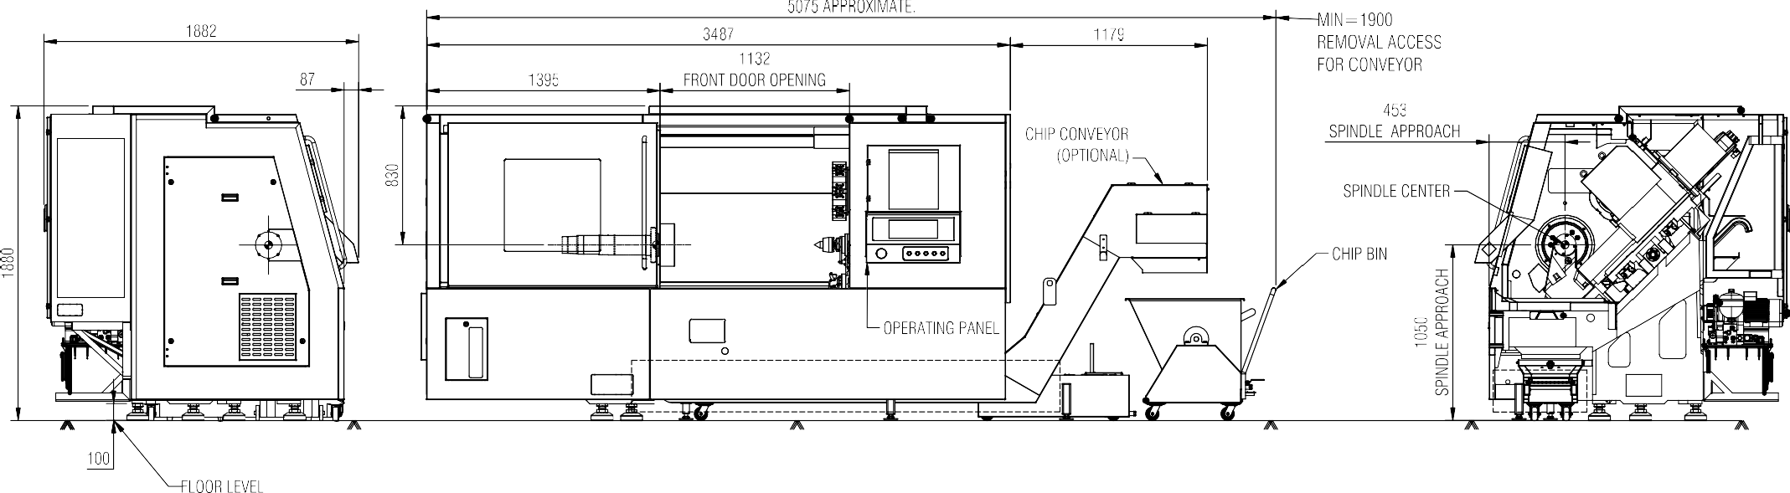

Machine layout

|  |  |  |  |  |  |  |  |  |  |  |  |  |  |  |  |  |  |  |  |
| --- | --- | --- | --- | --- | --- | --- | --- | --- | --- | --- | --- | --- | --- | --- | --- | --- | --- | --- | --- |
|  | |  |  |  |  | |  | | | |  | | | |  | | | | |
|  |  | | | | | | | | | | | | | | | | | |  |
|  |  |
|  |  |
|  |  |
|  |  |
|  | | | | |  | | | | | |  |  | | |  |  |  |
|  |  | | |  |  |  |
|  |  |  | | |  |  |  |  |
|  |  | | |  |  |  |
|  |  | | |  |  |  |
|  | | | | | |  |  | | |  |  |  |
|  | | | | | |  | |  | |  | |  |
|  | |  | |  | |  | |  | |  |
|  | |  | |  |
|  | |  |  |  | |  | | | | | | |
|  | |  |  |  |  | |  | | | |  | | | |  | | | | |



Assembly details C2CH0300202C

Page6.5.2of2

Machine layout With Respect To Foundation Holes

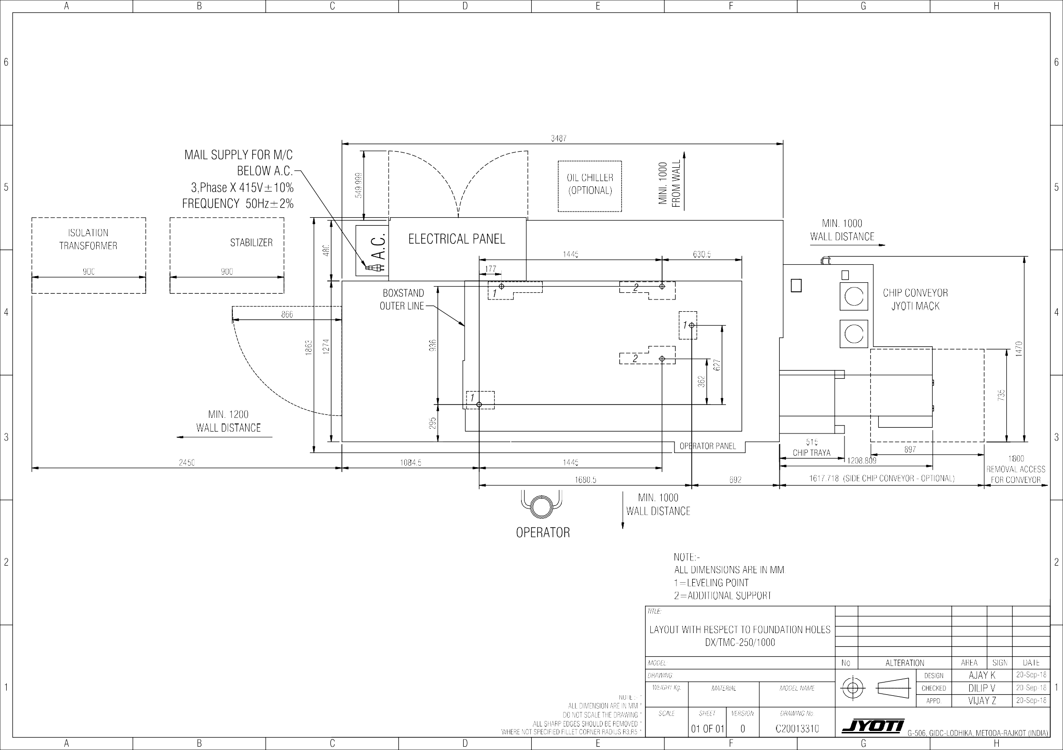



Foundation details C2CH0300300B Page 3.3.1 of 1

Foundation detail:

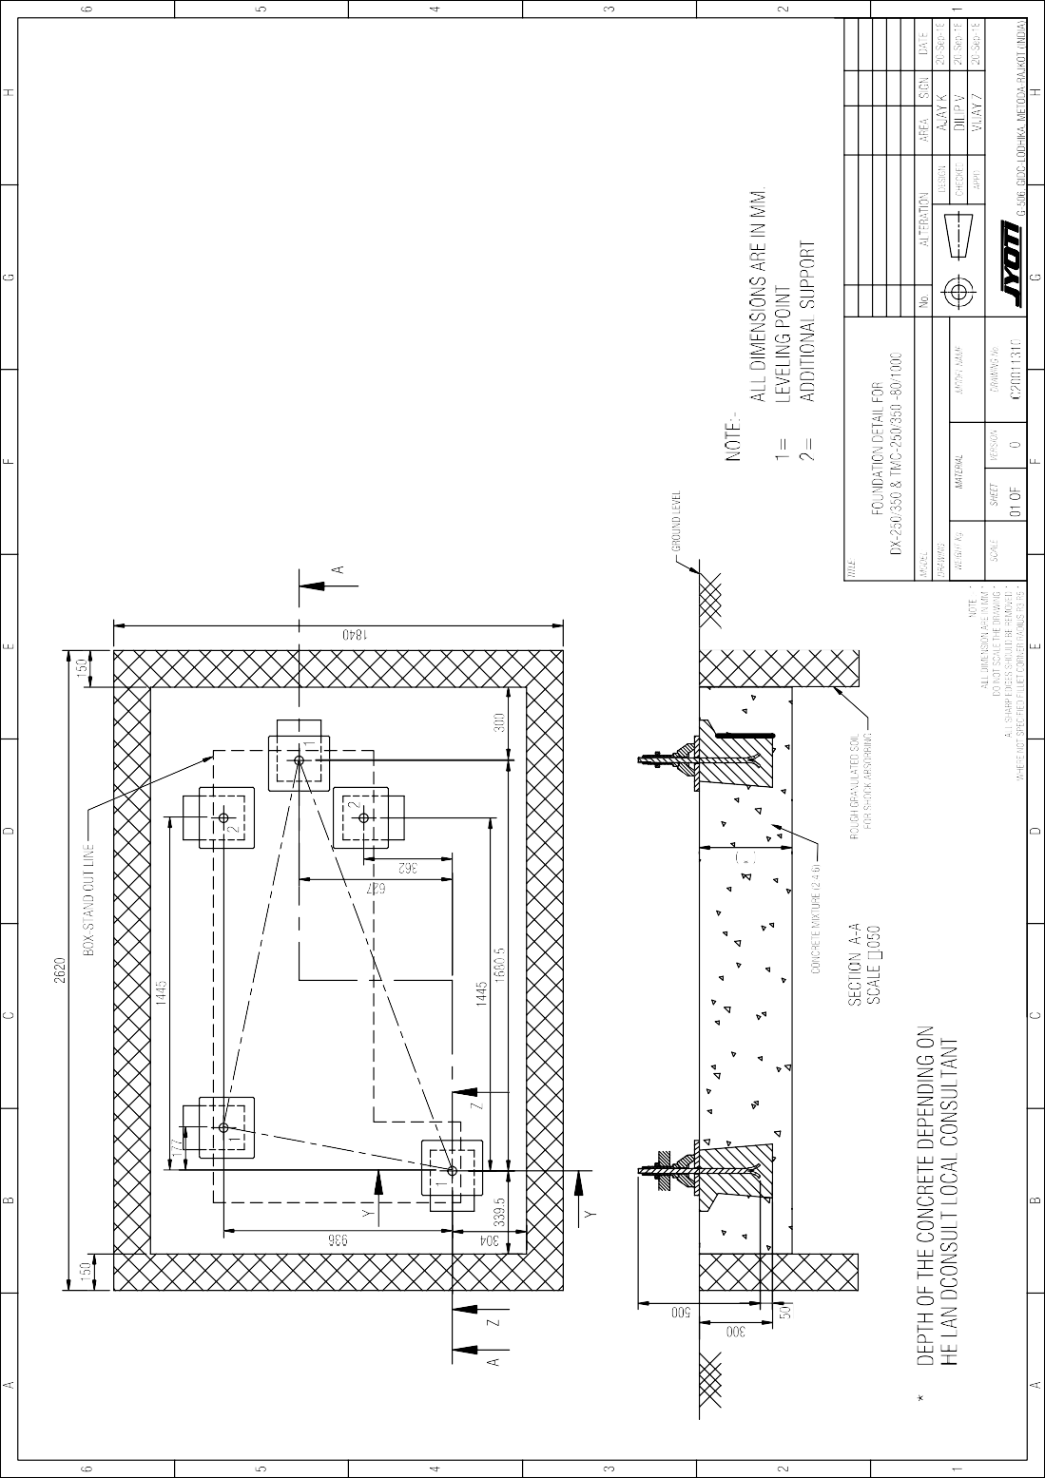

Foundation details C2CH0300401B Page3.4.1of1

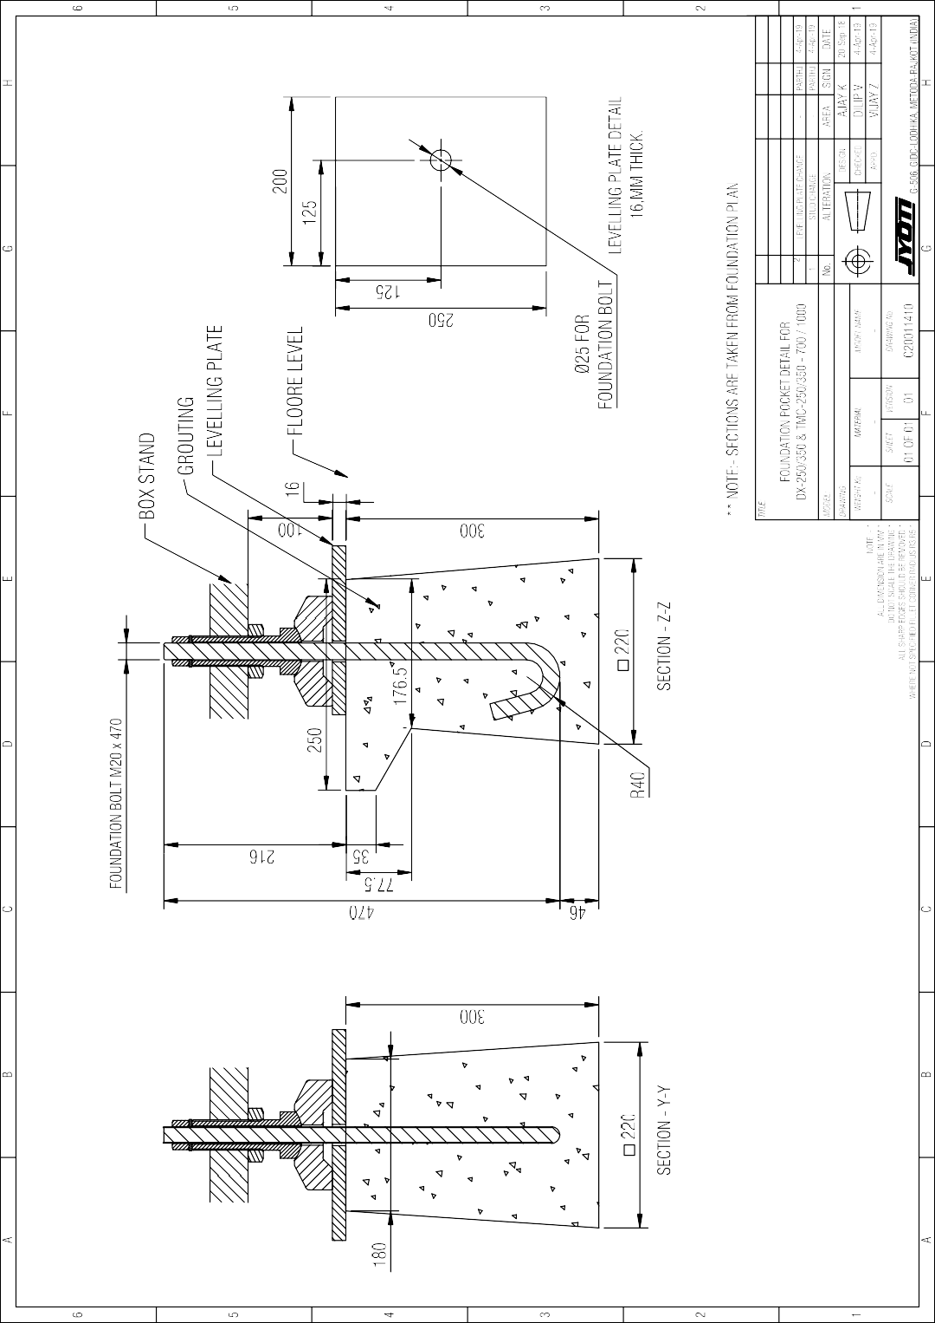Foundation pocket detail:



Foundation details V5CH0300503A Page 3.5.1 of 1

#### Incoming Power Supply Detail:

**Refer Drawing No. GA_DRG_05**

00 01

02 03 04

05 06 07 08

09 10 11

12 13

14 15

16 17 18

19 20 21 22

23 24 25

26 27

28 29

30 31 32

33 34

35 36

37 38 39

40 41

PROVISION FOR WATER INLET

(USE 25MM PVC PIPE)

OPEN COPPER STRIP

TO

##### COPPER TERMINAL STRIP

**SPECIFICATIONS AND GENERAL INSTRUCTIONS:**

COPPER STRIP IS OF 25MM x 4MM WITH FULL LENGTH FROM EARTH PIT TO MACHINE WITHOUT JOINTS COPPER PLATE SHOULD BE 300MM x 300MM x 5MM

EARTH PIT SHOULD BE 1.5mtr x 1.5mtr x 1.5mtr

25MMx4MM

ISOLATION TRANSFORMER/ VOLTAGE STABILIZER

TO

TO OTHER

TO EXTERNAL MAIN SWITCH EARTH TERMINAL(SFU

OR MPCB)

COPPER TERMNIAL STRIP/COPPER BUS BAR SHOULD BE ENOUGH STRONG TO CONNECT 4 EARTHING TERMINATIONS OR MORE (PREFERABLE 100A OR MORE CURRENT CAPACITY)

PUT A PVC PIPE OF Ø25MM WITH SIDE HOLES AT EACH LAYER FOR WATER POURING PROVISION AND POUR ENOUGH WATER AT EVERY 15 DAYS

MACHINE

BODY TO

EARTHING STRIP

FILL/MIX ENOUGH WATER WHILE MAKING OF EACH LAYER

WET SOIL LAYER-5 WOODEN COAL LAYER-4

MACHINE ELECTRICAL CABINET

FIX UP THE COPPER STRIP ON WALL WITH PROPER INSULATOR, AND NOT LAY DOWN ON FLOOR CONNECT MAXIMUM TWO CNC MACHINES WITH TYPE OF EARTHING PROVISION

ANY OTHER EXISTING LIVE AND HEALTHY CONNECTIONS(S) CAN BE JOIN WITH NEW EARTHING FOR MACHINE EARTHING FOR NEW EARTHING, CHEMICAL BASED EARTHING IS PREFERABLE WHICH IS LONG LIFE AND MAINTENANCE FREE

RAW SALT LAYER-3

WOODEN COAL LAYER-2

COPPER PLATE LAYER-1

EARTH PLATE

##### EARTH PIT

**BASIC FEATURES**

1. Input Range : Region wise

##### SERVO VOLTAGE STABILIZER SPECIFICATIONS

**MINIMUM PROTECTION FEATURES**

OPEN COPPER WIRE 4/5MM DIA.

EARTH PLATE

COPPER STRIP

OPEN COPPER WIRE 4/5MM DIA.

Voltage Frequency Wire

1. 380-460VAC 3Ø a) 50Hz a) 3-Wire System
2. 200-230VAC 3Ø b) 60Hz b) 4-Wire System
3. Ouput : Region Wise a) 415V (+ / - 1%)

b) 400V (+ / - 1%)

c) 220V (+ / - 1%)

1. Power correction speed :More than 80V/sec, unbalance
2. Efficiency :98% or more
3. Voltage correcton by AC servo Motors
4. Cooling :Nature Air cooled up to 80KVA and Oil cooled for higher rating
5. Input & Output cable entry with cable gland with clear marking.
6. Separate Earthing terminal, not only through body.
7. Completely enclosed body with air ventilation, lifting bolts & caster wheels
8. Microprocessor based control is preferable.
9. Under over voltage protection, Supply cut off with time delay.
10. Over load protection by MCCB with 30kA braking capacity.
11. Power cut off contactor with reset PB to avoid auto start.
12. Input/output voltage and current monitoring display (Digital/Analog) with phase selector switch/buttons.
13. Audio visual alarm for Under/over voltage and over load indication.
14. Manual Bypass facility for maintenance.
15. Spike arrestor at input side is preferable.

1 2



CONNECTION DETAILS FOR EARTH PLATE

MODEL NAME TITLE : CUSTOMER GA DRAWING

Created by

KirtidaD

00001

Created on

09-06-2012

GA_DRG

2

|  |  |  |  |  |  |  |  |  |  |  |  |  |  |  |  |  |  |  |  |  |  |  |  |  |  |  |  |  |  |  |  |  |  |  |  |  |  |  |  |  |  |  |  |  |  |  |  |  |  |  |  |  |  |
| --- | --- | --- | --- | --- | --- | --- | --- | --- | --- | --- | --- | --- | --- | --- | --- | --- | --- | --- | --- | --- | --- | --- | --- | --- | --- | --- | --- | --- | --- | --- | --- | --- | --- | --- | --- | --- | --- | --- | --- | --- | --- | --- | --- | --- | --- | --- | --- | --- | --- | --- | --- | --- | --- |
| 00 | 01 | | 02 | 03 | 04 | 05 | | 06 | 07 | 08 | 09 | | 10 | 11 | 12 | 13 | | 14 | 15 | 16 | 17 | | 18 | 19 | 20 | 21 | | 22 | 23 | 24 | 25 | | 26 | 27 | 28 | 29 | | 30 | 31 | | 32 | 33 | | 34 | 35 | 36 | 37 | | 38 | 39 | 40 | 41 | |
|  | |  | | | | |  | | | | |  | | | | |  | | | | |  | | | | |  | | | | |  | | | | |  | | | | | |  | | | | |  | | | | |  |
|  | |  | | | | |  | | | | |  | | | | |  | | | | |  | | | | |  | | | | |  | | | | |  | | | | | |  | | | | |  | | | | |  |
| N N BK N BK  E E Y/G E Y/G   1. R BK R BK 2. S BK S BK 3. T BK T BK   SVS  U1 V1 W1 PE N U2 V2 W2 PE N  BK BK BK Y/G BK  R S T E N  E  U1 V1 W1   1. ISOLATION TRANSFORMER OR SERVO VOLTAGE STABILIZER IS STRICTLY IT   RECOMMANDED FOR INPUT SUPPLY OF MACHINE, WHICH SHOULD BE  PROTECTED BY SFU OR MCCB U2 V2 W2   1. FOR WIRES/CABLE SIZE CONSERN WITH ELECTRICAL PERSON   N   1. AVOID ANY JOINT & LOOPING IN MAIN POWER SUPPLY & IN EARTHING LINE 2. ALL WIRES/CABLES SHOULD BE JOINT WITH COPPER FASTENERS & LUGS.   BK BK BK Y/G BK   1. ALL WIRES/CABLES SHOULD BE LAYED WITH METAL OR HIGH QUALITY PVC R S T E N   CONDUIT.   1. SEPARATE EARTHING FOR A MACHINE IS PREFERABLE   L1 L2 L3 E N  6. ALL WIRES SHOULD BE FLEXIBLE COPPER  TO MACHINE MAINS SUPPLY TERMINAL BLOCK  FOR SIZE OF SVS OR ISO X'MER, PLEASE CONSERN MTB....... | | | | | | | | | | | | | | | | | | | | | | | | | | | | | | | | | | | | | | | | | | | | | | | | | | | | | |
|  | | | | | | | | | | | | MODEL NAME | | | | TITLE : CUSTOMER SUPPLY PREPARATION | | | | | | | | | | | | | | | | | | | | | | | | 00002 | | | | | Created by  KirtidaD | | | | GA_DRG | | | | |
|  | | | | Created on  21-07-2012 | | | |
| 2 | | | | |



Description of the machine C2CH0400101A Page 4.1.1 of 6



# Descråptåon of the machåne

4

List of contents

#### 4. Description of the machine

1 Technical data …………………………………………….. 4.1.3

1. General description of machine …………………………. 4.1.4
2. Description of CNC System ……………………………… 4.2.1

4 Power torque diagram ……………………………………. 4.3.1

Description of the machine C2CH0400101A Page 4.1.3 of 6



|  |  |  |  |
| --- | --- | --- | --- |
| **Technical data:** |  | | |
|  |  | **DX-250** | **TMC-250** |
| Swing over bed | mm | 600 | 600 |
| Standard Turning Dia. | mm | 300 | 300 |
| Maximum Turning Dia. | mm | 480 | 480 |
| Maximum Turning Length | mm | 700 / 1000 | 700/1000 |
| **Slides**  Cross (X-axis) Travel | mm | 250 | 250 |
| Longitudinal (Z-axis) Travel | mm | 700 / 1000 | 700/1000 |
| Rapid Feed ( X & Z axis) | m/min | 24 | 24 |
| **Main spindle**  Spindle Motor Power(Fanuc) | kW | 15/11 | 15/11 |
| Spindle Motor Power(Siemens) | kW | 18/12 | 18/12 |
| Spindle Bore  Spindle Nose Max. Bar Capacity | mm  mm | 80  A28 65 | 80  A28 65 |
| Speed Range | rpm | 50-2500 | 50-2500 |
| **Turret**  No. of stations |  | JST100 8 | LTT100 12 |
| Max. Boring Bar Dia. | mm | 40 | 40 |
| Tool Size (Cross Sectional) | mm | 25x25 | - |
| **Tail stock**  Quill diameter | mm | 100 | 100 |
| Quill stroke | mm | 120 | 120 |
| Thrust (adjustable) | Kgf. (max) | 500 | 500 |
| **Accuracy**  Positioning | mm | 0.010 | 0.010 |
| Repeatability | mm | 0.005 | 0.005 |
| **Weight** (Approx) | Kg. | 5750 / 6000 | 5750 / 6000 |
| **Dimensions** (Approx) (LxWxH) | mm | 3500x1850x1900 | 3500x1850x1900 |



**General description of Machine:**

The DX-250/DX-350 & TMC-250/350 is designed to perform a variety of machining operations such as straight, taper turning, drilling, boring, contouring with linear and circular interpolation, internal and external threading (Parallel or taper) etc. The machine is suitable for chucking and bar types of work pieces. Tail stock can be used for long shaft type work or as a support for the components with heavy external turning.

The basic structure of the machine is a computer-optimized withstands torsional loads and compressive loads with graded casting having maximum rigidity and stability. The Linear Motion guide ways are used for saddle and cross slide movements.

The head stock is rigid closed box construction without any big opening as the cartridge spindle assembly inserted in the head stock. At the rear end of the spindle, the timing pulley for the main drive and the encoder- timing pulley are directly mounted. The main spindle in DX-250/TMC-250 is driven by a 18/12 kW & in DX-350 by 27.8/18.5 kW variable speed AC servo motor through the timing belt. The rpm range of spindle for DX- 250/TMC-250 is 50-3500 with constant torque and 500-3250 with constant power. The rpm range of spindle for DX-350/TMC-350 is 50- 2500 with constant torque and 750-2500 with constant power.

The feed drive for the saddle (z-axis) and the feed drive for the cross slide (x-axis) are by AC servomotors, which are coupled with ball screw by bellow coupling. The ball screw nut and the bearings are preloaded to eliminate backlash and to improve stiffness. The standard rapid traverse rate for both Z and X-axes are 24 m/min.

The standard turret for DX-250/350 is high speed bi-directional 8-tooling stations & with wedge lock system, and for TMC-250/350 is high speed bi-directional 12 tooling station servo turret. All the 12 station can be used for either live tool holders or static tool holders.

Tailstock system with MT-5 taper and live center is provided on an auxiliary bed to increase the capability of the machine without affecting any of the standard features. The tailstock unit is adjustable on the auxiliary bed for different work piece lengths.

The lubrication of the spindle bearing is done by grease. The guide ways for both Z and X-axis along with the ball screw nut are pulse lubricated by a centralized automatic lubrication / manual greasing system.

Description of the machine C2CH0400101A Page 4.1.4 of 6

Description of the machine C2CH0400101A Page 4.1.5 of 6



#### Salient Features:

* Computer-optimized machine structure with graded casting for maximum rigidity and stability.
* Linear Motion Guide ways for saddle and cross-slide
* Saddle guide ways protected on either side by telescopic covers in additions to wipers.
* Automatic metered lubrication for guide ways and other parts requiring intermittent lubrication.
* Main spindle supported on high precision angular contact ball bearing / double row cylindrical roller bearings with built-in pre load and for-life grease lubrication.
* Programming of spindle speeds in steps of one rpm.
* Pre-loaded & pre-tensioned ball screws for longitudinal and cross drives mounted on precision bearings to avoid backlash, and to get high positioning accuracy.
* Laser calibrated axis for high positioning accuracy, and repeatability
* Bi-directional shortest path turret indexing.
* Front insertion / removal type chip tray minimizes floor space.
* Pressure gauge for chuck cylinder, tail stock and system pressure.
* Absolute encoder feedback for all AXIS.
* Controlled temp., humidity & dust free electronics

Description of the machine C2CH0400101A Page 4.1.6 of 6



#### Standard Accessories / Equipments:

* Center to suit spindle bore.
* Sliding machine cover for operator safety.
* Set of external and internal tool holders on Turret.
* Machine lighting equipment. Set of service tools in kit.
* Electrical complete with wiring suitable for standard 415 V, 50Hz, 3-phase AC supply. *(Also available 220V,60Hz,3-Phase AC supply for US & CANADA)*
* Hydraulic power pack with motor and control elements.
* Chip tray with coolant motor and pump.

#### Special Accessories / Equipment: offered optionally with the machine:

* Work holding devices – chucks, cylinders, collets etc.
* Chip conveyor with built-in coolant tank.
* Bar feeding attachment to suit different sizes of bars.
* Part ejectors and part catchers. Bar pullers mounted on turret for advancing bar stock.
* Voltage stabilizer suitable for spindle Drive, Feed Drives and CNC System.
* Work piece loading and unloading devices.
* Electrical to suit other standard power supply prevailing in other countries.

Description of the machine J8CH0400200A Page 4.2.1 of 1

**1. Description of CNC system**

Refer Controller Doc-On-CD/DVD supply along with machine. For more details, contact After Sales Department.

Foundation details C4CH0400303B Page- 4.3.1 of 1

#### P-T DIAGRAM:

**SEE THE ATTACHED DRAWING:**

C20014400_PT_11KW_2500RPM_BiI12(1-2)Ver01 C40013200_PT_15KW_2500ROM_BiI15(1-2), C40015100_PT_15KW_2500ROM_BiI15(1-2)-GB, C40013100_PT_15KW_2500ROM_BiIP30(1-2), C40011600_PT_18.5KW_2500RPM_Ai18(1-2), C40014900_PT_18.5KW_2500RPM_Ai18(1-2)-GB C20018000_PT_11KW_35000RPM_BiIP22(1-2)

|  |  |  |  |  |  |  |  |  |  |  |  |  |
| --- | --- | --- | --- | --- | --- | --- | --- | --- | --- | --- | --- | --- |
|  |  |  |  | 1000 RPM | | 2500 RPM | | |  |  | | |
|  | 50 RPM |  |  | 750 RPM | | 1750 RPM 3500 RPM | | |  |  | | |
|  |  |  |  |  | |  | | | 191 N.m |  | | |
|  |  |  |  |  | |  | | | 105 N.m |  | | |
|  |  |  |  |  | |  | | | 47.8 N.m |  | | |
|  |  |  |  |  | |  | | | 36.2 N.m |  | | |
|  |  |  |  |  | |  | | | 24.6 N.m |  | | |
|  |  |  |  |  | |  | | | 20.4 N.m |  | | |
| 15KW |  |  |  |  | |  | | |  |  | | |
| 11kW |  |  |  |  | |  | | |  |  | | |
| 1kW |  |  |  |  | |  | | |  |  | | |
| 0.5kW |  |  |  |  | |  | | |  |  | | |
|  |  |  |  |  | |  | | |  | Power S2-15Minutes | | |
|  |  |  |  |  | |  | | |  | Power S1 | | |
|  |  |  |  |  | |  | | |  | Torque S2-15Minutes | | |
|  |  |  |  |  | |  | | |  | Torque S1 | | |
| NOTE:  SPINDLE A2_6 (MAX. 3500 RPM) A2_8 (MAX. 2500 RPM) | *TITLE:* | | | |  | |  | | |  |  |  |
| **P-T DIAGRAM 11KW 2500RPM BiI12 (1:2 Pulley ratio)** | | | |  | |  | | |  |  |  |
|  | |  | | |  |  |  |
|  | |  | | |  |  |  |
| MODEL: | - | | | No. | | ALTERATION | | | AREA | SIGN | DATE |
| DRAWING: | - | | |  | | | DESIGN | | Abhijeet J | | 18-Jan-14 |
| WEIGHT Kg. | MATERIAL | | MODEL NAME | CHECKED | | Kirti D | | 18-Jan-14 |
| - | - | |  | APPD | | Vijay Z | | 18-Jan-14 |
| SCALE: | SHEET | VERSION | DRAWING NO. | G-506, GIDC-LODHIKA,METODA-RAJKOT (INDIA) | | | | | | | |
| 1:1 | 01 OF 02 | 01 | C20014400 |

|  |  |  |  |  |  |  |  |  |  |  |
| --- | --- | --- | --- | --- | --- | --- | --- | --- | --- | --- |
| 1500 RPM 3500 RPM  375 RPM  50 RPM 500 RPM 2500 RPM  382 N.m  210 N.m  38.2 N.m  28.6 N.m  15KW 13.6 N.m  11kW  7.4 N.m  5kW  2.7kW  2kW  1.1kW  Power S2-15Minutes Power S1  Torque S2-15Minutes Torque S1 | | | | | | | | | | |
|  | *TITLE:* | | | |  |  | |  |  |  |
| **P-T DIAGRAM 11KW 3500RPM BiIP22(1:2 Pulley ratio)** | | | |  |  | |  |  |  |
|  |  | |  |  |  |
|  |  | |  |  | |
| MODEL: | - | | | No. | ALTERATION | | AREA | SIGN | DATE |
| DRAWING: | - | | |  | | DESIGN | Abhijeet J | | 24-Dec-18 |
| WEIGHT Kg. | MATERIAL | | MODEL NAME | CHECKED |  | |  |
| - | - | |  | APPD | Vijay Z | | 24-Dec-18 |
| SCALE: | SHEET | VERSION | DRAWING NO. | G-506, GIDC-LODHIKA,METODA-RAJKOT (INDIA) | | | | | |
| 1:1 | 01 OF 01 | 00 | C20018000 |

|  |  |  |  |  |  |  |  |  |  |  |
| --- | --- | --- | --- | --- | --- | --- | --- | --- | --- | --- |
| 22kW  18.5kW  1.5kW  1.2kW | 50 RPM |  |  | 750 RPM | 1500 RPM  2500 RPM | | 280.2 N.m  235.4 N.m  140.2 N.m  117.8 N.m  84 N.m  70.6 N.m  Power S2-30Minutes Power S1  Torque S2-30Minutes Torque S1 | | |  |
|  | *TITLE:* | | | |  |  | |  |  |  |
|  |  | | | |  |  | |  |  |  |
|  | **P-T DIAGRAM 18.5KW Ai18(1:2 Pulley ratio)** | | | |  |  | |  |  |  |
|  |  | | | |  |  | |  |  |  |
|  | MODEL: | - | | | No. | ALTERATION | | AREA | SIGN | DATE |
| NOTE: | DRAWING: | - | | |  | | DESIGN | Abhijeet J | | 18-Jan-14 |
| SPINDLE- | WEIGHT Kg. | MATERIAL | | MODEL NAME | CHECKED |  | |  |
| A2_8 (MAX. 2500,RPM) | - | - | | - | APPD | Vijay Z | | 18-Jan-14 |
| A2_11 (MAX. 1500,RPM) | SCALE: | SHEET | VERSION | DRAWING NO. |  | | | | | |
| SB140 (MAX. 1000,RPM) |  | | | | | |
| 1:1 | 01 OF 02 | 01 | C40011600 |
|  | G-506, GIDC-LODHIKA,METODA-RAJKOT (INDIA) | | | | | |

|  |  |  |  |  |  |  |  |  |  |  |  |
| --- | --- | --- | --- | --- | --- | --- | --- | --- | --- | --- | --- |
|  |  |  |  | 375 RPM | 1500 RPM | |  | |  | | |
|  | 50 RPM |  |  | 500 RPM | 2500 RPM | |  | |  | | |
|  |  |  |  |  |  | | 470 N.m | |  | | |
|  |  |  |  |  |  | | 286.4N.m | |  | | |
|  |  |  |  |  |  | | 45.8N.m | |  | | |
|  |  |  |  |  |  | | 38.2 N.m | |  | | |
| 18.5kW |  |  |  |  |  | |  | |  | | |
| 15KW |  |  |  |  |  | |  | |  | | |
| 2.5kW |  |  |  |  |  | |  | |  | | |
| 1.5kW |  |  |  |  |  | |  | |  | | |
|  |  |  |  |  |  | |  | | Power S2-15Minutes | | |
|  |  |  |  |  |  | |  | | Power S1 | | |
|  |  |  |  |  |  | |  | | Torque S2-15Minutes | | |
|  |  |  |  |  |  | |  | | Torque S1 | | |
|  | *TITLE:* | | | |  |  | | |  |  |  |
| **P-T DIAGRAM 15KW 2500RPM BiIP30(1:2 Pulley ratio)** | | | |  |  | | |  |  |  |
|  |  | | |  |  |  |
|  |  | | |  |  |  |
| MODEL: | - | | | No. | ALTERATION | | | AREA | SIGN | DATE |
| DRAWING: | - | | |  | | | DESIGN | Abhijeet J | | 20-Apr-14 |
| WEIGHT Kg. | MATERIAL | | MODEL NAME | CHECKED |  | |  |
| - | - | |  | APPD | Vijay Z | | 20-Apr-14 |
| SCALE: | SHEET | VERSION | DRAWING NO. | G-506, GIDC-LODHIKA,METODA-RAJKOT (INDIA) | | | | | | |
| 1:1 | 01 OF 01 | 00 | C40013100 |

|  |  |  |  |  |  |  |  |  |  |  |
| --- | --- | --- | --- | --- | --- | --- | --- | --- | --- | --- |
| 750 RPM 1750 RPM  50 RPM 1000 RPM 2500 RPM  235.6 N.m  143.2 N.m  60 N.m  49.6 N.m  18.5kW  15KW  1.2kW  0.7kW  Power S2-15Minutes Power S1  Torque S2-15Minutes Torque S1 | | | | | | | | | | |
|  | *TITLE:* | | | |  |  | |  |  |  |
| **P-T DIAGRAM 15KW 2500RPM BiI15(1:2 Pulley ratio)** | | | |  |  | |  |  |  |
|  |  | |  |  |  |
|  |  | |  |  |  |
| MODEL: | - | | | No. | ALTERATION | | AREA | SIGN | DATE |
| DRAWING: | - | | |  | | DESIGN | Abhijeet J | | 20-Apr-14 |
| WEIGHT Kg. | MATERIAL | | MODEL NAME | CHECKED |  | |  |
| - | - | |  | APPD | Vijay Z | | 20-Apr-14 |
| SCALE: | SHEET | VERSION | DRAWING NO. | G-506, GIDC-LODHIKA,METODA-RAJKOT (INDIA) | | | | | |
| 1:1 | 01 OF 01 | 00 | C40013200 |

|  |  |  |  |  |  |  |  |  |  |  |
| --- | --- | --- | --- | --- | --- | --- | --- | --- | --- | --- |
| 626 RPM 1500 RPM  50 RPM 187.5 RPM 750 RPM 2500 RPM  1120.8 N.m  941.6 N.m  280.2 N.m  235.4 N.m  140.2 N.m  117.8 N.m  84 N.m  70.6 N.m  22kW  18.5kW  5.9kW  4.9kW  Power S2-30Minutes Power S1  Torque S2-30Minutes  Torque S1 | | | | | | | | | | |
| NOTE: SPINDLE-  A2_8 (MAX. 2500,RPM) A2_11 (MAX. 1500,RPM) SB140 (MAX. 1000,RPM) | *TITLE:* | | | |  |  | |  |  |  |
| **P-T DIAGRAM 18.5KW Ai18(1:2 Pulley ratio & 1:4 gear box ratio)** | | | |  |  | |  |  |  |
|  |  | |  |  |  |
|  |  | |  |  |  |
| MODEL: | - | | | No. | ALTERATION | | AREA | SIGN | DATE |
| DRAWING: | - | | |  | | DESIGN | Abhijeet J | | 22-Feb-14 |
| WEIGHT Kg. | MATERIAL | | MODEL NAME | CHECKED |  | |  |
| - | - | |  | APPD | Vijay Z | | 22-Feb-14 |
| SCALE: | SHEET | VERSION | DRAWING NO. | G-506, GIDC-LODHIKA,METODA-RAJKOT (INDIA) | | | | | |
| 1:1 | 01 OF 01 | 00 | C40014900 |

|  |  |  |  |  |  |  |  |  |  |  |
| --- | --- | --- | --- | --- | --- | --- | --- | --- | --- | --- |
| 250 RPM 751 RPM 2500 RPM  50 RPM 187.5 RPM 437.5 RPM 1000 RPM 1750 RPM  942.4 N.m  572.8 N.m  235.6 N.m  143.2 N.m  60 N.m  49.6 N.m  18.5kW  15kW  4.9kW  3.0kW  Power S2-15Minutes Power S1  Torque S2-15Minutes  Torque S1 | | | | | | | | | | |
|  | *TITLE:* | | | |  |  | |  |  |  |
| **P-T DIAGRAM 15KW 2500RPM BiI15(1:2 Pulley ratio & 1:4 gear box ratio)** | | | |  |  | |  |  |  |
|  |  | |  |  |  |
|  |  | |  |  |  |
| MODEL: | - | | | No. | ALTERATION | | AREA | SIGN | DATE |
| DRAWING: | - | | |  | | DESIGN | Abhijeet J | | 24-Apr-14 |
| WEIGHT Kg. | MATERIAL | | MODEL NAME | CHECKED |  | |  |
| - | - | |  | APPD | Vijay Z | | 24-Apr-14 |
| SCALE: | SHEET | VERSION | DRAWING NO. | G-506, GIDC-LODHIKA,METODA-RAJKOT (INDIA) | | | | | |
| 1:1 | 01 OF 01 | 00 | C40015100 |

Machine integral modules C2CH0500101A Page 5.1.1 of 15

# Machine integral modules 5

### List of contents

1. **Machine integral modules**

1 Base, bed and fittings ………………………………….. 5.1.3

2 Saddle, cross slide & axis drives……………………… 5.1.4

3 Turret…………………………………………………….. 5.1.6

4 Main drive & Head stock ……………….……………… 5.1.7

5 Coolant system …………………………………………. 5.1.9

6 Hydraulic system.…………………….…………………. 5.1.10

7 Lubrication system ……………………………………... 5.1.11

8 Chucking system………………………………………… 5.1.12

9 Tail stock…………………………………………………. 5.1.13

10 Door interlock system…………………………………… 5.1.14

11 Foot switch………………………………………………. 5.1.15

Machine integral modules C2CH0500101A Page 5.1.2 of 15

#### NOTE:-

IMAGE & PHOTOGRAPHS SHOWN IN THIS CHAPTER ARE FOR ILLUSTRATION PURPOSE ONLY

Machine integral modules C2CH0500101A Page 5.1.3 of 15

#### Standard Machine Base, Bed and fittings:

The bed is in slanted mono block, reinforced having computer optimized design to withstand torsional loads and a compressive load is made of graded casting. This feature ensures free flow of swarf and coolant, easy loading and unloading of jobs, easy access to cutting tools and clear visibility of tools under cutting operation.

The carriage guide ways are linear motion guide ways which are oil lubricated automatically by a centralized pulse lubrication system for long life. The head stock is mounted at the left end of the bed. The bed also acts as a support for the main motor, hydraulic power pack and the electrical control cabinet. In addition the protection covers of the machine are sliding on elements fixed onto the base. The base is provided with hooks for lifting the machine. The base is having leveling and clamping facility for preventing vibration.

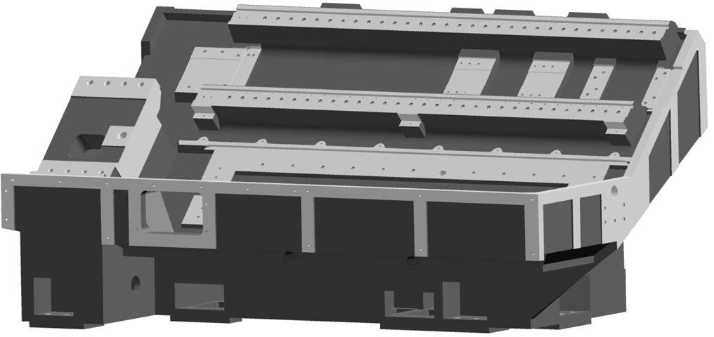

The Z-axis ball screw and motor support brackets are fixed on the face of bed and doweled after alignment. The z-axis servomotor and ball screw is coupled with bellow coupling. The dogs for actuation the Z- axis travel limit switches are permanently fixed on the bed and should not be disturbed. The pulse lubrication motor pump unit is mounted at left-front end of the machine. Bellow covers for the bed guide ways electric cables and pipe brackets are also fixed on the bed, at the rear.

**IMPROTANT:** IT IS ESSETIAL TO PREVENT ACCUMULATION OF CHIPS OR DUST ON THE TELESCOPE / BELLOW COVERS.

Machine integral modules C2CH0500101A Page 5.1.4 of 15

#### Saddle, cross-slide and Axis Drives:

The carriage assembly containing the saddle and cross slide. Turret is mounted on the X-axis LM guide ways. The slide way bronze wipers fixed at the ends of moving elements keep away the chips and dust from the sliding contact guide ways and retain the inside oil film. Lubrication for saddle and cross slide is by metered oil from the automatic pulse lubrication system.

The Z-axis ball screw is driven by servomotor coupled with bellow coupling. The ball screw is supported at the head stock end on a combined ball screw support angular contact bearing and by a ball bearing at the tail stock end.

Similarly, the X axis ball screw is driven by a servomotor coupled by bellow coupling. The servomotor has a built-in fail safe brake arrangement for holding up the sliding passes, when the power is off. The X axis ball screw is supported on a match pair angular contact ball screw support bearing, which is located at the top.

###### IMPORTANT:

NO ATTEMPT SHOULD BE MADE TO ADJUST OR DISMANTLE THE BALL SCREW. THE BEARING OR THE NUT, AS IT WILL RESULT IN CHANGE OF THE SET PRE-LOAD / ALIGNMENT AND CONSEQUENT DAMAGE.

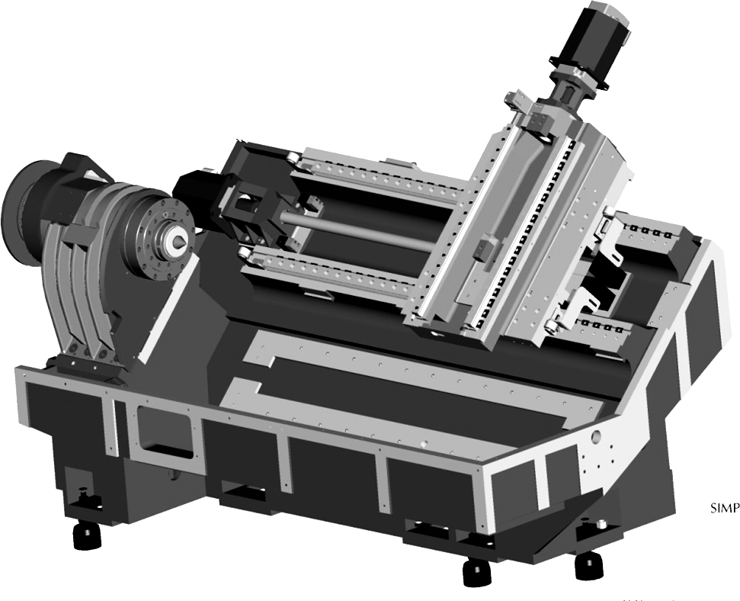

Machine integral modules C2CH0500101A Page 5.1.5 of 15

In addition to the software limits stored in the CNC control system, the saddle and cross slide are equipped with the limit switches for ‘Emergency Stop’ limit switch gets actuated/the feed motion, spindle rotation and hydraulic stops system immediately, similar, to what happens when pressing the red mushroom type emergency push button. In the case of z axis, two stop dogs near the tail stock end controlling of saddle travel are provided viz., ‘Home’, and ‘+ve’ limit. The other stop dog near the head stock are meant for ‘-ve’ limit. The stop dogs actuate the micro switch mounted on the saddle and moves with it. In the case of x-axis, the two stops dogs fixed to the bottom end of the cross slide are intended for ‘Home’ and ‘+ve’ limit, while the upper stop dog for and ‘-ve’ limit. The micro switches actuated by these dogs are fixed to the right of the saddle.

SOFTWARE LIMITS ARE ACTIVE ONLY AFTER REFERENCING THE RESPECTIVE AXES.

The software limits are with respect to the axis reference point and positive and negative feed holds. Hardware limits (micro switches and stop dogs) area always active to safeguard the machine elements.

Machine integral modules C2CH0500101A Page 5.1.6 of 15

#### Turret:

The standard turret has 8 station wedges lock type tooling. It can accommodate both external and internal tool holders. The turret can be indexed manually by one station in the clockwise direction (looking towards the face of the turret from the head stock side) by operation the pushbutton on the operator panel on the control station through single block operation using M-code or through programming. For further details refer turret manual.

In turn-mill center there is 12,station VDI30 turret (BMT45 Standard is also offered as an option in turn-mill center)

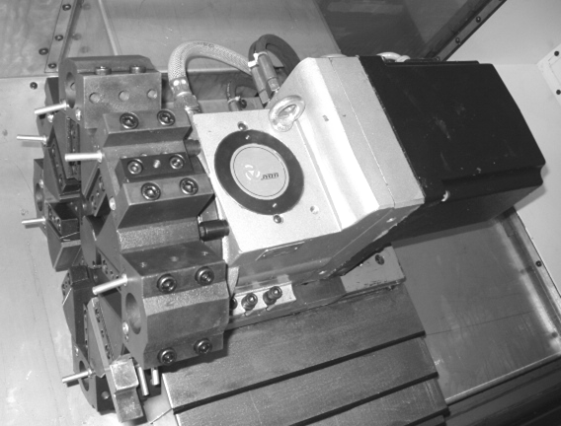

Machine integral modules C2CH0500101A Page 5.1.7 of 15

#### Main Drive and Head Stock:

The main drive motor is mounted on adjustable rail and whole assembly bolted on the left side of the box stand. The built in shaft encoder monitors actual speed for feedback information to the spindle drive control. Timing belt is used for power transmission from motor to spindle. The head stock is bolted on the box stand with provision for precise geometric alignment by the adjusting mechanism. However it is not necessary to adjust it, as it is preset at the works. The machine is provided with two optional spindle noses according to customer requirement. Spindle nose of A2 6 and A2 8 are optional provision for customer requirement.

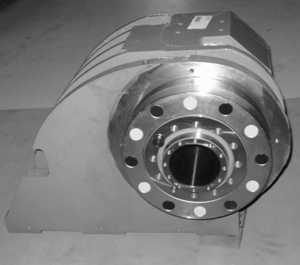

The main spindle assembly containing bearing and cartridge system, cartridge is located in the bore and bolts in face of the head stock. The main spindle is supported on high precision bearings, three angular contact ball bearings in front and with two angular contact ball bearings in rear to take the reaction of the cutting load effectively. Main spindle pulley is mounted on spindle taper. The timing pulley of the encoder shaft gets the drive from another timing pulley which is mounted on spindle pulley. The encoder shaft pulley is with taper locking arrangement. The bearing assembly is life grease lubricated with precise quality for lifetime. The grease used is of KLUBER LUBRICATION ISOFLEX NBU 15.

Machine integral modules C2CH0500101A Page 5.1.8 of 15

###### Encoder:

The spindle incremental encoder mounted outside the head stock is driven by timing belt. The encoder output shaft pulses for monitoring exact spindle speed. The timing belt encoder is used in DX-250/350 while gear teeth encoder is used in TMC-250/350 directly on the spindle to ensure precision positional accuracy of the spindle while using it as a c-axis.

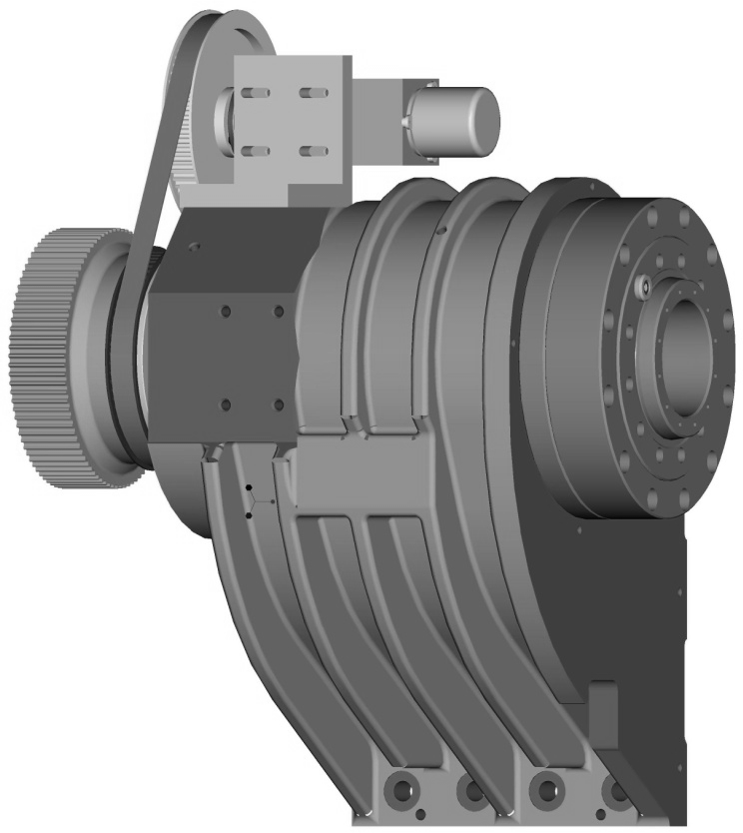

Oil drain hole is provided in spindle. The oil drain hole may be clogged with dust etc. clean the drain hole every week.

 **CAUTION:**

DO NOT DIRECT A COOLANT JET TOWARDS THE SPINDLE NOSE:

EXTREME CARE SHOULD BE TAKEN TO AVOID DAMAGE TO THE SPINDLE WHILE MOUNTING WORK HOLDING DEVICES AND ACTUATION CYLINDERS

USE ONLY BALANCED FIXTURES ON THE SPINDLE TO AVOID DAMAGE TO THE BEARINGS.

Machine integral modules C2CH0500101A Page 5.1.9 of 15

#### Coolant System:

The coolant system forms a part of the coolant tray/chip conveyor. It comprises of a motor driven immersion type centrifugal pump and coolant nozzle placed on the spindle.

 **IMPORTANT:**

DO NOT OPERATE THE COOLANT PUMP WITHOUT THE REQUIRED QUANTITY OF COOLANT IN THE COOLANT TANKS. CHECK THE CONDITON OF THE COOLANT PERIODICAL.

The coolant supply permits flow only to the tool station selected and also only after clamping of the turret disc after indexing. The coolant jet can be adjusted to the required position near to the cutting edge.

Machine integral modules C2CH0500101A Page 5.1.10 of 15

#### Hydraulic System:

The centralized hydraulic power pack kept at the rear is firmly bolted to the base through the brackets. The power pack and the controls mounted on the power pack, supply oil for the following.

* 1. Turret indexing

Clamping and de-clamping of Bi-direction rotation, if the turret is hydraulically operated.

* 1. Work-holding cylinder actuation.
  2. Quill movement.

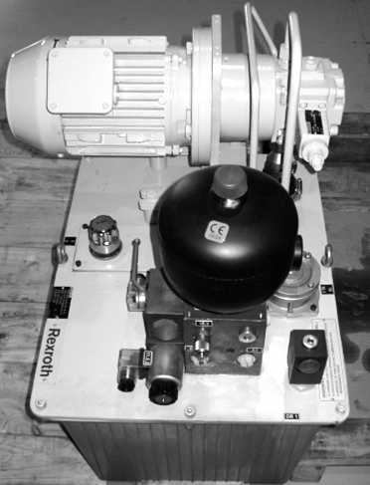

Machine integral modules C2CH0500101A Page 5.1.11 of 15

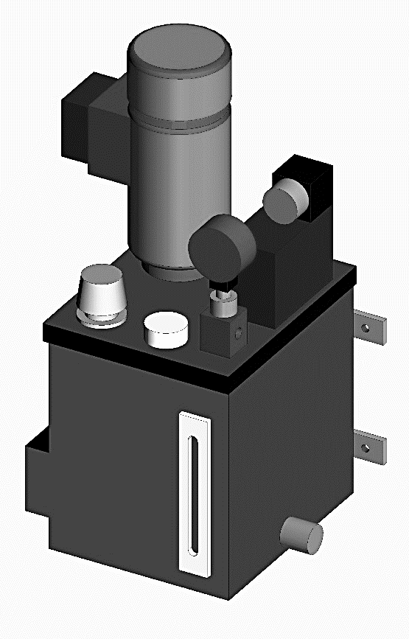

#### Operation of Accessories:

NO PRESSURE / QUANTITY SETTINGS EXCEPT FOR WORK. HOLDING CYLINDER AND TAIL STOCK QUILL MAY BE DISTURBED. ANY OIL LEAKAGE SHOULD BE REPORTED AND RECTIFIED IMMEDIATELY.

It should be ensured that all hoses, which are traveling are clear of any obstruction.

#### Lubrication System:

The main spindle bearings and ball screw support bearings are grease lubricated for life and require no attention. The centralized automatic pulse lubrication system is used for lubricating the following elements.

* Saddle and cross slide guide ways. Ball screw-nuts.
* The lubricator unit of the pulse lubrication system, complete with all the equipment, like motor, pump, valves, pressure gauge etc. is mounted on the left end of the base. Fill the tank with the lubricating oil to the required level periodically. A list of approved oils is given in the lubrication Manual. It is not necessary to do any adjustment.

Machine integral modules C2CH0500101A Page 5.1.12 of 15

#### Chucking System:

A chuck mounted on the spindle front end is connected to the rotary hydraulic cylinder through draw tube. Advance of cylinder piston to the chuck side allows chuck jaw to be opened through wedge mechanism, and the retraction allows it to be closed. The rotary hydraulic cylinder is composed of cylinder part, check valve and rotary joint part. The check valve, even when supply oil pressure unusually drops due to pressure source, etc. is fitted to maintain constant in the cylinder. Chuck jaws must be formed to the configuration of work piece to be chucked. The chuck has restriction to the usage to maintain safety, high accuracy and long service life, and caution for handling. Read the enclosed chuck instruction manual thoroughly, and follow the instruction.

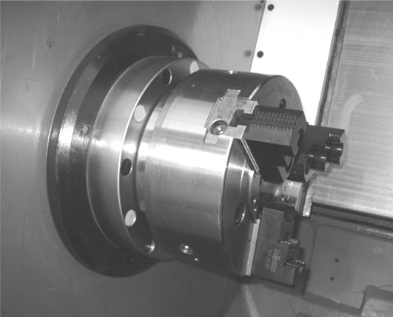

Machine integral modules C2CH0500101A Page 5.1.13 of 15

#### Tail stock:

The tail stock, which supports the right center of the work piece against the head stock, consists of the tail stock quill live center and tail stock body.

The rigid tail stock body is mounted on solid wrap around box ways.

The guide ways are hardened and precision ground. Auto lubrication is provided to the tail stock quill as. The quill stroke is activated either the programme or foot switch.

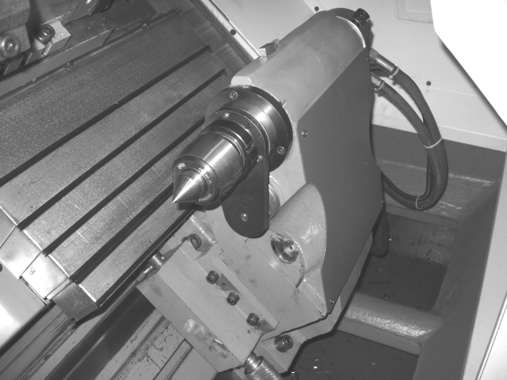

Machine integral modules C2CH0500101A Page 5.1.14 of 15

#### Door inter lock switch:

Operating with a separate actuation key which is fixed on the movable front door, the door interlock device is installed as one of safety devices at above the front door to ensure operator’s safety. If an attempt is made to start rotating the spindle, index the turret or feed and axis while the front door is in the open, this device is automatically actuated to stop the machine operations and display the alarm message on screen.

Machine integral modules C2CH0500101A Page 5.1.15 of 15

#### Foot Switch:

The foot operated switch at the front of the machine is designed for safety requirements with protection cover. The switch body with a waterproof structure is made of die-casting aluminum alloy. Advance and retraction of tail stock quill can be performed by the foot pedal switch respectively.

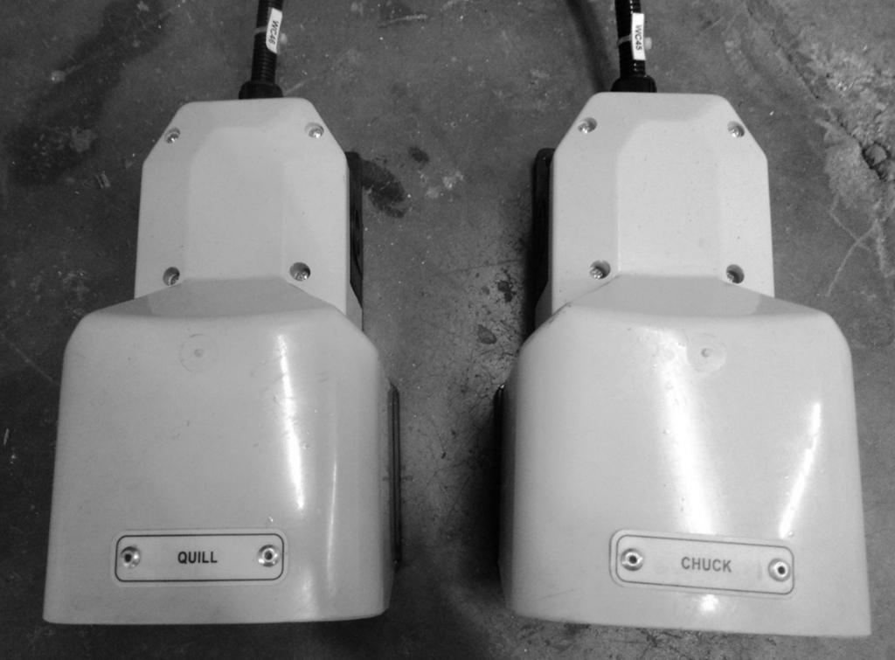

Machine integral modules C2CH0500201E Page 5.2.1 of 13

#### Electrical Cabinet:

**Control Wiring**

* + Control wiring consisting of all feedback devices wiring and control output wiring.
  + Fuse protected potential 24VDC PNP type supply for all control elements.
  + Output of SMPS are distributed by modular type (pre- linked) panel connectors.

#### Power Wiring

* + Incoming power is routed through servo stabilizer from main switch of the shop.
  + Incoming power is distributed from distribution blocks for all three phases and neutral.
  + Panel cooler and lighting power is given directly from MCB.
  + All induction motors are protected by MPCBs.

#### CE Control Wiring

* + The machine with CE/CSA norms is interfaced with safety category defined PL-D
  + Various different methodology and priority of the machine functions are changed as per the norms of CE.

**Control panel consoles**

**Features:**

#### FANUC 0i TF is used as the control system on Turning. It is a microprocessor 4-axis numerical control system suitable for turning center with all the necessary functional features.

**Individual manufacturer's special instruction for operation and maintenance of Special accessories/equipments should be strictly followed.**

#### OPRATING PANEL:

**The alpha key group contains the A to Z on two levels arranged in accordance with use in programming.**

#### The numerical key group contains the digits for 0 to 9 and other arithmetic signs

**Cursor key group is used to move or navigate the screen Control key includes the special functions.**

#### The hotkeys group is used for the direct selection of operating areas.

**Machine Control Panel**

Machine integral modules C2CH0500201E Page 5.2.2 of 13

Various functions consist into machine control panel for easy operation for operator.

#### Emergency stop push button

➔Press the red push button in emergency situations, for life or machinery

➔All drives are shut down with a controlled braking torque Turn the red button and Unlocks the E-stop

➔Danger! Only unlock the E-stop and start the machinery after alarm acknowledging and being insured that any defaults and / or damages has being serviced or repaired

➔Never unlock an E-Stop which you have not activated yourself!

Machine integral modules C2CH0500201E Page 5.2.3 of 13

➔Never use an E-Stop to stops the machine processes!

#### Jog – mode

➔Continuous or incremental manual axes shifting mode, using direction keys + or – or an electronic hand wheel

➔To activate this mode, Press this key

* + The associated LED switches on
  + The associated mode is active

➔To deactivate this mode, Press this key again

* + The associated LED switches off
  + The associated mode is inactive

#### MDA - manual data automatic

➔Machine can be controlled by executing block or blocks of sequences,

➔To activate this mode, Press this key

* + The associated LED switches on
  + The associated mode is active

➔To deactivate this mode, Press this key again

* + The associated LED switches off
  + The associated mode is inactive

#### Automatic

➔Machine control using automatic programs execution.

➔To activate this mode, Press this key

* + The associated LED switches on
  + The associated mode is active

➔To deactivate this mode, Press this key again

* + The associated LED switches off
  + The associated mode is inactive

.

Machine integral modules C2CH0500201E Page 5.2.4 of 13

#### Ref – Point

➔The "Jog" mode must be active to approach a reference point

➔To activate this mode, Press this key

* + The associated LED switches on
  + The associated mode is active

➔To deactivate this mode, Press this key again

* + The associated LED switches off
  + The associated mode is inactive

#### Single Block

➔Allows executing a work piece program block by block.

➔One of these modes must been selected:

#### “Automatic”

* + **“MDA”**

➔To allows this mode, Press this key

* + Activates the block by block execution of the current work piece program
  + On screen, the channel status message bar displays SBL 1, SBL 2 or SBL 3 (stop in the cycle from software version 5)
  + In interrupt status, the channel status message bar displays “Stop: single block mode”
  + the associated LED switches on

➔To execute the current block, Press the “Start Cycle” key,

* + Execute the current work piece program block
  + Execution stops after each block

➔To execute the next current block

➔Press the “Start Cycle” key once again,

* + Execute the next current work piece program block.

#### M01

➔It is used to select or deselect the option of stop of program I running

Machine integral modules C2CH0500201E Page 5.2.5 of 13

Machine integral modules C2CH0500201E Page 5.2.6 of 13

➔This is to activate the optional stop command given in the part program , with this selection only program will stop at M01

#### M/C ON

➔To start machine virtually from control panel, this key is used

➔To activate it, Press this desired key

* + The associated LED will active

#### DRN

➔This key is used for dry cutting.

➔To start dry cutting, Press the desired key

* + The associated mode will active
  + Associate LED will Switch on

➔ To deactivate one mode, Press the desired key again

* + The associated mode is inactive
  + The associated LED switches off

#### WCS/MCS (Work Coordinate System/Machine Coordinate System)

➔In the Machine operating area, switches between

* + The machine coordinate system (MCS)
  + The work piece coordinate system (WCS)

➔To switch between both modes, Press this key until the intended mode is active

* + The associated LED switches on

#### PRT SEL

➔ It is used to Stimulate entire program without hardware interference

➔ To verify a functionality of program, Press this key

* + System will start execution of program
  + The associated LED switches on

➔ To stop a programmed cooling, Press this key again

* + System will generate Alarm
  + The associated LED switches off

#### Coolant

➔ It is used to start coolant liquid flow

➔ To restart a programmed cooling, Press this key

* + The nozzle cooling starts
  + The associated LED switches on

➔ To stop a programmed cooling, Press this key again

* + The nozzle cooling stops
  + The associated LED switches off

#### Chip Fwd

➔To move chip conveyor forward, Press this key

* + The chip moves forward
  + The associated LED switches on

➔ To stop chip conveyor forward movement, Press this key again

* + The chip conveyor stops movement
  + The associated LED switches off

Machine integral modules C2CH0500201E Page 5.2.7 of 13

#### Chip Rev

➔To move chip conveyor reverse, Press this key

* + The chip conveyor moves reverse
  + The associated LED switches on

➔ To stop chip conveyor reverse movement, Press this key again

* + The chip conveyor stops movement
  + The associated LED switches off

#### CHUCK CL INT

➔ It is used to clamp hollow cylindrical job in different manner

➔ To clamp job via internal diameter in chuck, Press this key

* + The associated LED switches on.

➔ To stop operation in this mode, Press this key again

* The associated LED switches off

#### CHUCK CL EXT

➔ It is used to clamp hollow cylindrical job in different manner

➔ To clamp job via external diameter in chuck, Press this key

* + The associated LED switches on.

➔ To stop operation in this mode, Press this key again

* + The associated LED switches off

#### Lubrication ON

➔ It is used to start lubrication flow

➔ To restart a programmed lubrication, Press this key

* + The needle lubrication starts
  + The associated LED switches on

➔ To stop a programmed cooling, Press this key again

* + The needle lubrication stops

Machine integral modules C2CH0500201E Page 5.2.8 of 13

* + The associated LED switches off

➔To sPush "Rapid" key and the “+” or the "-" keys on same time

* + Moves quickly the selected axis into positive or negative direction.

#### Turret JOG

➔To operate turret in JOG mode, Press this key.

* + The associated LED switches on.

➔ To stop operation in this mode, Press this key again

* The associated LED switches off

#### Door Open

➔To open main door via program, Press this key

* + Main Door opens
  + The associated LED switches on stopped spindle

➔To close main door via program, Press this key

* + Main Door closes
  + The associated LED switches on stopped spindle

#### Spindle Clock

➔It is used to run Spindle clockwise direction

➔To activate this mode, Press this key

* + The associated LED switches on
  + The associated mode is active

➔To deactivate this mode, Press this key again

* + The associated LED switches off
  + The associated mode is inactive

.

Machine integral modules C2CH0500201E Page 5.2.9 of 13

#### Spindle Counter clock

➔It is used to run Spindle clockwise direction

➔To activate this mode, Press this key

* + The associated LED switches on.
  + The associated mode is active.

➔To deactivate this mode, Press this key again

* + The associated LED switches off.
  + The associated mode is inactive.

#### Cycle Start

➔To start the cycle, Press this key

* + Starts the selected work piece program at the current block.
  + The associated LED switches on.
  + Program name is displayed on, top of the screen.

#### Cycle stop

➔To stop the cycle, Press this key

* + Stops the execution of the current work piece program
  + The associated LED switches on.

#### Reset

➔Press this key and aborts the execution of the current work piece program

* + Deletes messages from cycle monitoring, except for “Power On”, “Start program” and “Acknowledge Alarm” warnings
  + The channel is shifted to “Reset” state
  + The CNC remains synchronized with the machine,
  + The CNC is initialized and ready to execute a new program

Machine integral modules C2CH0500201E Page 5.2.10 of 13

#### Axis movement keys

➔To select the axis for traversing:

➔Push one key, "X+" or "X-" or "Z+" or "Z-"

* + The selected axis is active and moves in respected direction
  + The associated LED turns on

#### Rapid

➔ For rapid traversing adjustment

* + Push "Rapid" key and the “X+” or “X-”or “Z+”or “Z-” keys on same time
  + 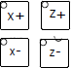Moves quickly the selected axis into positive or negative direction

#### Inc Sel - incremental selection

➔ Incremental manual shifting by variable increments

➔ Incremental manual shifting using preset increments values (1, 10, 100, 1000 or 10000 increments)

#### Spn Start

➔ To start the spindle, Press this key

* + Accelerates the spindle to the program defined value,
  + After control acceptance, the associated LED switches on

#### Spn Stop

➔ To start the spindle, Press this key

* + Accelerates the spindle to the program defined value,
  + After control acceptance, the associated LED switches on

Machine integral modules C2CH0500201E Page 5.2.11 of 13

#### Feed Start

➔ To start the feed adjustment, Press this key

* + Work piece program continues in the current block,
  + The feed is accelerated to the defined program value,
  + sAfter control acceptance, the associated LED switches on

#### Feed Stop

➔ To start the feed adjustment, Press this key

* + Work piece program continues in the current block,
  + The feed is accelerated to the defined program value,
  + After control acceptance, the associated LED switches on

#### Part Catcher Up/Down

➔ To move part catcher up, Press this key

* + The associated LED switches on
  + The part catcher moves up

➔ To move part catcher up, Press this key again,

* + The associated LED switches off
  + The part catcher moves down

#### Steady Rest Cl/Dcl

➔ To clamp job in steady rest, Press this key

* + The associated LED switches on
  + The steady rest clamps job

➔ To declamp job in steady rest, Press this key again,

* + The associated LED switches off
  + The part catcher moves down

#### Coolant Through Spindle

➔ To activate Coolant in spindle mode, Press this key

* + The associated LED switches on
  + The coolant starts

➔ To deactivate this mode, Press this key again

* + The associated LED switches off
  + The coolant stops

Machine integral modules C2CH0500201E Page 5.2.12 of 13

Machine integral modules C2CH0500201E Page 5.2.13 of 13

#### Blank 1/2/3/4

➔ This keys are user defined user can defined any function on this according requirement.

#### Spindle override - spindle speed override switch

➔ The rotary switch with latch positions allows

increasing or decreasing the programmed spindle speed “S” (equivalent to 100%).

➔ Control range: 50% to 120% of programmed spindle speed.

➔ Each step has 10% between each latch.

➔ To set the spindle speed value:

* + Turn the rotary until the intended speed value
  + Clockwise to increase the speed value.
  + Counter-clockwise to decrease the speed value.
  + The set spindle speed value “S” is displayed as an absolute value and a percentage on the screen, in the “Spindles” frame (vertical soft key in basic display)

#### Feed rate override switch (G1 and G0) to adjust the feed rate:

➔ Turn the switch until the intended feed rate.

➔ 0% to 120% of programmed federate on rapid traversing, the 100% value is not exceeded.

Assembly details C2CH0600101A Page 6.1.1 of 3



# Assembly detaåls

6

List of contents

1. **Assembly details**

1 Nomenclature of machine ……………………….......... 6.1.3

1. X-axis ball screw assembly …………………………… 6.2.1
2. Z-axis ball screw assembly ……………………………. 6.4.1

4 X - Axis assembly……………………………………….. 6.5.1

5 Z - Axis assembly……………………………………….. 6.7.1

6 Spindle assembly……………………………………….. 6.8.1

7 Clamping assembly……………………………………. 6.12.1

8 Encoder Assembly……………………………………… 6.13.1

9 Turret Assembly………………………………………… 6.14.1

10 Tailstock Assembly…………………………………….. 6.15.1

11 Quill Assembly………………………………………….. 6.16.1

12 Lubrication system……………… ……………………... 6.21.1

13 Coolant system………………………………………….. 6.22.1

14 Spindle Motor Assembly……………………………….. 6.25.1

15 Hydraulic Diagram………………………………………. 6.28.1

16 Traction Assembly………………………………………. 6.30.1

Assembly details C2CH0600101A Page 6.1.3 of 3

Nomenclature of DX250 / TMC250

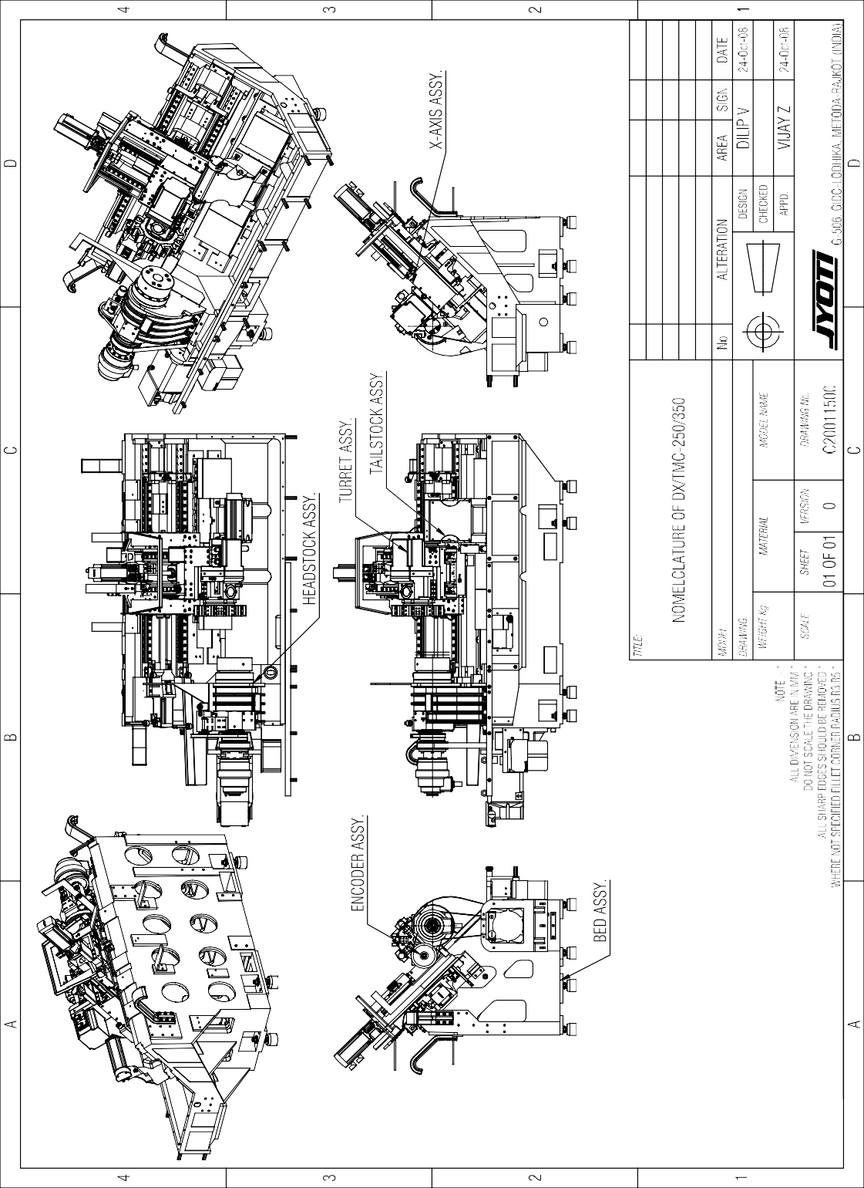



Assembly details C2CH0600201F Page 6.2.1of1

#### X-axis ball screw assembly (for FANUC controller) BSB

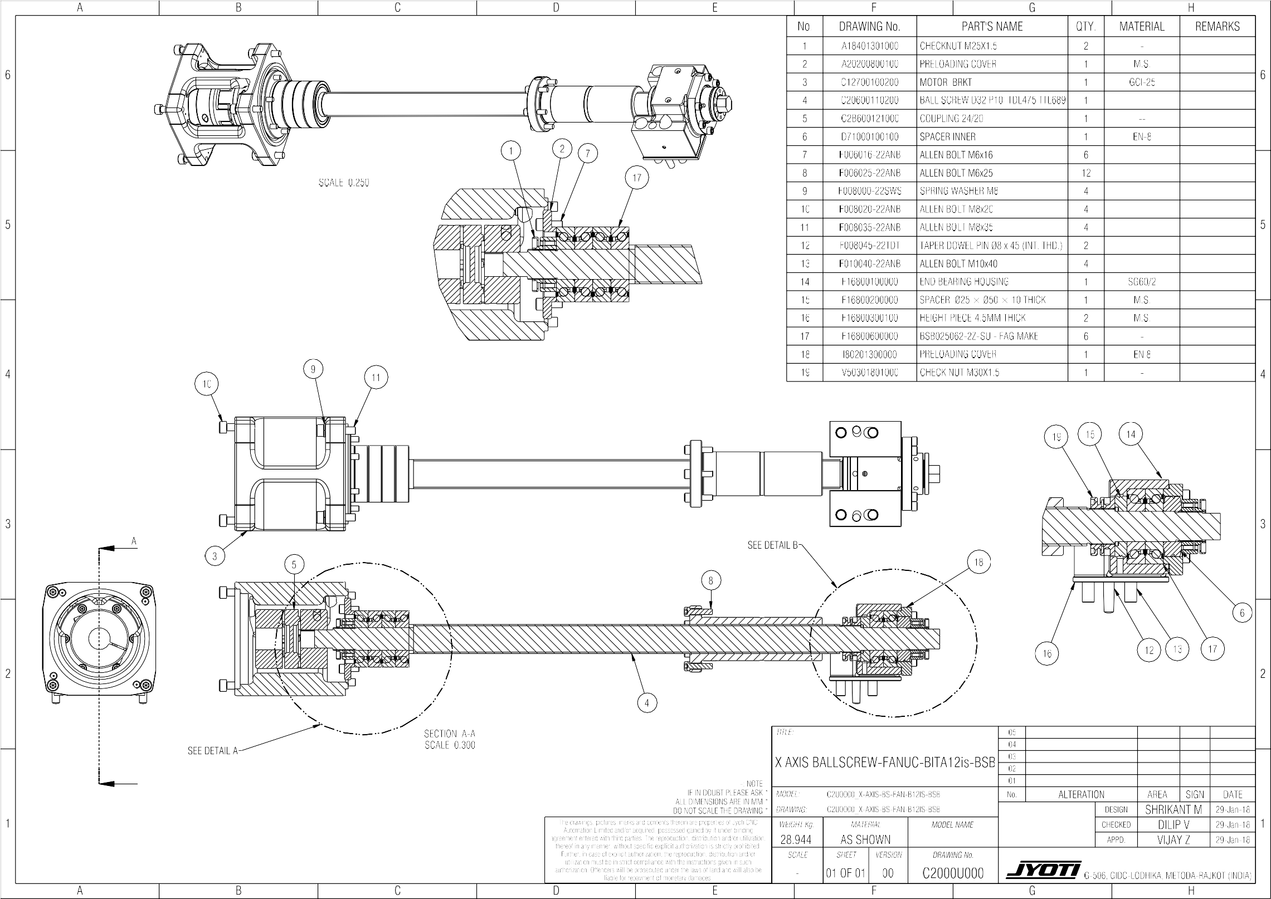

Assembly details C2CH0600400L Page 6.4.1of1

**Z-axis ball screw assembly (Z1000) (for FANUC BITA12is)**



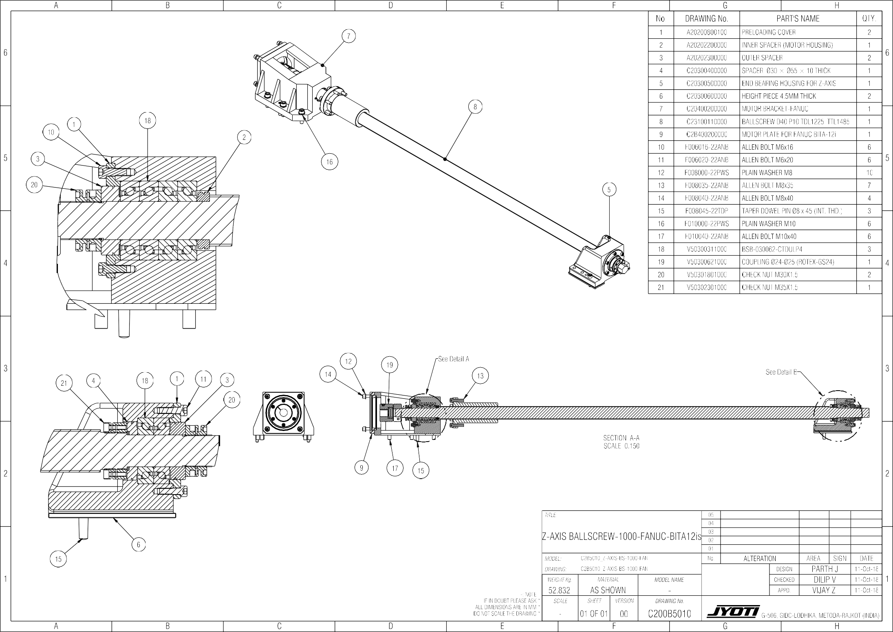

Assembly details C2CH0600501A Page6.5.1of1

X-axis assembly

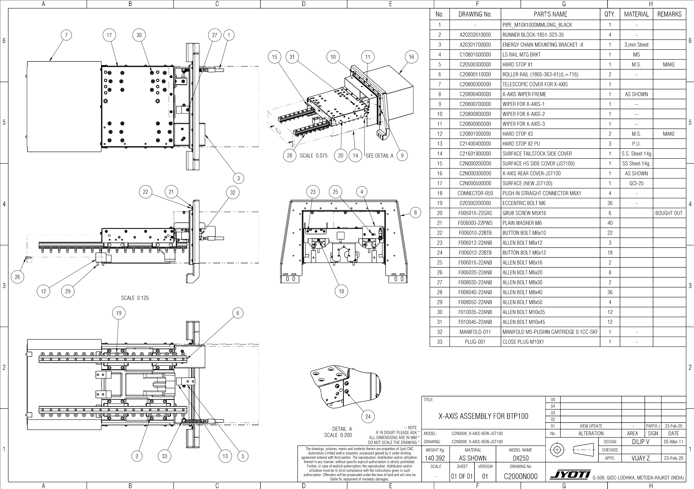

Assembly details C2CH0600700B Page 6.7.1of1

Z-axis assembly

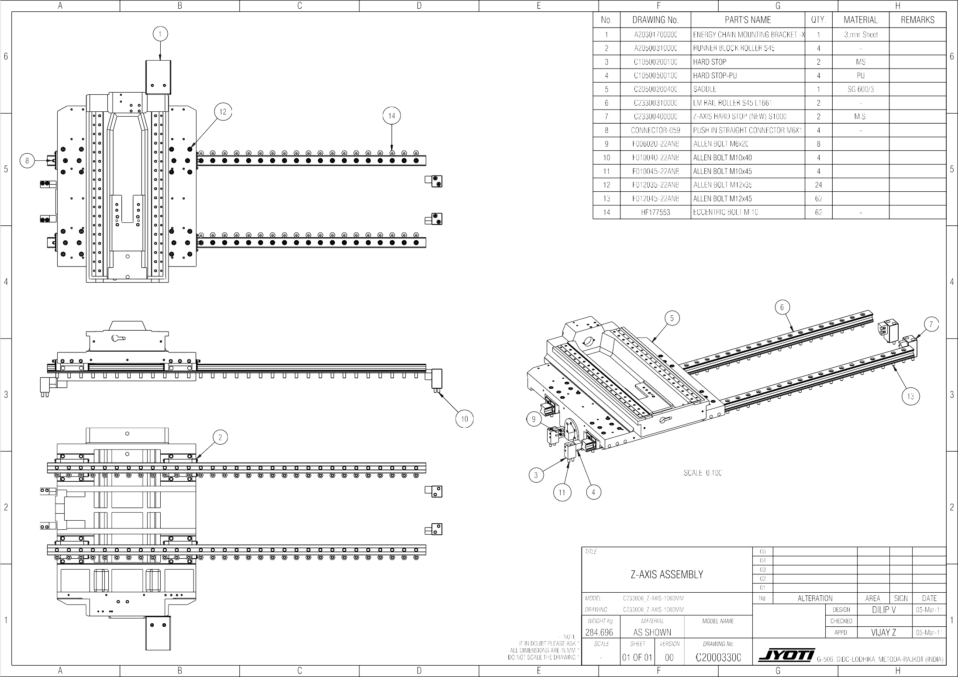



Assembly details C2CH0600801B Page 6.8.1of3

Head stock A28assembly

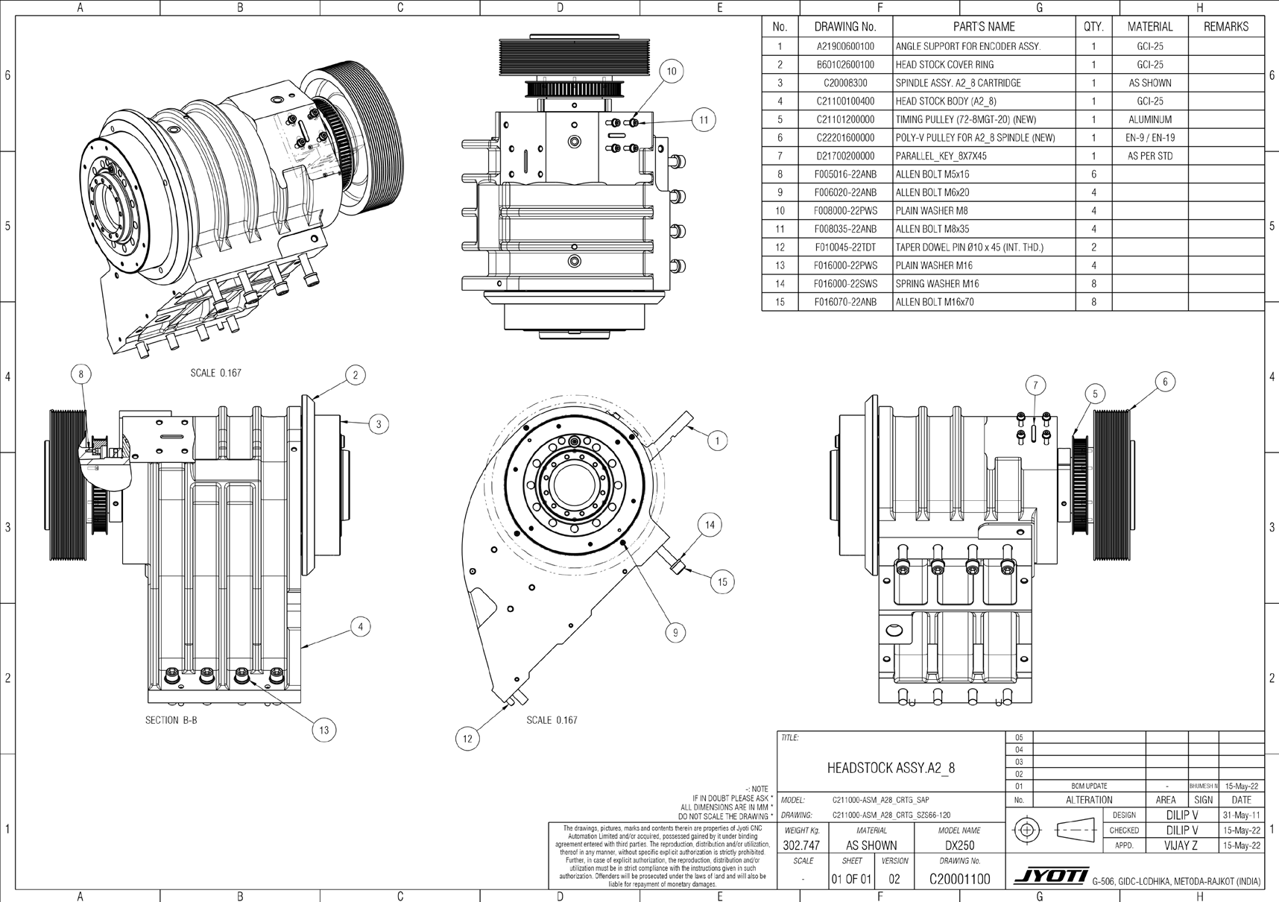

Assembly details C2CH0600801B Page 6.8.2of3

Spindle A28 assembly

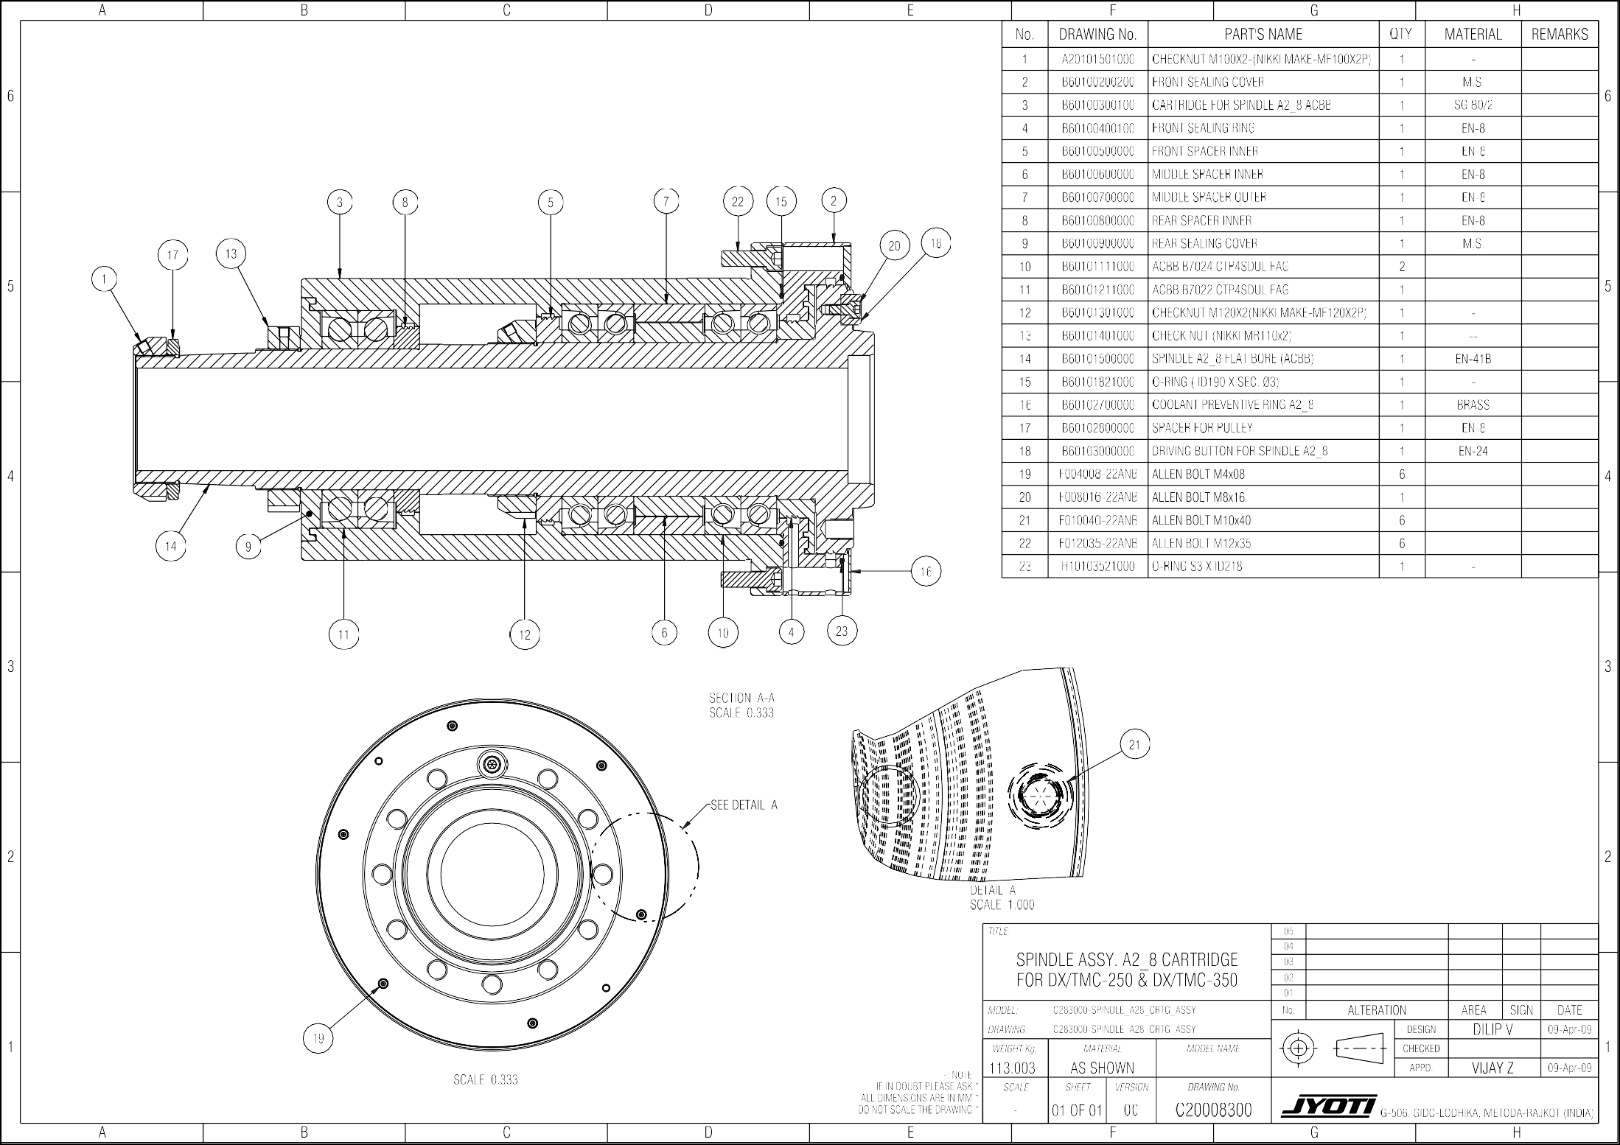

Assembly details C2CH0600801B Page 6.8.3of3

Spindle A28 Nose Details

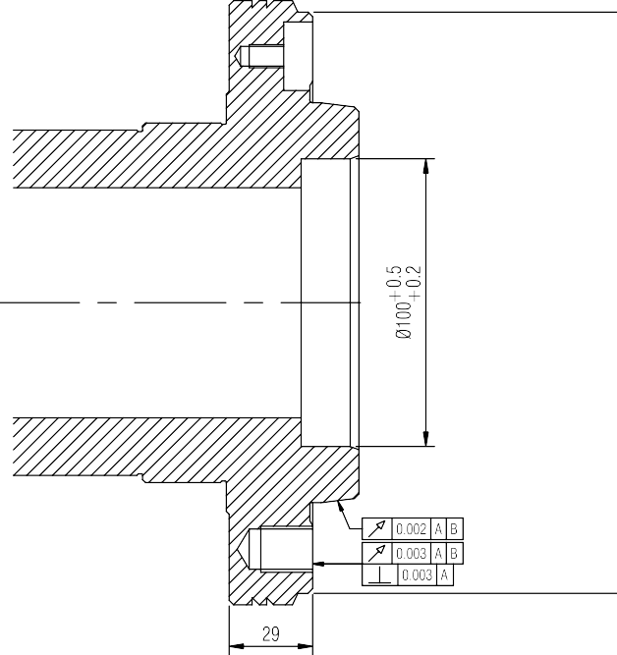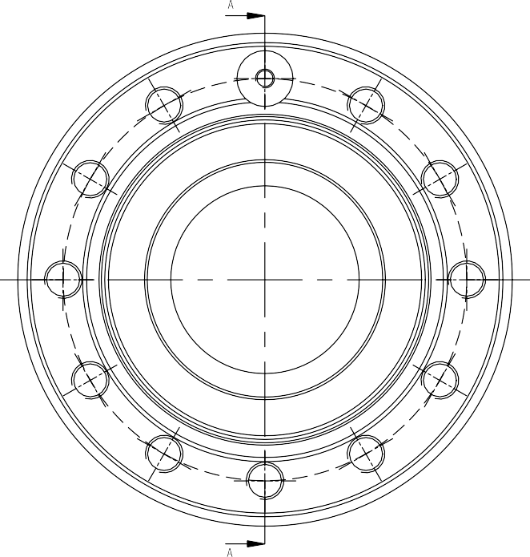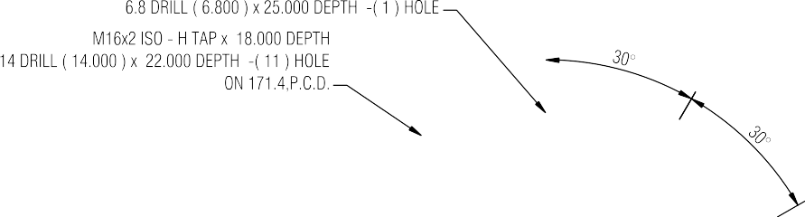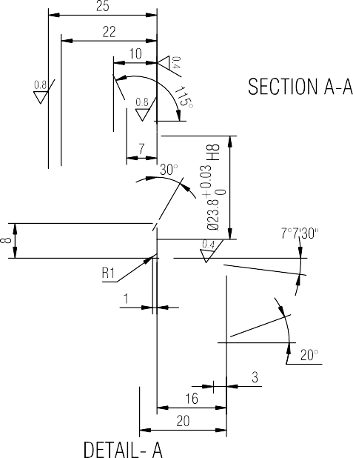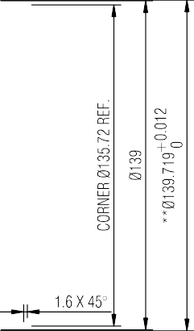

Assembly details C2CH0601201N Page 6.12.1of1

M-CLAMPING A2_8+ WH350/3 +S1875

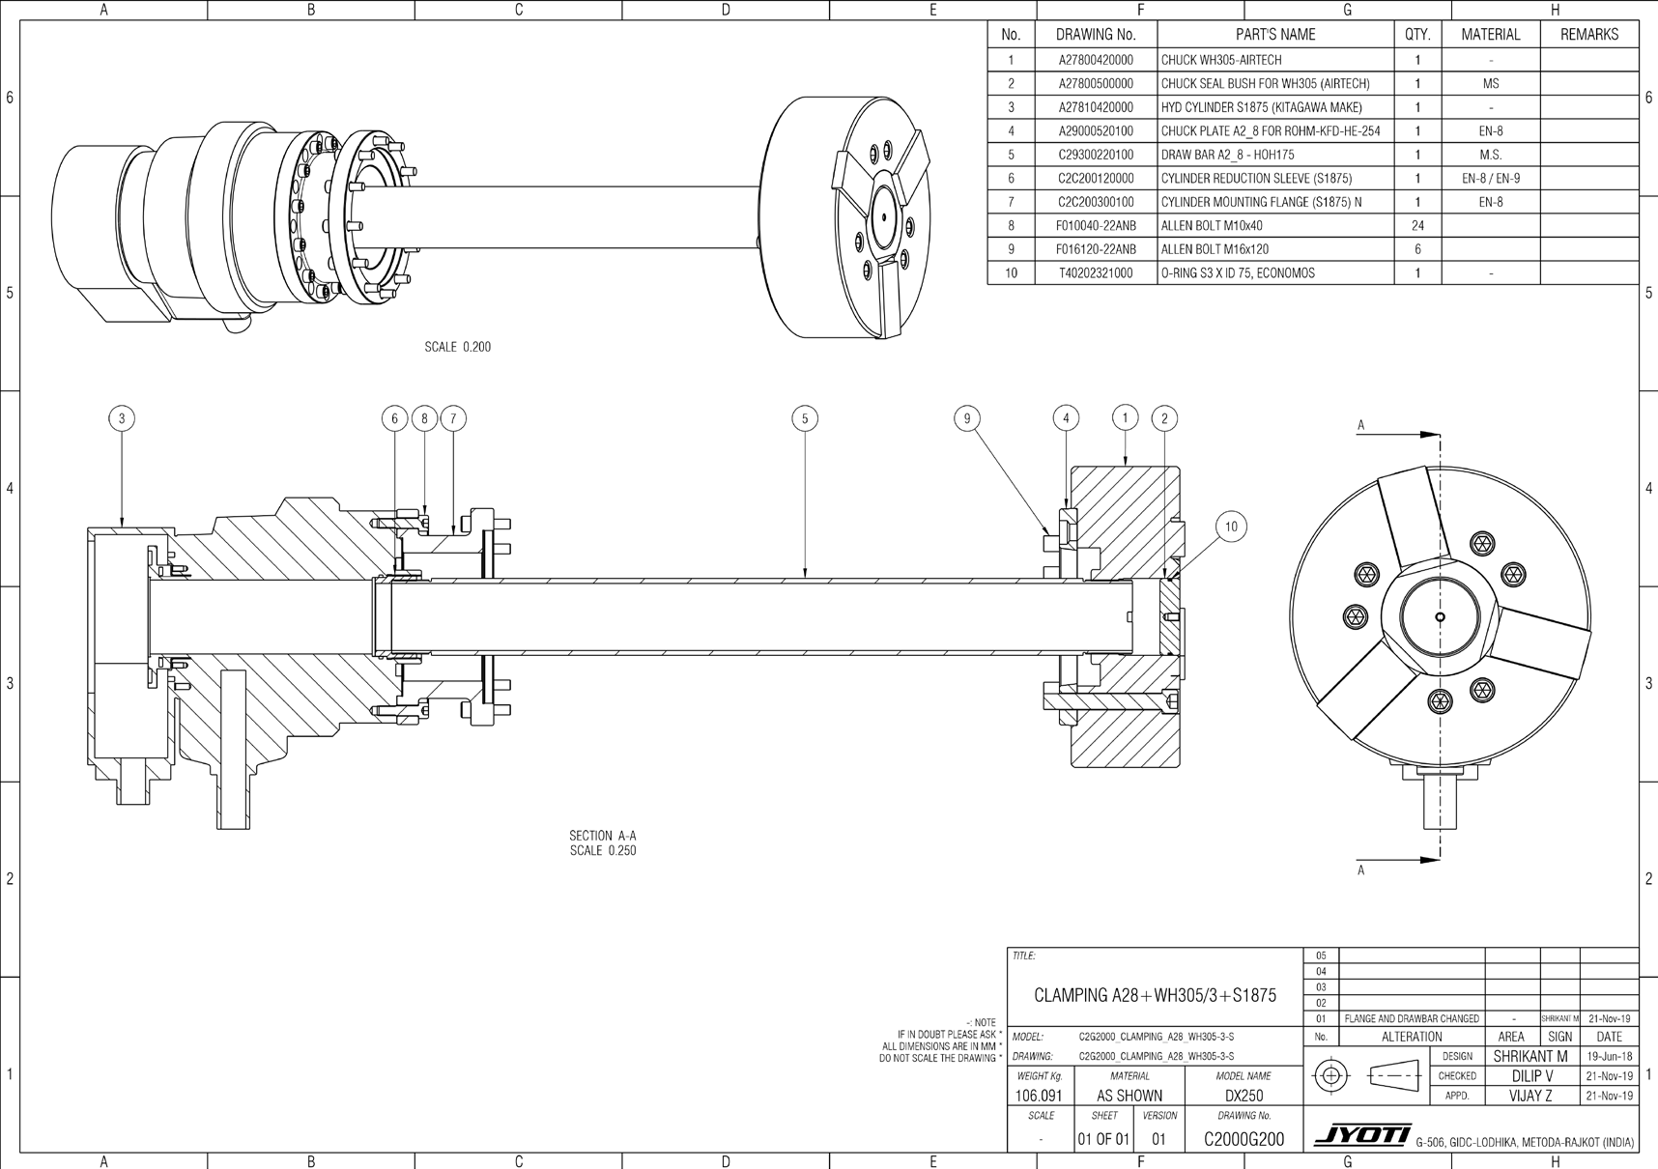

Assembly details A1CH0601300A Page 6.13.1 of1

Encoder assembly (SIEMENS)

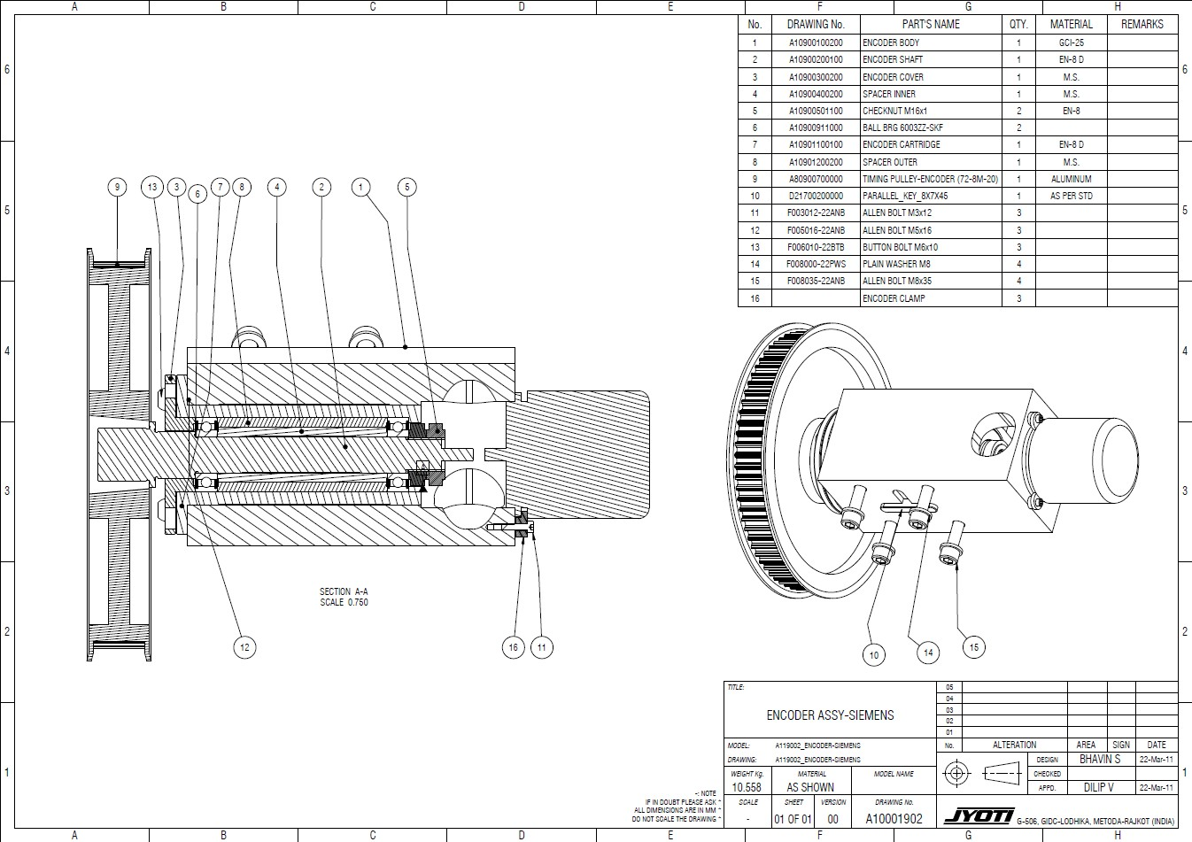

Assembly details C2CH0601400E Page 6.14.1of1

Turret Assembly (JST100)

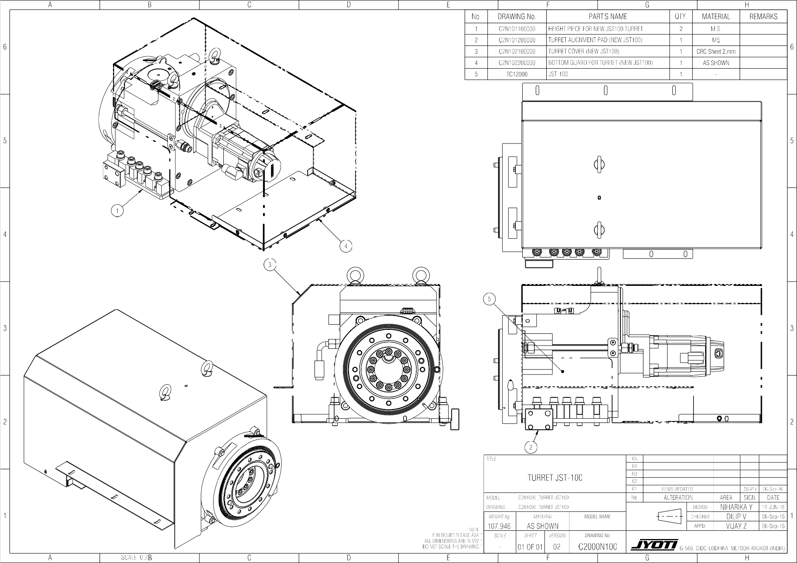



Assembly details C2CH0601500B Page 6.15.1 of 1

#### Tail Stock Assembly

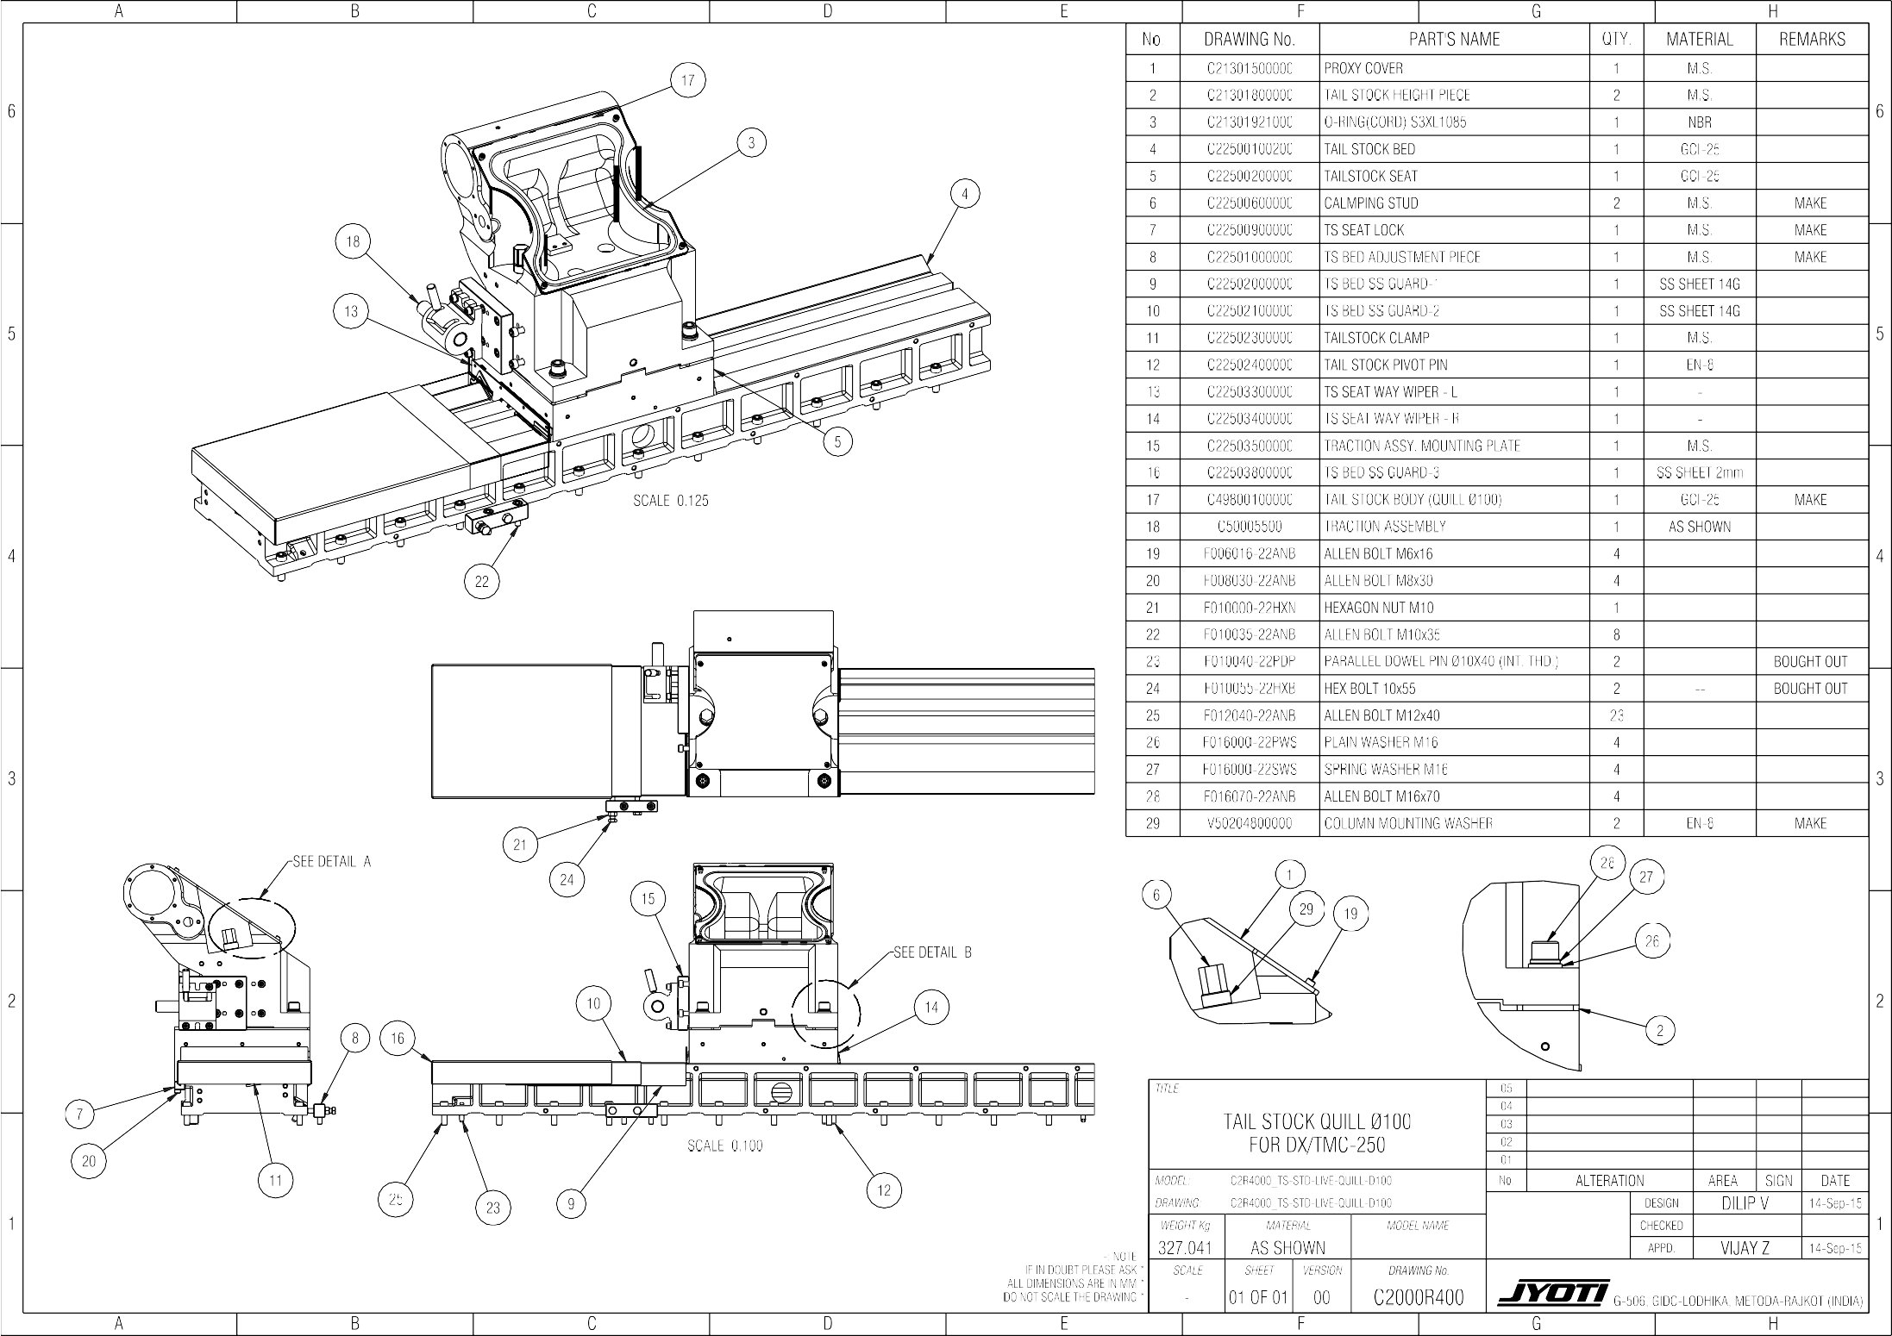



Assembly details C2CH0601600D Page 6.16.1of1

**Quill Assembly (Revolving center MT5)** Ø100

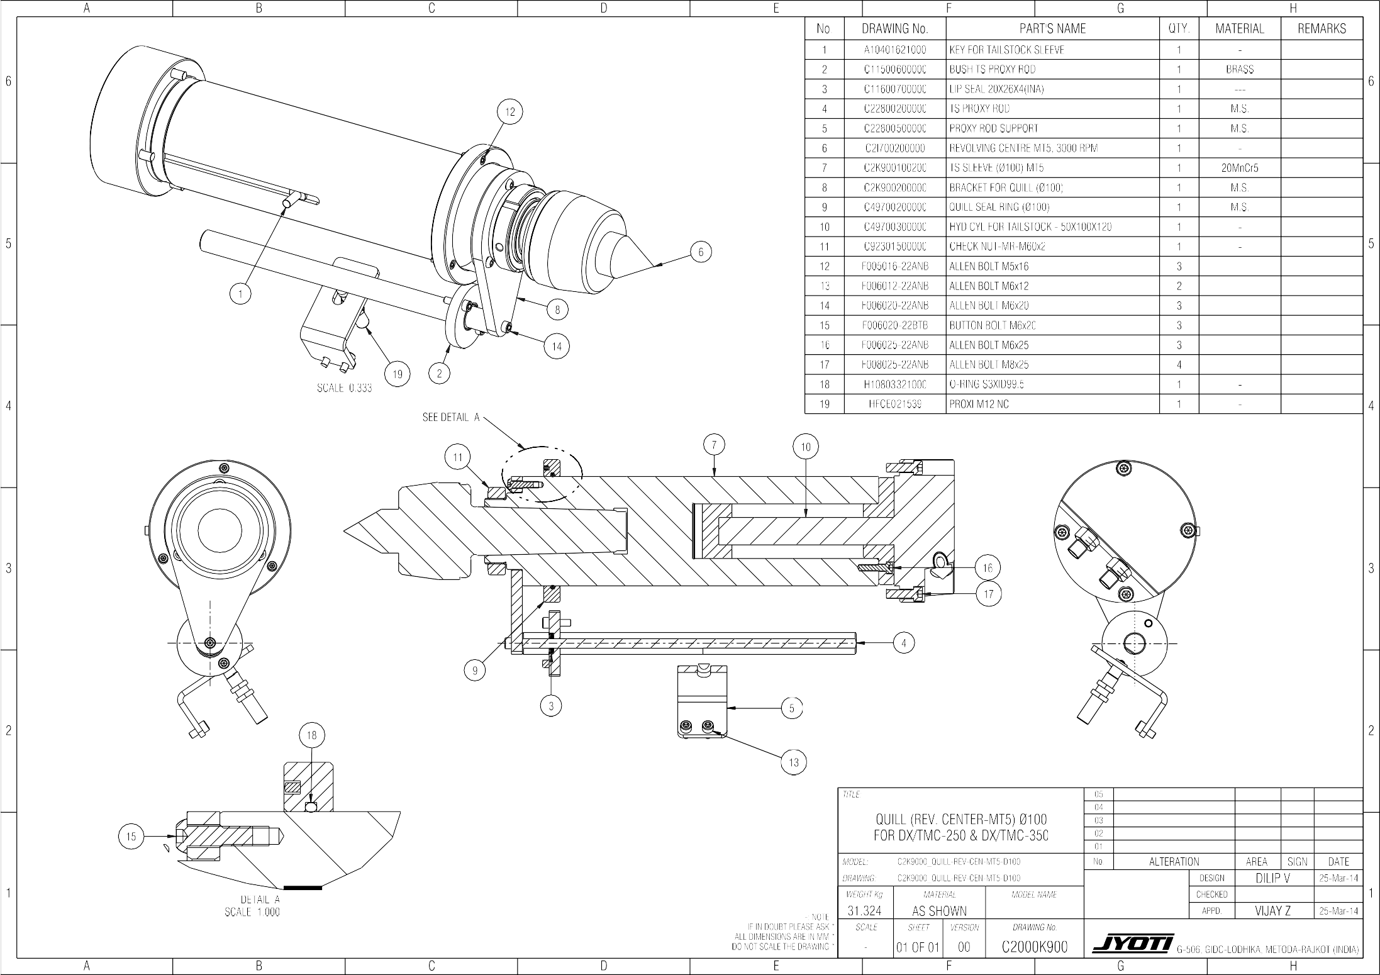



Assembly details C2CH0602102C Page 6.21.1 of 1

#### Lubrication System:

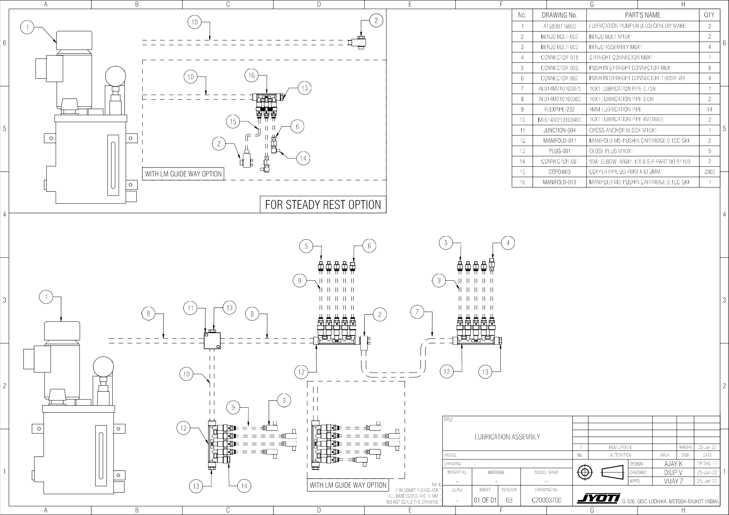

Assembly details C2CH0602203A Page 6.22.1 of 1

**Coolant System:**

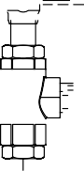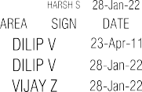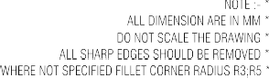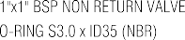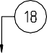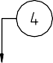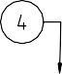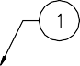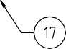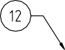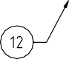

Assembly details C2CH0602500L Page 6.25.1of1



**SPINDLE MTR. ASSY. -FANUC (ALFA18i/22i) +A2_8**

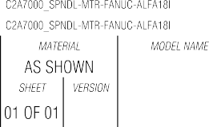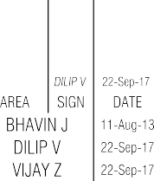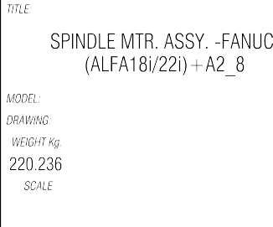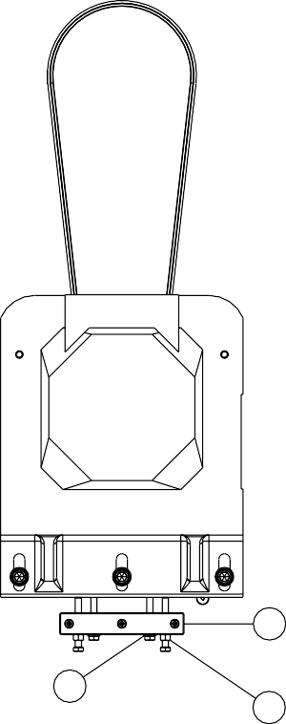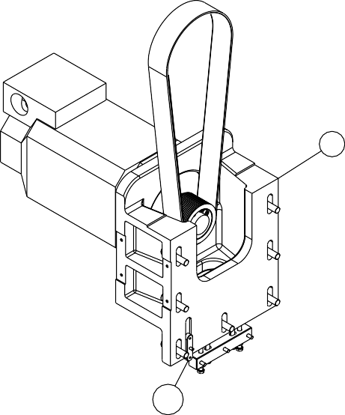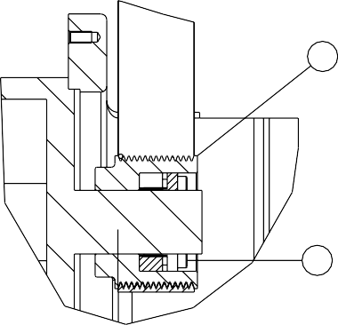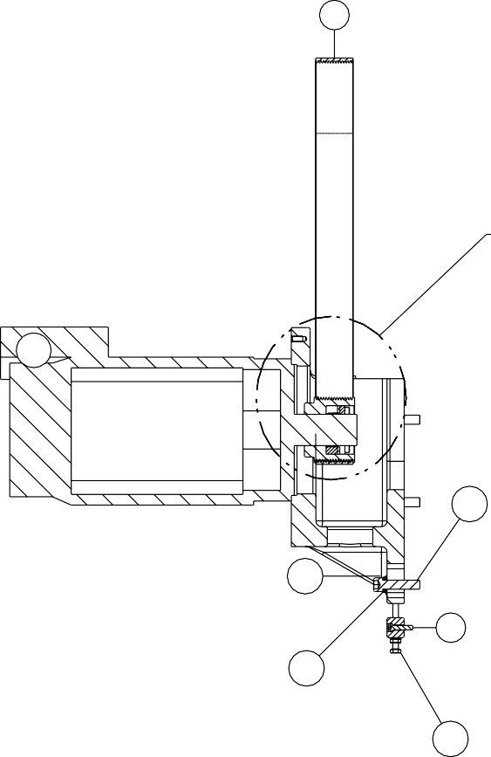

Assembly details C2CH0602802A Page 6.28.1of1

**Hydraulic Routing Diagram**

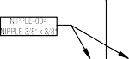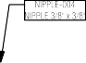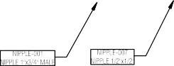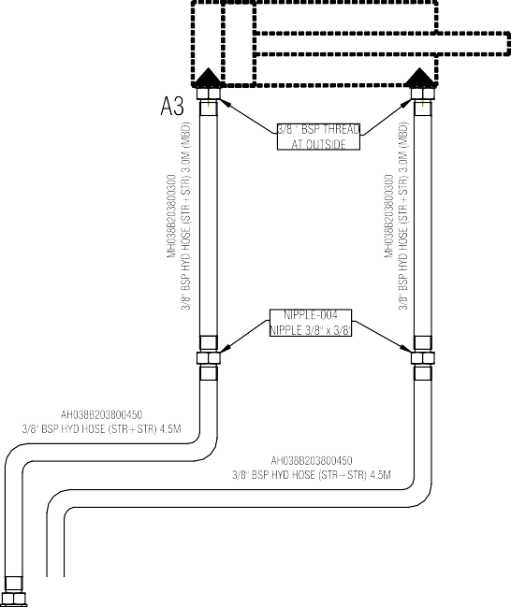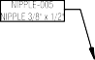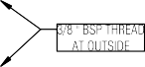

Operating Instructions D8CH0700100A Page – 7.1.1 of 11

# Operating instructions 7

### List of contents

1. **Operating Instructions**
   1. Precautions before Starting…………..………………... 7.1.2 7.2 Warming up ……………………………........................ 7.1.3

7.3 Operation of the machine……...………………………. 7.1.4 7.4 Safety functions ………………………………………… 7.1.9 7.5 Cleaning 7.1.10

7.6 Preservation and Storage… 7.1.11

#### Precautions before Starting Operations:

This section deals mainly with the operating procedures of your CNC lathe under manual control. So the information given here is essential to every operator, whether you are new to a CNC lathe or an “old pro”. Follow these three points.

* + 1. Actually operate the CNC lathe by yourself in reference to this instruction Manual and the operating manual.
    2. Learn the symbols for the numerical control terms.
    3. After you have a general idea of how your CNC lathe operates read this manual repeatedly and also the Programming Manual of NC unit maker.

###### CAUTION:

Bring the machine to a complete stop by turning off the main switch before operations such as setup or adjustments inside the chip guard are carried out.

Also turn off the main switch before you attempt to work inside the machine at the rear side of the machine.

###### NC Operation:

Before you begin to operate the machine automatically, make it a rule to check the following points against a process sheet, a program manuscript, or any other chart giving detailed machining instructions:

1. Setting of hydraulic power chuck jaws and their griping pressure.
2. Installation and arrangement of individual cutting tools with respect to their operating sequence.
3. Setting of tool offsets.
4. Setting of zero offsets.
5. Setting of federate override to 100%.
6. Setting of soft-wired limit positions for each axis. All essential information on the setup and check-up procedure is described in the sections that follow.
7. Positioning of the turret to the turret indexing position
8. Positioning of tail stock (when the machine is equipped with tail stock).

Operating Instructions D8CH0700100A Page – 7.1.2 of 11

All essential information on the setup and check-up procedure is described in the sections that follow.

1. After making or editing program, see simulation (at that time axis should be in safe position).
2. If any interference of Job, chuck, tool or any Machine part is possible during machine operation set working area lamination where operator can set his own working area limit (for more details see manual cnc controller).
3. Check the pressure of Lubrication Unit & check the oil circulation in pipes.

###### Never rotate the spindle without a tool.

**Never exceed the maximum speed authorised for the tool.**

#### Warming-up:

###### Purpose of warming-up

When the machine is operated again after standstill for a long time of after various troubles, the warming-up of the machine is necessary for the stability of lubrication, fluid temperature and precision and for the machine life. When starting operation in the morning, Operator should perform the machine warming-up.

For the warming-up, auto-operation by means of program is more desirable than manual operation.

###### CAUTION:

* Period: unloaded operation for more than 15 minutes. (Longer in Winter)
* Spindle speed; approximately 500 rpm.
* Traverse: proper execution of cutting feed rate and rapid traverse in turn.
* Check the condition of lubrication during the warming-up.
* Check the Turret indexing functioning by program.

Operating Instructions D8CH0700100A Page – 7.1.3 of 11

#### Operation of the Machine:

The main operation of the machine is described in this section. Before operating the machine, the operator is advised to study and familiarizes himself with the location and function of the various controls of the machine.

For preparing a complete part program through Manual Data Input (MDA) mode, or for machining a component entirely using MDA mode, and observe the guidelines given in the operating instructions and Programming Instructions of the CNC machine system.

###### Putting the Machine into operation:

Keep the 'Emergency' push button at the Operator's station pressed. When pressed, this latches on its own, and will remain closed until released manually

* Turn the main isolator switch at the electrical cabinet 'On'.
* The control switched ‘On'.
* The screen now displays the current operating mode.
* Release the ‘Emergency' push button. Now the machine is ready for operation.

###### Caution!

The emergency stop buttons must not be used for a normal stop. This would result in the pre-programmed parameters being most and damage both the current work piece and the machining tool.

###### Referencing of the Axes:

Install tool and holder on the position other than reference position. It is very difficult to align cutting points of each tool to specified reference position in order to attach tool on holder. Tool tip worn during cycle causes larger work diameter than specified.

NC program is executed, assuming that every cutting tool has been correctly installed, because variable factors such as installation position and reference position shall be corrected. The corrected difference refers to tool offset value. Tool offset shall be made before first machining, after first cutting, and during cycle, because tool wear degree must be considered even if installed as specified first.

Operating Instructions D8CH0700100A Page – 7.1.4 of 11

NC system has tool offset function that corrects tool error automatically when each tool is indexed into cutting position. Each tool position difference of T-groove plate can be off set by manual switch as in the figure below:

As in the figure, tools tip is placed in the following coordinate point of reference point. X-axis: +60 mm (diameter) Z-axis: -40 mm. Offset value of tool position is -60.00 mm in X-axes, and +40.00 mm in Z- axes, as in the figure above. If tool is correctly installed on reference point, offset value is “0” on both axes.

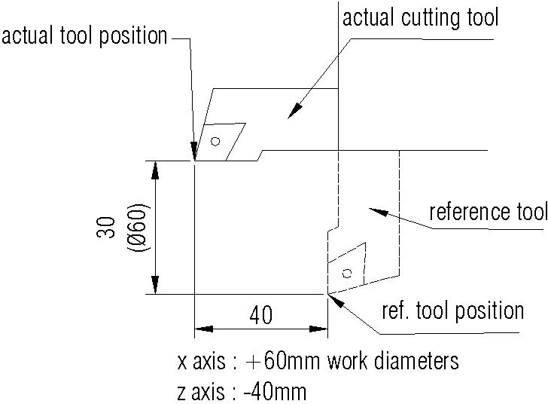

In case of machining without tool offset, tool will move along dot line as in the figure below. After tool offset value is input, tool moves along correct program routing indicated full line. Tool offset is made automatically when T-grove plate moves by inputting desired offset value for each cutting tool of T-grove plate. For measurement and input of tool offset, refer to instruction manual of NC unit.

Operating Instructions D8CH0700100A Page – 7.1.5 of 11

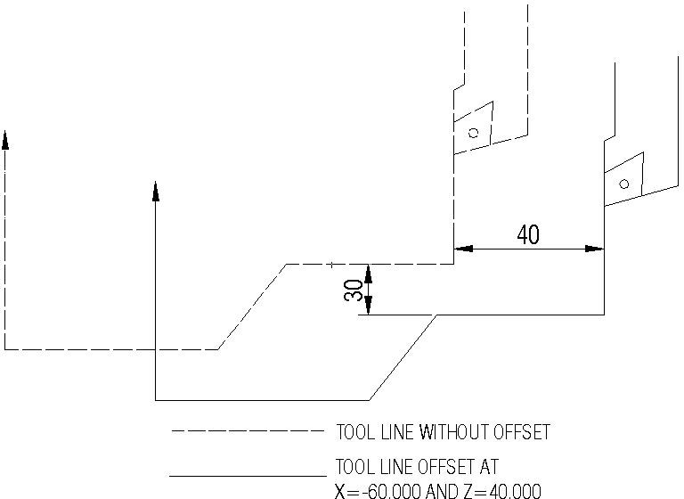

###### NOTICE:

**Tool offset check**

1. After first offset value is input into NC make first cutting operation and measure machining area dimension.
2. In case of error, make tool offset again for correction.
3. In case of dimension error due to tool wear, measure actual machining dimension error due to tool wear, measure actual machining dimension of work and add the error to offset value.

###### CAUTION:

**Setting of start point:**

1. Start point for initial machining if the start point of tool post is changed according to work configuration, non machining time can be reduced. When work or machining process has been changed, the start point for machine reference point shall be changed.
   1. Setting of X-axis start point

Setting procedure of start point is as follow:

* + 1. Machine the outside diameter of work at manual cycle using reference tool.

Operating Instructions D8CH0700100A Page – 7.1.6 of 11

* + 1. Move tool away from work only at Z-axes direction and measure machining area with micrometer.
  1. Setting of Z-axis start point
     1. Rotating spindle, contact reference tool on the sectional surface of work.
     2. Adjust Z-axis coordinate point of CRT to “O” at the area where tool contacts the sectional surface work.
     3. In case the cutting of work face is 2 mm and Z of G59 is 200 mm, move tool 198 mm at “+Z” direction, referring to the position value of CRT. The point is start point of Z-axis.

###### NOTICE:

1. Resetting of starting position after power failure. To prepare for such case that the power source is unexpectedly disconnected during operation or power failure occurs, it is recommended to check and record the relation between the zero position and starting position. When setting of zero position and starting position. When setting or zero position for X and Z axis is completed, follow the procedure described.
   1. Return the tool to the zero position for X and Z axis.
   2. Record the numerical values for X and Z axis which are displayed on the position display unit at that time.
   3. Return the tool to the starting positions for X and Z axis and continue the matching operation.
   4. Suppose that the power source is disconnected or power failure occurs.
   5. Turn the power source on.
   6. Return the tool to the zero positions of X and Z axis.
   7. Reset the display on the position display unit to 0 for both X and Z axis.
   8. Move the tool in “~-“direction for both of X and Z axis until the values recorded as above are displayed. Thus, the tool is returned to the starting position. When, however, time elapses after power failure, machining dimensions may become different because of thermal displacement etc. of the machine.

Operating Instructions D8CH0700100A Page – 7.1.7 of 11

Operating Instructions D8CH0700100A Page – 7.1.8 of 11

###### CAUTION:

**Automatic operation**

When tool setting, setting of starting position and tape checks are all completed, automatic operation is to be started by setting the tape or memorizing the tape on the numerical control unit. Prior to automatic operation, however, be sure to check for the following points.

1. Check the set value of federate. Override switch. Normally, it is recommended to set it to 100%
2. Check the set value of spindle speed override switch. Normally, it is recommended to set it to 100%
3. Check the dry run toggle switch if OFF, If lamp is ON, turn OFF the toggle switch, and lamp is turned OFF.
4. Set the machine lock/display lock toggle switch to the neutral position.
5. Check whether that the optional block skip toggle switch is set to the ON position or OFF position. Usually, set this switch to OFF when cutting the first work piece and keep it ON when cutting the second and subsequent work pieces.
6. Check whether the optional stop toggle switch is set to the ON or OFF position. Usually, set this switch to ON when cutting the first work piece and keep it turn OFF when cutting the second the subsequent work piece.

.

#### Safety Functions:

* Always bear the risk of a collision in mind.
* Never insert a hand, arm or head between moving parts or parts which are liable to shift.
* Depending on the programming, a cycle may end after a “stop machine” command. Take account of this before taking any action. Always take account of the inertia of certain moving parts.
* The machine is equipped with limit proxy devices managed by the numerical control. Do not attempt to disable them.
* There is a risk of swarf projection. Protect your eyes.
* The temperature of the swarf may be very high and cause serious burns.
* Beware of cutting tools.
* Keep hands well away from cutting tools in manual setting mode.
* Beware of the risks in the event of a tool breaking, especially in setting mode.
* Take all due precautions when unloading tools. They may be very hot and are sharp.
* Ensure that the controls cannot be operated during a tool change.
* The user is responsible for using the protective devices provided and for checking the state and operation regularly.
* Provide for the extraction of sprinkler fluid vapours in accordance with labour regulations.
* Use of the machine in an explosive atmosphere is not allowed.
* Use protective equipment: gloves, glasses, etc.
* Safety footwear compulsory.
* Wear ear muffs.

Operating Instructions D8CH0700100A Page – 7.1.9 of 11

* Machining can produce shrill noises in certain cases, independently of machine noise.
* Only use cutting tools suited to the machine and the machining job to be performed. They must be in good condition.
* The workpiece clamping devices must be in good condition and suited to the machine and the machining job to be performed.
* Avoid excessive vibration.
* Make sure that there is no danger to people when the machine is put into operation.

#### Cleaning:

* **DAILY CLEANING:** The operator must clean the machine and its accessories thoroughly every day.
* Clean the sprinkler fluid filter. See the documentation for this device depending on the options provided.
* Remove the swarf (do not use compressed air as this would blow the swarf everywhere including the smallest corners).
* Empty the swarf trays.
* Swarf must be removed while the spindle is stopped.
* Wear gloves and use an appropriate hook.
* Clean the table slots.
* Clean the tool holder taper shaft.
* Clean the telescopic slide way guards.
* Clean the protective windows without scratching them.
* Do not spray water.
* Dry the machine.

Operating Instructions D8CH0700100A Page – 7.1.10 of 11

Operating Instructions D8CH0700100A Page – 7.1.11 of 11

* Also clean the floor in the vicinity of the machine as it may be slippery from the oils.
* The user must also ensure that used oils are collected.

###### Caution!

* During cleaning work on the machine, the spindle must not be rotating and the movement controls must not be activated.
* During cleaning work on the machine, the air barrier and spindle lubrication must be running.

#### Preservation and Storage:

If the machine is to remain unused for several months following machine shutdown, it is advisable to:

* Coat the machined parts with special protective grease.
* Drain:
  + the hydraulic power unit,
  + the lubrication unit,
  + the spindle cooling unit.

Storage conditions: Temperature: - 30 to + 60 °C.

Humidity: < 80 % condensation-free.

Maintenance C2CH0800100B Page 8.1.1 of 2



# Maåntenance

8

List of contents

1. **Maintenance**

1 Tools………………………………………………………… 8.1.3

2 Adjustment & fittings ……………………………............... 8.2.1

3 Coolant system…………………………………………….. 8.2.4

4 Control system……………………………………………... 8.2.5

4 Repairs……………………………………………………… 8.3.1

5 General Precautions………………………………………. 8.3.2

6 Preventive maintenance schedule …….………………… 8.3.3

7 Maintenance chart…………………………………………. 8.4.1

Maintenance C2CH0800100B Page 8.1.2 of 2



#### Tools:

Only standard conventional tools are required for machine maintenance.

* Allen Key Set
* Fix Spanner Set
* Voltmeter
* Bosch 46-piece tool kit
* Adjustable Spanner 35x305mm length
* Internal Circlip Plier
* External Circlip Plier

###### CAUTION:

* Use suitable tools in good condition.
* **The operations are to be carried out with machine power switched off. The machine must be tagged out (pneumatically and electrically).**

Maintenance C2CH0800200A Page 8.2.1 of 8

#### Adjustment & Fittings:

The machine bed is slanted mono block design of high quality graded gray cast iron having multiple rib single piece structure to absorb vibration and supports the whole machine.

The head stock is mounted on the left side of the box stand. The carriage assembly is sliding on the bed guide ways. The z-axis motor is supported on the bed and the ball screw is mounted on the scoop of the guide ways. The main drive motor is fixed to the left of the base and the hydraulic power pack is at the rear right of the base. The bed guide ways (Z-axis) of the carriage movement is protected by special wipers on left side & roll up cover on right side. The telescopic covers protect the guide ways and the ball screw from sharp, dust and coolant and prevent coolant and chip splashing to the rear side.

###### Telescopic cover/steel bellows/wiper Adjustment:

The telescopic covers/steel bellows do not require any adjustment, But if wipers of the telescopic or flaps of steel bellows are worn and/or damaged then it should be replaced and/or repaired. However it should be checked for smooth movement and for any unusual sounds. In case of any undue vibration of the machine, check the leveling of the machine and lock the leveling screws.

###### Dismantling and Reassembly:

The telescopic covers are dismantled to change the rubber wipers or replacing them as a total unit.

For dismantling of x-axis telescopic cover move the worktable to a central position. Then remove table guards from both sides after the remove the screws connecting the working table. Now the telescopic covers can be carefully lifted from the top guide rail.

To remove the y-axis telescopic cover, first remove y-slide guards from both sides then remove the screws connecting the y-slide.

###### CAUTION:

Keep attention while doing maintenance or setting, as steel bellows contain sharp edges.

THE CONDITION OF THE PROTECTIVE ELEMENTS FOR THE GUIDE WAY AND SLIDE WAY IS VERY IMPORTANT FOR THE PROPER FUNCTIONING AND LIFE OF THE MACHINE.

Maintenance C2CH0800200A Page 8.2.2 of 8

###### Ball screw and End bearing Adjustments (Z and X axes):

The ball screw end bearings have been pre loaded to the specified values. As such no adjustments are required from your end. JYOTI personnel using appropriate tools and equipment, if required, should only do any readjustment.

The manufacturer has carried out the pre loading of the ball nut and this should never be tampered with. For any replacement of the ball screw/nut our service personnel should be consulted.

###### CAUTION

SINCE THE BALL SCREW SUPPORT BEARING PRE LOAD AND BALL SCREW NUT PRE LOAD SETTING ARE VERY IMPORTANT AND HAVE TO BE CARRIED OUT BY USING SPECIAL TOOLS. THESE HAVE TO BE DONE BY JYOTI PERSONNEL ONLY: ANY CARELESS ADJUSTMENTS MIGHT DAMAGE THE ENTIRE CARRIAGE MOVEMENT AND DRIVE SYSTEM.

###### Turret Dismantling and Re-assembly:

**Dismantling:**

Removing the turret from the cross slide:

If major repairs are involved dismantling and reassembling of the turret will be required, the turret assembly has to be dismantled from the cross slide. Remove all hydraulic lubrication and electrical connections after removing all the tools from the disc. Use a suitable rope to sling the turret housing using a hoisting device so that the housing will not fall, while the Hex. Nut 6 nos. and the internal threaded taper pins are removed. Now the housing can be lifted carefully and kept on a wooden table.

If it is required to dismantle the turret motor then the motor cover at the rear side of the turret is needed to remove. To remove the cover first of all move the z-axis to right hand end (from front) position, then remove guard which is attached to x-axis rear cover.

###### Caution:



Don’t remove guard attached with x-axis rear cover without moving the z-axis to right (from front) hand end position.

Maintenance C2CH0800200A Page 8.2.3 of 8

###### Re-assembly;

Inspect the entire component and the standard parts in the assembly for any damage and replace bearings, o-rings etc. if necessary.

###### Proximity Switches:

There are two proximity switches for sensing the forward (unclamp) and backward (clamped) position of the turret disc. The LED indicates whether the proximity switch is actuated or not. It can be rest by; adjusting the check nuts so as to maintain a gap of 1 to 1.5 mm between the sensing face and actuator.

###### Head Stock Adjustments:

The head stock with the spindle has been aligned with respect to the main guide way in the tool plane in a both plane primary & secondary. However, any accident involving tools or turret and Head Stock or job could cause to deviations to this alignment. In such case, realignment can be carried out in the following manner. There is an adjustment arrangement for spindle parallelism with respect to the main guide ways (Please see the picture). The pivoting pin is in the front bottom center of the head stock. So you can adjust to spindle parallelism by just adjusting the bolts as shown in the picture.

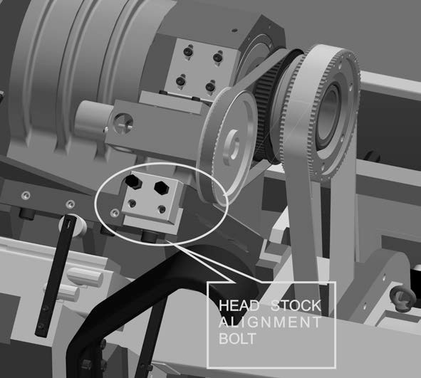

Maintenance C2CH0800200A Page 8.2.4 of 8

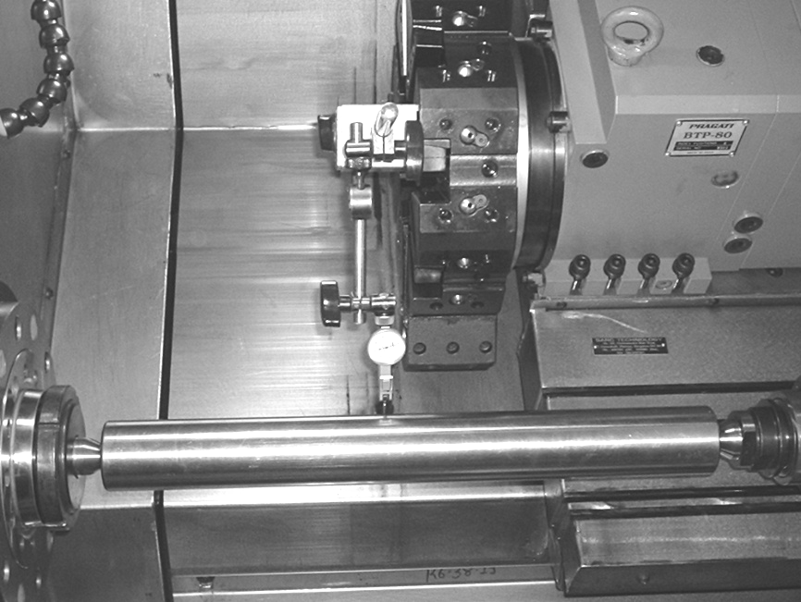

Insert the mandrel in to the spindle taper bore. Check the run out of spindle at the 300 mm mandrel length. Mount the dial indicators on any suitable portion of the carriage assembly to check the parallelism in both. Move the carriage and measure the difference in at the ends of the mandrel. This reading shows parallelism of spindle axis to z-axis.

To retain this parallelism, loosen all the clamping bolt of head stock body very lightly and do fine adjustment through adjustment bolts which is at the rear right end of the head stock. No adjustment will be required in the vertical plane. Keep the reading of the dial indicators within permissible limits and tighten the entire the bolts without disturbing the readings. Check the reading finally to confirm the results.

Before aligning the head stock carefully check that there is no part in the spindle bearing system or head stock is damaged and if found so, replace the parts before aligning.

###### Adjusting the Spindle Bearings:

Necessary adjustments have been made at our factory for the required pre load on the spindle bearings for the proper functioning. The angular contact bearing system is for life grease lubricated with special synthetic grease and run in at the specified conditions. No adjustments are required unless the bearings are damaged due to accident or due wear.

However it is wise to check the radial run out and axial play to ascertain the condition of the bearing. The drag torque as new and after years of use will also vary considerable. If the measured value is above the recommended value then the bearing assembly is to be checked with the guidance of JYOTI service engineer and replace, if necessary.

Maintenance C2CH0800200A Page 8.2.5 of 8

###### Adjusting belt of Spindle Drive:

An arrangement for adjusting the belt tension is given as shown here under.

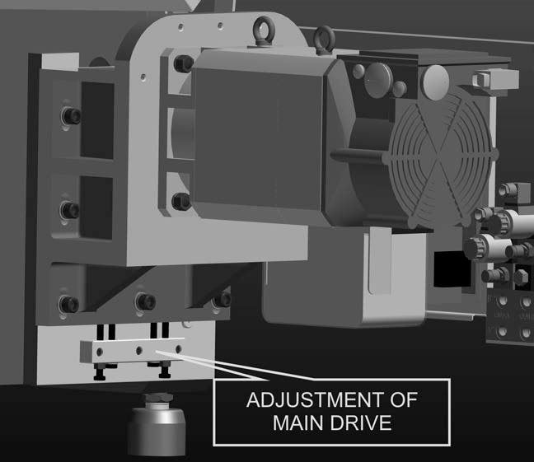

###### Coolant System:

A pump with electric motor is mounted in the coolant sump portion of the chip conveyor.

Piping to selected tool station through a special sealing arrangement connects the output of the pump.

Additional pressure filter is provided in special cases. The filter contain high grade stainless steel mesh element(reusable),resin impregnated fiber free water resistant organic paper element(disposable) and glass fiber(disposable). Start up – slacken the vent plug or pressure drop indicator or the banking plug to permit free escape of air, commence filling the filter and when fluid appears retighten.

Maintenance C2CH0800200A Page 8.2.6 of 8

###### Cleaning the filter elements:

1. Loose contamination can be washed from the surface of the filter element by agitating the elements in a suitable solvent. Only S.S. elements should be cleaned, although paper and glass fiber elements can be washed in this manner in an emergency only.
2. Lightly brush the element to remove the more stubborn particles. This should be effective for larger particles and be suitable for elements of 25 micron and above. For finer elements, including metal felt, and where there is heavy or dense contamination ultrasonic cleaning will be required.
3. After washing, an air line should be used to dry the element and to blow loose particles from the inside to the outside of the elements.

#### Maintenance of the hydraulic system

###### Reservoir:

Large removable covers are provided at the ends of the reservoir for easy accessibility during cleaning. A replaceable fine mesh wire screen provided in the air breather keeps foreign matter out of the reservoir when new fluid is added. A baffle plate extending lengthwise through the centre of the tank reduces turbulence created by return flow, and controls the direction of fluid circulation. Because a large portion of fluid contaminants accumulates in the reservoir, a good preventive maintenance program is required for periodically draining and cleaning the reservoir and for flushing with a solvent compatible with the hydraulic fluid being used. After cleaning, the reservoir should be filled to the required level with a clean, high quality hydraulic fluid conforming to the specifications listed in this Manual. After filling, operate the system for a few minutes so that the oil displaces the entrapped air in the circuit. The oil level should be rechecked now and more oil should be added if necessary.

###### Strainers and Filters:

It is important to keep the hydraulic fluid clean, for ensuring long life and trouble free performance of the hydraulic components. When the system operates at high speed and pressure, the contaminants could cause excessive wear and power loss and also malfunction of components. Maintenance and replacement costs can be reduced through good filtration. Check a condition of strainers & filters fitted on hydraulic system time to time as given in maintenance schedule.

Maintenance C2CH0800200A Page 8.2.7 of 8

###### Filling and Flushing:

**Oil Change:**

The frequency with which the oil in the hydraulic system is changed depends on both the fluid and the operating conditions involved. The importance of good draining practice cannot be over emphasized.

Periodic laboratory analysis is the most accurate method for determining the frequency. The fluid supplier can often run these tests. In general, fluid should be changed when viscosity and acidity begin to increase as a result of breakdown and contamination.

Changing the fluid at the operating temperature of the system will drain off as much of the impurities in suspensions as possible. Scheduled drainage at proper intervals also will require less time and effort in restoring proper system conditions.

* + Though precautions should always be observed for ensuring a clean hydraulic system, as follows :
  + Flush the entire system for removing paint, metal chips, welding shots, lint, etc.
  + Filter every change of oil for preventing the ingress of contaminants into the system.
  + Provide continuous oil filtration for removing sludge and products of wear and corrosion generated during system operation.
  + Provide air breathers with proper filters for protecting the system from the entry of air borne contaminants.

###### Oil:

It is not recommended to fill the system with sub standard oil. High quality oil keeps system clean and operates within the recommended temperature range will give increased life.

Oil should be stored in a clean environment, preferably having a temperature to avoid formation of condensation. Barrels should rest on their side to avoid collection contamination in barrel ends.

Remove any dirt from the barrel, and check that the barrel contents have not been subjected to water contamination. It is strongly advised that the filling of the tank be done using a 25 micron filter.

Maintenance C2CH0800200A Page 8.2.8 of 8

###### Flushing:

Ideally, flushing should be carried out with the actual fluid that will be used in the system. If possible, a flushing pump should be used, which will create oil velocities in excess of those in actual use. It is usual to make small loops having one actuator, and to flush each actuator loop in turn. Make sure that all fluid passes through a high efficiency filter, finer than that used in the system.

If the packaged system pump has to be used, make sure that clean oil and low operating pressure are used. During flushing, check that the filters do not reach by-pass conditions. Change filters elements before and after flushing.

If the system is clean, there is no necessity to change the oil, since this might create the possibility of introducing fresh contamination.

###### Common problems:

Some of the problems occurring most frequently in hydraulic system operation, like insufficient oil in the reservoir, clogged or dirty oil filters, loose intake lines, wrong direction of rotation of pumps, too heavy or too light oils, or too high or low operating pressure. These problems can be easily overcome with only a basic knowledge of hydraulics and an attention to the maintenance procedures. A planned maintenance program will result in reduced operating cost and downtime.

In order to increase the efficiency of the hydraulic system, overheating, excessive pressures and fluid contamination should be avoided. It is relatively easy to learn the signs and symptoms of impending hydraulic troubles.

The operator can hear any unusual noise, can feel the excessive operating temperature, and see the leaking lines and leaky fittings and oil deposits on hand around the machine. Dirty or discolored oil would indicate the need for a filter exchange, or even the oil itself. It is important to note that as much as 70% of all hydraulic problems are traceable directly to the fluid. For reliable performance, periodicals sampling and testing are essential. A noisy pump may be the result of normal wear, but it could also be caused by cavitations due to a clogged inlet strainer. Noise could also result from air leaking through a loose fitting in the intake in or through a damaged shaft seal; in this case, foaming can be observed in the reservoir. Once entrapped in the fluid, air causes spongy or erratic actuation of cylinder and motors.

Slow or sluggish actuators could be the result of low oil temperature or too high viscosity which may cause by internal leakage through the actuator or its controls. A worn out pump too may cause slow movement. Loose mounted bolts or brackets of motor and pump shafts may result in shaft seal or packing to wear, if not corrected immediately.

Maintenance G0CH0800300A Page 8.3.1 of 6

#### Repairs:

###### General information

As a general rule, if the machine is stripped down for the purpose of replacing parts, the following rules must be observed:

* + - Work on a perfectly clean machine.
    - Only qualified staff must be allowed to work on the machine.
    - Consult the drawings provided with the machine and, if necessary, contact sales executive form Jyoti.
    - Adopt good mechanical practice and take particular care of the guide ways and machined components.
    - Only use original spare parts.
    - Do not alter the characteristics of the machine.

###### CAUTION!

Before putting the machine back into production, carry out the necessary tests, adjustments and operational checks. Call in a Jyoti technician if necessary.

###### SPECIFIC INFORMATION:

For safety reasons or due to the need for precision, some components may only be **removed by a Jyoti technician**:

* + - Removal of the electro spindle:
    - Complex operations requiring specific tools.
    - Removal of the various limit switches/proxies on the three axes: specific nature of the adjustments.

Maintenance G0CH0800300A Page 8.3.2 of 6

#### General precautions:

###### Precautions before start:

* + - Check condensate level & ensure that it does not cross half the height of bowl.
    - Check all electrical connections.
    - Ensure that input pneumatic air is chemical free/oil free & does not have abrasive content in it. (if pneumatic is available in machine)
    - Check all the guide ways for the presence of lubricating oil.
    - If any paint is peeled off from any element, the area has to be repainted to prevent spreading of corrosion.

###### During Working:

* + - Make sure that all covers and guards are in their respective position;
    - Never allow any welding work near the machine when the machine is ‘ON';

###### At the End of shift:

* + - Clean the entire machine, guide ways, panels and cabinets.
    - Oil all bright parts after cleaning.
    - Clean and oil the telescopic covers at the end of the day and check for smooth movement. Remove the coolant, chips and the used lubricating oil from the machine surface with a clean rug.
    - Check for any damage or accumulation of chips, dust on the micro switch actuating dogs for the X, Y and Z-axis travel dogs.

Maintenance G0CH0800300A Page 8.3.3 of 6

#### Preventive maintenance schedule:

Preventive maintenance carried out with meticulous care is an essential precondition for the trouble free operation of the machining center. Depending upon the importance of the problem or malfunction, corrective action should be taken immediately, or on a planned basis. It pays to follow the recommended preventive maintenance procedures listed below. The procedure has been scheduled as daily and for every 200 hrs., 500 hrs., 1000 hrs., 2000 hrs., 4000 hrs., and 8000 hrs. of operation.

###### Below mentioned points are applicable based of machine configuration

**Daily Preventive Maintenance Schedule:**

Before the beginning of a shift:

* + - * Check oil level in lubricating oil reservoir: Replenish if necessary.
      * Check coolant level: Replenish if necessary.
      * Check all electrical indication lamps; check for proper functioning;
      * Any error messages on screen: take appropriate corrective action;
      * Clean the cutting chips, oil, water, dust, etc & wipe the machine.
      * Put on anti-rust or grease on the moving surface of the machine.
      * Check operating panel indicator.
      * Make sure the air pressure is between 5 to 6 bars.
      * Inspect for any coolant leak from the base and bed fittings and rectify immediately.
      * Clean the pneumatic filter. (Twice a day if humidity in air is more).
      * Check pneumatic lubrication. Use oil grade 32(OSFW-32- FESTO make).

Maintenance G0CH0800300A Page 8.3.4 of 6

* + - * Check all the pneumatic lines & connectors for leakage & loose connections with valves & filters.
      * Check for loose connections in all the solenoid coils.

###### 200 Hours Preventive Maintenance Schedule:

* + - * Complete all items listed in “Daily Preventive Maintenance Schedule".
      * Check that fuse bases and fuse links are properly seated, and if you notice arcing or pitting on the contact blades, clean them with fine emery paper. Replace blown fuses with fuses of same capacity only.
      * Check whether the overload relays operate, by pressing down and releasing the reset button a few times. While replacing relays, take care to use correct ratings, and set the overload relay for correct rating.
      * Check A.C. air filter for clogging, if closed, clean it properly.
      * Clean the air filter on main motor blower (if provided).
      * Check all feedback devices such as micro-switches, proximity switches, pressure switches, etc., for proper working.
      * Drain the coolant and clean the tank.
      * Check telescopic covers and wipers on the machine. If damaged or showing signs of wear, they must be replaced.
      * Check for any damage of the rubber packing used in the sealing to prevent coolant leakage.
      * Check for dust/dirt, oil in the pneumatic filter element & clean it thoroughly.
      * Change the cutting oil.
      * Clean filter of coolant system.
      * Inspect the lubricating connections fitted.
      * Replace-damaged part, if any.

Maintenance G0CH0800300A Page 8.3.5 of 6

###### 500 Hours Preventive Maintenance Schedule:

* + - * Complete all items listed in “200 Hours Preventive Maintenance Schedule".
      * Check and clean all the air break contactors. If the contactors are badly pitted or worn out, replace them with new contactors. Check that all connectors are proper and secure, while replacing a damaged contactor.
      * Check tension of spindle drive belt and adjust if necessary.
      * Check all wipers and replace if necessary.
      * Check tension of drive chain of chip conveyor, if provided, and adjust if required.
      * Clean the coolant tank, flush the coolant and refill with new coolant.
      * Clean the baffle in the pump in the pump compartment.
      * Check packing for any leakage.

###### 1000 Hours Preventive Maintenance Schedule:

* + - * Complete all items listed in “500 Hours Preventive Maintenance Schedule".
      * Check that the relays are properly seated. If visible signs of pitting or arcing are seen, replace them.
      * Check lubrication oil flow at all points. (Refer "Lubrication System Manual").
      * Do level test and adjustment of the working table and the machine.
      * Make sure the action of the solenoid and micro switch are accurate.

Maintenance G0CH0800300A Page 8.3.6 of 6

###### 2000 Hours Preventive Maintenance Schedule:

* + - * Complete all items listed in "1000 Hours Preventive Maintenance Schedule".
      * Check all terminals for loose connection or damage. Tighten and make sure that wires are secured properly in their terminals.
      * Level the machine.
      * Remove the telescopic covers from the saddle wings and the saddle guide ways and wipe thoroughly. The frequency of inspection depends on the nature of the work material being machined.

###### 4000 Hours Preventive Maintenance Schedule:

* + - * Complete all items listed in “2000 Hours Preventive Maintenance Schedule".
      * Check all the relays and distributors on the machine.
      * Auto lubricant on the oil pressure unit shall all be replaced, also, clean the interior and the filter.
      * Check the function of the measuring meters and indicators.

###### 8000 Hours Preventive Maintenance Schedule:

* + - * Complete all items listed in "4000 Hours Preventive Maintenance Schedule".
      * Grease all AC motors.
      * Replace all piston distributors in the lubrication system.



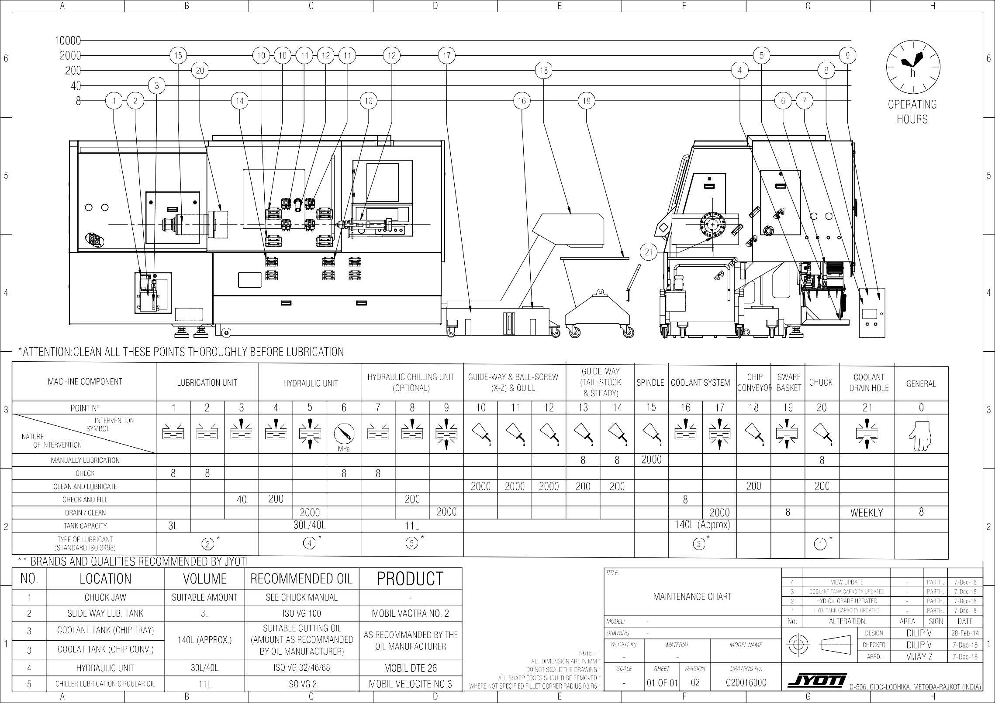Maintenance Chart



Maintenance

C2CH0800402A

Page 8.4.1 of 1

Machining range & tooling C2CH0900101C Page 9.1.1 of 1



# Machånång range & toolång

9

List of contents

1. **Machining range & tooling**

1 Machining range diagrams………………………......... 9.2.1

2 Tool interference diagrams……………………………. 9.2.2

3 Tail stock interference….………………………............ 9.3.1



Machining Range and Tooling C2CH0900200V Page 9.2.1 of 1

X-AXIS MIN.= 30

10 O.T.

X-AXIS STROKE=250 X-AXIS MAX.= 280

X -ve DIRECTION

MRANGE-A2_8 JST100 Z-700-1000

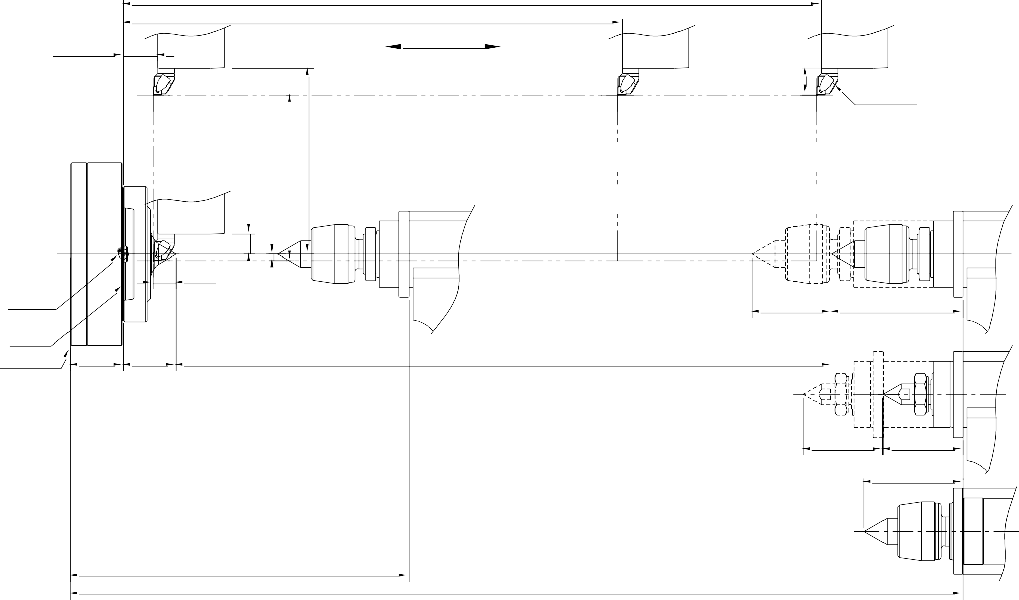

40

X +ve DIRECTION

|  |  |  |  |  |  |  |  |  |  |  |  |  |  |  |  |  |  |  |  |  |  |  |  |  |
| --- | --- | --- | --- | --- | --- | --- | --- | --- | --- | --- | --- | --- | --- | --- | --- | --- | --- | --- | --- | --- | --- | --- | --- | --- |
| A | | B | | | | C | | D | | E | | F | | | | G | | | | H | | | | |
|  |  | |  |  |  | |  | | Z-AXIS MAX.= 1051.5 (FOR Z=1000) | | | | |  | | | | | | |  |  |  |  |
|  |  | |  |  |  | |  | | Z-AXIS MAX.= 751.5 (FOR Z=700) | | | | |  | | | | | | |  |  |  |  |
| 6 | 51.5  Z-AXIS MIN. | |  |  |  | | Z -ve DIRECTION | | Z +ve DIRECTION | | | | |  | | | | | | |  |  |  | 6 |
|  |  | |  |  |  | |  | |  | | | | | AXIAL TOOL 32x32 | | | | | | |  |  |  |  |
| 5 |  | |  |  |  | |  | |  | | | | |  | | | | | | |  |  |  | 5 |
|  |  | |  |  |  | |  | |  | | | | |  | | | | | | |  |  |  |  |
|  |  |
|  |  | |  | 34.6 |  | |  | |  | | | | |  | | | | | | |  |  |  |  |
| 4 | MACHINE ZERO | |  |  |  | |  | |  | | | | | QUILL STROKE 120 198 | | | | | | |  |  |  | 4 |
|  | FACE OF SPINDLE A28 | |  |  |  | |  | |  | | | | | HYD. QUILL WITH REV. CENTER | | | | | | |  |  |  |  |
|  | HEAD STOCK FACE 80 | | 79 |  |  | |  | | 988 | | | | |  | | | | | | |  |  |  |  |
| 3 |  | |  |  |  | |  | |  | | | | | QUILL STROKE 120 120.5 | | | | | | |  |  |  | 3 |
|  |  | |  |  |  | |  | |  | | | | | HYD. QUILL WITH LIVE CENTER | | | | | | |  |  |  |  |
|  |  | |  |  |  | |  | |  | | | | | 149 | | | | | | |  |  |  |  |
| 2 |  | |  |  | MIN =*510 | |  | |  | | | | | FIX QUILL WITH REV. CENTER | | | | | | |  |  |  | 2 |
|  |  | |  |  |  | |  | | STEADYTAILSTOCK MAX = 1345 | | | | |  | | | | | | |  |  |  |  |
|  |  | | | | | | | | | | *TITLE:* | | | | | |  |  | | |  |  |  |  |
|  |  | | | | | | | | | | MACHINING RANGE DIAGRAM | | | | | |  |  | | |  |  |  |  |
|  |  |  | | |  |  |  |  |
|  |  | | | | | | | | | | A2_8 JST100 Z-700-1000 | | | | | |  |
|  |  | | |  |  |  |
|  |  | | | | | | | | | |  | | | | | | 1 |  | | |  |  |  |  |
|  |  | | | | | | | | | | *MODEL:* | |  | | | | No. | ALTERATION | | | AREA | SIGN | DATE |  |
| 1 |  | | | | | | | | | | *DRAWING:* | |  | | | |  | | DESIGN | | PARTH J | | 27-Mar-24 | 1 |
| *WEIGHT Kg.* | | *MATERIAL* | | *MODEL NAME* | | CHECKED | | DILIP V | | 27-Mar-24 |
|  | NOTE :- * | | | | | | | | | |  |
| - | | - | | - | | APPD. | | VIJAY Z | | 27-Mar-24 |
|  | ALL DIMENSION ARE IN MM * | | | | | | | | | |  |
| *SCALE* | | *SHEET* | *VERSION* | *DRAWING No.* | |  | | | | | | |
|  | DO NOT SCALE THE DRAWING * | | | | | | | | | |  | | | | | | |  |
|  | ALL SHARP EDGES SHOULD BE REMOVED * | | | | | | | | | |  | | | | | | |  |
|  | | 01 OF 01 | 00 | C20021900 | |
|  | WHERE NOT SPECIFIED FILLET CORNER RADIUS R3;R5 * | | | | | | | | | | G-506, GIDC-LODHIKA, METODA-RAJKOT (INDIA) | | | | | | |  |
| A | | B | | | | C | | D | | E | | F | | | | G | | | | H | | | | |



Machining Range and Tooling C2CH0900300M Page 9.2.1 of 1

71

TOOL INTERFERENCE DIAGRAMS (JST100-8S-32X32-BB-D50) S

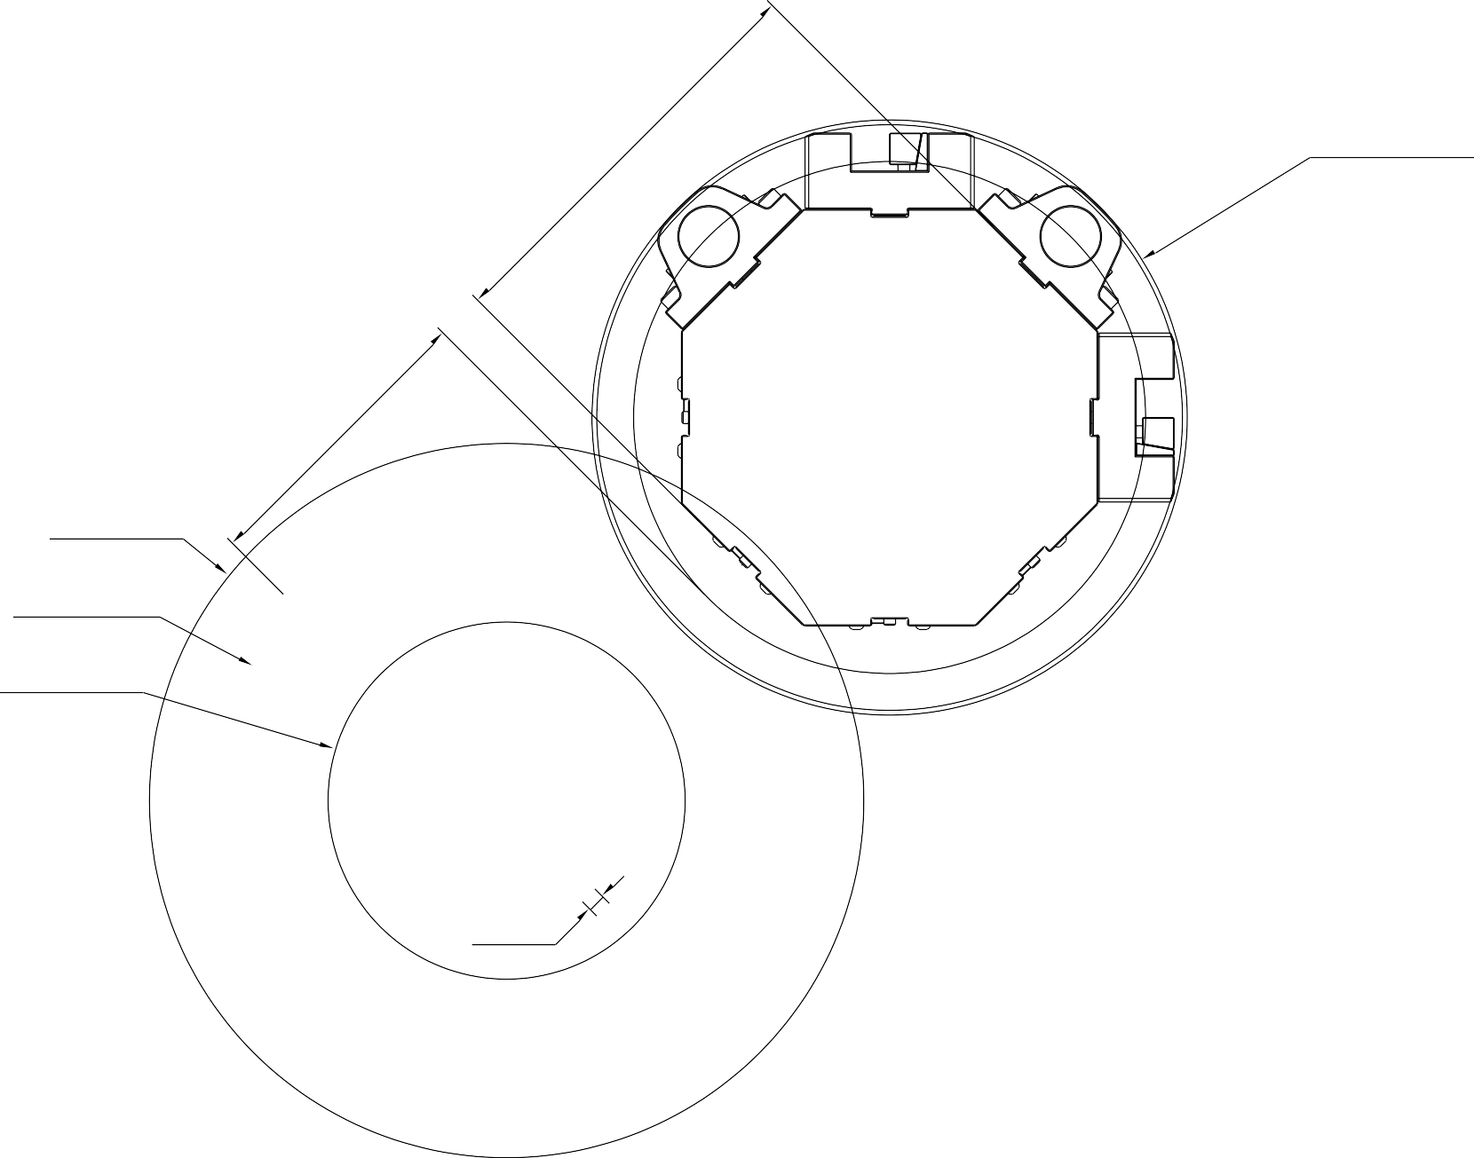

|  |  |  |  |  |  |  |  |  |  |  |  |  |  |  |  |  |  |  |  |
| --- | --- | --- | --- | --- | --- | --- | --- | --- | --- | --- | --- | --- | --- | --- | --- | --- | --- | --- | --- |
| A | | B | C | D | E | | F | | | | G | | | | H | | | | |
| 6 | Ø307.5  32 Ø50  BORING BAR DIA.  Ø500  TOOL HOLDER SWING    Ø600 SWING OVER BED  Ø480  MAX. TURNING DIA.  Ø300  STD. TURNING DIA. Ø276.3    10 O.T.  15 BORING TOOL O. T | | | | | | | | | | | | | | | | | | 6 |
| 5 | 5 |
| 4 | 4 |
| 3 | 3 |
| 2 | 2 |
| NOTE :- * ALL DIMENSION ARE IN MM * DO NOT SCALE THE DRAWING *  ALL SHARP EDGES SHOULD BE REMOVED * WHERE NOT SPECIFIED FILLET CORNER RADIUS R3;R5 * | | | | | *TITLE:* | | | | | | 5 |  | | |  |  |  |
| TOOL INTERFERENCE DIAGRAM JST100 8ST 32X32 BB D50 | | | | | | 4 |  | | |  |  |  |
| 1 | 3 |  | | |  |  |  | 1 |
| 2 |  | | |  |  |  |
| 1 | VIEW UPDATED | | | - | PARTHJ | 27-Mar-24 |
| *MODEL:* | |  | | | | No. | ALTERATION | | | AREA | SIGN | DATE |
| *DRAWING:* | |  | | | |  | | DESIGN | | DILIP V | | 10-Oct-14 |
| *WEIGHT Kg.* | | *MATERIAL* | | *MODEL NAME* | | CHECKED | |  | |  |
| - | | - | | - | | APPD. | | VIJAY Z | | 27-Mar-24 |
| *SCALE* | | *SHEET* | *VERSION* | *DRAWING No.* | | G-506, GIDC-LODHIKA, METODA-RAJKOT (INDIA) | | | | | | |
|  | | 01 OF 01 | 01 | C20016400 | |
| A | | B | C | D | E | | F | | | | G | | | | H | | | | |

Machining Range and Tooling C4CH0900401A Page 9.4.1 of 1

Tail stock Interference (tool size 32x32)

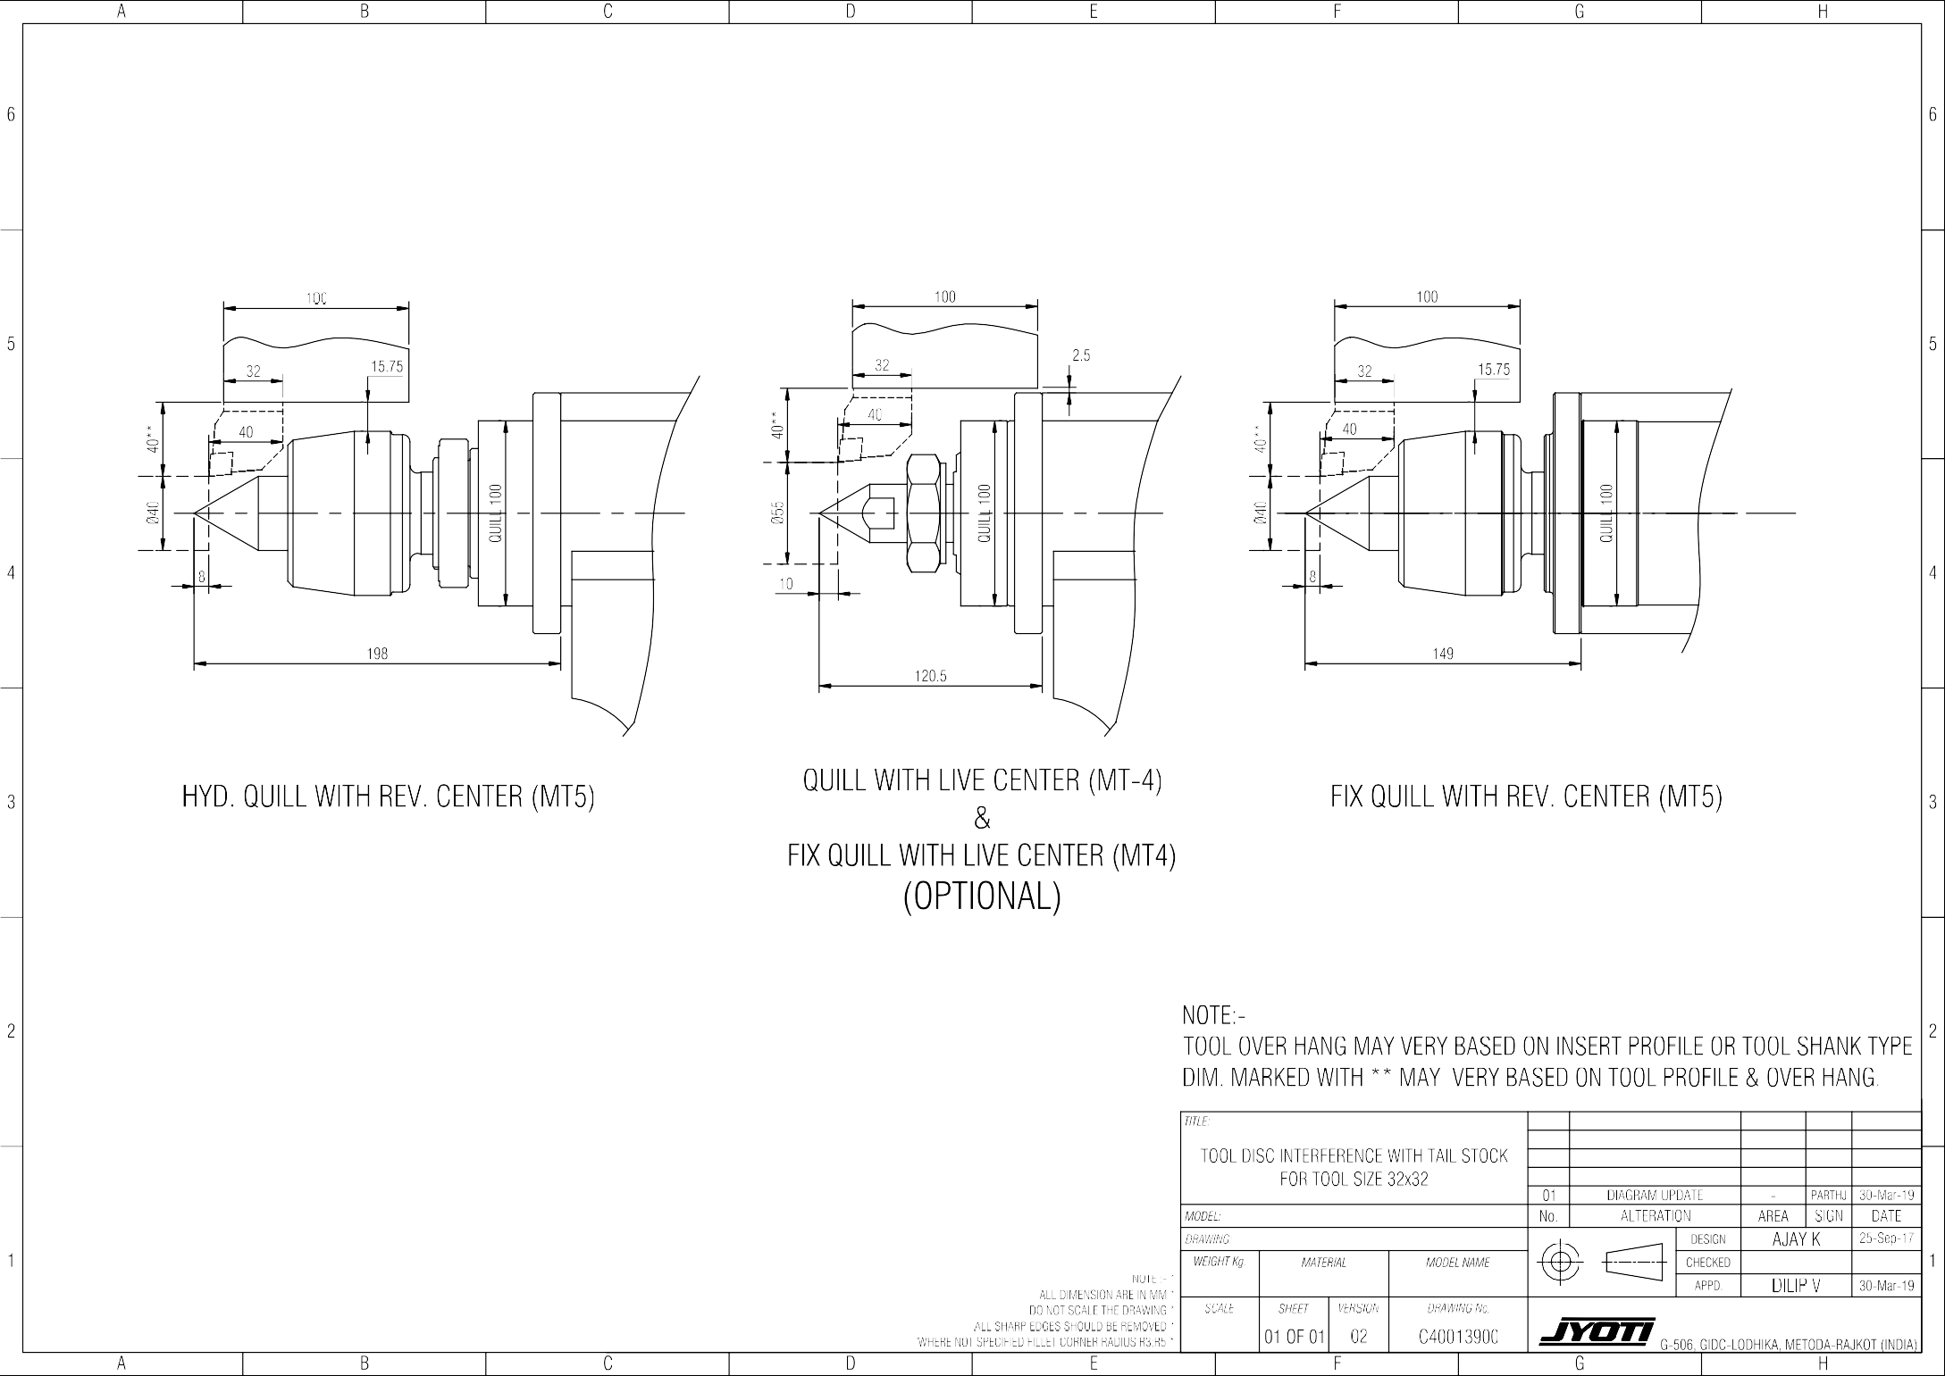

Machining Range and Tooling L0CH0900700A Page 9.5.1 of 2

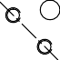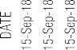

###### Normal Cutting Tool Application

Machining Range and Tooling L0CH0900700A Page 9.5.2 of 2

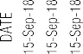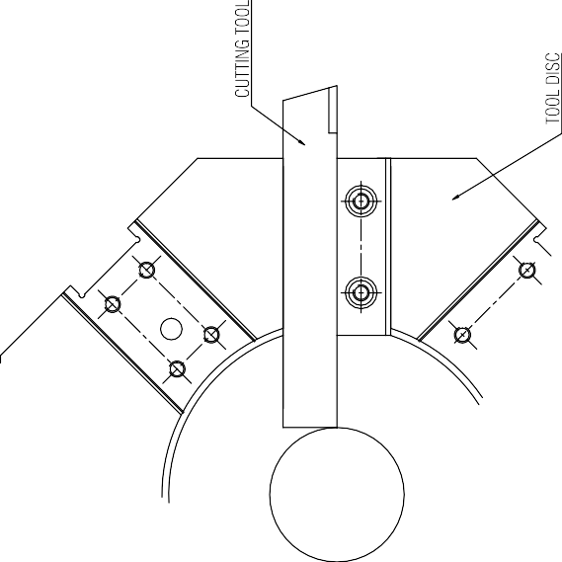

**Reverse Cutting Tool Application**

# Supplier’s product list

``

List of contents

1. **Suppliers product list**

10

Suppliers Product List C2CH1000101B Page 10.1.1 of 3

1. Suppliers Product List 10.1.3

``

Suppliers Product List C2CH1000101B Page 10.1.2 of 3

|  |  |  |  |  |  |
| --- | --- | --- | --- | --- | --- |
| **Sr.**  **no.** | **Description** | **Part Code** | **Supplier** | **Included in**  **Machine?** | **Remark** |
| 1 | HYDRAULIC POWER PACK | C12500117100 | FLSPL | YES/NO |  |
| REXROTH | YES/NO |  |
| YUKEN | YES/NO |  |
| 2 | LUBRICATION PUMP(ALU-3) | A15800116000 | CENLUB | YES/NO |  |
| 3 | COOLANT PUMP RKM120 | V58800316000 | RAJAMANE | YES/NO |  |
| COOLANT PUMP RKM254 | HF174508 | RAJAMANE | YES/NO |  |
| COOLANT PUMP RKM608 | D80900200000 | RAJAMANE | YES/NO |  |
| COOLANT PUMP RKM620 | G26200400000 | RAJAMANE | YES/NO |  |
| 4 | HYD CHUCK DIA. 250-3JAWS | C16800120000 | KITAGAWA | YES/NO |  |
| HYD CHUCK DIA. 305-3JAWS | C44400120000 | KITAGAWA | YES/NO |  |
| HYD CHUCK DIA. 380-3JAWS | C46600120000 | KITAGAWA | YES/NO |  |
| HYD CHUCK DIA. 250-3JAWS | A17800320000 | AIRTECH | YES/NO |  |
| HYD CHUCK DIA. 305-3JAWS | A27800420000 | AIRTECH | YES/NO |  |
| HYD CHUCK DIA. 380-3JAWS | C29300120000 | AIRTECH | YES/NO |  |
| 5 | HYD CYLINDER S1875 | A27810420000 | KITAGAWA | YES/NO |  |
| HYD CYLINDER S2091 | C44400220000 | KITAGAWA | YES/NO |  |
| HYD CYLINDER HOHSA175 | C2M400100000 | AIRTECH | YES/NO |  |
| HYD CYLINDER HOHSA200 | C5A100100000 | AIRTECH | YES/NO |  |
| 6 | TURRET JST-100 / LTT-100 | TC***** | JYOTI | YES/NO |  |
| 7 | CHIP TRAY ( Z-700) | C220000 | JYOTI | YES/NO |  |
| CHIP TRAY ( Z-1000) | C291000 | JYOTI | YES/NO |  |
| CHIP CONVEYOR HINGED TYPE | C22901200000 | JYOTI | YES/NO |  |
| CHIP CONVEYOR SCRAPPER TYPE (Z-700) | C2C400100000 | V.I.P. | YES/NO |  |
| CHIP CONVEYOR SCRAPPER TYPE (Z-1000) | C2C300100000 | V.I.P. | YES/NO |  |
| 8 | IN-LINE FILTER-25L225G100RMVOP | C12401116000 | BHAGWATI | YES/NO |  |
| 9 | STEADY REST FRU-2 | C29700100000 | FAR | YES/NO |  |
| STEADY REST FRUB-3 | C2B300100000 | FAR | YES/NO |  |
| STEADY REST HS312 | C2I900100000 | FAR | YES/NO |  |
| STEADY REST SHS-523SP1 | C49000100000 | FAR | YES/NO |  |
| STEADY REST FRUB-3.1 | C49000100000 | FAR | YES/NO |  |
| 10 | GEARBOX ZF-2K121 (FOR SIEMENS) | C29800500000 | ZF | YES/NO |  |
| GEARBOX CE11 (FOR SIEMENS) | BARUFFALDI | YES/NO |  |
| GEARBOX ZF-2K120 (FOR FANUC) | C2E900300000 | ZF | YES/NO |  |
| GEARBOX CE11 (FOR FANUC) | BARUFFALDI | YES/NO |  |

``

Suppliers Product List C2CH1000101B Page 10.1.3 of 3

|  |  |  |  |  |  |
| --- | --- | --- | --- | --- | --- |
| **Sr.**  **no.** | **Description** | **Part Code** | **Supplier** | **Included in Machine?** | **Remark** |
| 11 | POLY-V BELT-MICRO-V/14 PL1613 | C22201200000 |  | YES/NO |  |
| TIMING BELT (1600-8MGT-50) | C29800300000 |  | YES/NO |  |
| 12 | ENCODER TIMING BELT (1584-8MGT-20) | C27800221000 |  | YES/NO |  |
| 13 | BARFEEDER QUICKFEED-12 | C15400112000 | FAR | YES/NO |  |
| BARFEEDER MF-3 | C2C500112000 | FAR | YES/NO |  |
| BARFEEDER QUICKFEED-15 | C1K400100000 | FAR | YES/NO |  |
| 14 | BAR PULLER ALF32 | C19600100000 | AUTOLINK | YES/NO |  |
| 15 | AIR GUN LSP-1/4-C | PNE-37 |  | YES/NO |  |
| 16 | COOLANT GUN 2299 12 01 | V5G200100000 | LEGRIS | YES/NO |  |
| 17 | TOOL PROBE HPMA A-2181-0430 -10inch | C2C900113000 | RENISHAW | YES/NO |  |
| 18 | JOB MEASURING PROBE OLP40 | C2I100100000 |  | YES/NO |  |

#### User application documents List of contents

User Application Documents J8CH1100101A Page 11.1.1 of 2

1 CNC Backup …………………………………………..

1. Electrical Circuit Diagram …………………………….
2. Machine Operating Instruction ……………………….

11

User Application Documents J8CH1100101A Page 11.1.2 of 2

Listed Details and documents are supplied in digital print in Pen drive/CD/DVD along with Jyoti Machines.

1. Machine Controller Backup

This is helpful while any accident or due power failure, all data would get corrupted or formatted

1. Electrical Circuit Diagram

This document consists Jyoti CNC machine Electrical interfacing details.

1. Machine Operating Instruction

This document consists basic instruction of machine operation like,

* 1. Alarms & Messages Remedies
  2. M-codes list